# The CPT SharePoint 2016 VM Setup Guide

**Setup Time**: 8 to 12 hours

**Overview**: Before you can begin to work on the lab exercises for a Critical Path Training course on SharePoint 2016, you must first build or acquire a virtual machine (VM) with all the prerequisite software installed by following the instructions provided in this document.

This guide will step you through using the Microsoft's Hyper-V to create a new VM and install the Windows Server 2012 R2 operating system onto a new server named **WingtipServer**. You will then create a new Active Directory domain named **wingtip.com** by promoting **WingtipServer** to be a domain controller. After that, you will install SQL Server 2016. Next you will download the installation files for **SharePoint Server 2016**. You will then install and configure SharePoint 2016 and create all of the starting points needed by the lab files.

In later tasks in this setup guide, you will download the installation files and install **Office 2016, Visual Studio 2015,** and **SharePoint Designer 2013**. Once you have completed all the tasks in this setup guide, you will have created a VM that can be used as the starting point for any of the Great SharePoint Adventure 2016 training course offered by Critical Path Training.

Please note that the instructions and screenshots in this setup guide are based on Microsoft's Hyper-V Environment. If you plan to build the VM using a different virtualization product other than Hyper-V such as VMWare, you will have to make adjustments as you move through this setup guide for the ways in which your virtualization product differs from Hyper-V.

### Task 1: Make Sure You Meet the Hardware Requirements

Before getting started, make sure you have a student workstation that meets the following requirements

1. Make sure you have a host computer running Windows 10, Windows Server 2016 or Windows Server 2012 R2.
2. Make sure your host computer is configured to run Hyper-V.
3. Make sure your host computer has at least 120GB of free hard drive space
4. Make sure your host computer has enough RAM to run a VM with SharePoint Server 2016
   1. 16GB is the recommended amount of RAM.
   2. 12GB should be considered the minimum amount of RAM to achieve acceptable performance.
   3. Running with less than 12GB of RAM of your host computer will likely lead to poor performance and is not recommended.
5. Make sure your host computer has a connection to the Internet.
   1. The connection can be based on either a network card with a cable plugged in or a wireless connection.

Note that the instructions and the screenshots of the host computer and the Hyper-V environment in this document were created using Windows 10. Things will look a bit different with Hyper-V if you are running Windows Server 2016 or Windows Server 2012 R2.

### Task 2: Configure the Hyper-V Network Adapters on the Host Computer

In this task you will configure two Hyper-V network adapters. This task involves creating two virtual switches in Hyper-V that will be used to configure both an internal network adapter and an external network adapter. The internal network adapter will be used to configure a static IP address in the VM. The external network adapter will be used to connect the VM to the Internet.

1. Launch the Hyper-V Manager: Start 🡪 Administrative Tools 🡪 Hyper-V Manager.

The host computer that was used to create the following screenshots is named **HULLABALOO**. Your screen will look a little different because your host computer will have a different name.

1. Create a new virtual switch named **Internal** for an internal network adapter:
   1. In the **Actions** pane on the right-hand side of the screen, click **Virtual Switch Manager**.

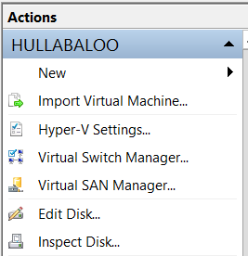

* 1. In the **Virtual Switch Manager** dialog, create a new virtual switch by selecting **Internal** and then clicking the **Create Virtual Switch** button.

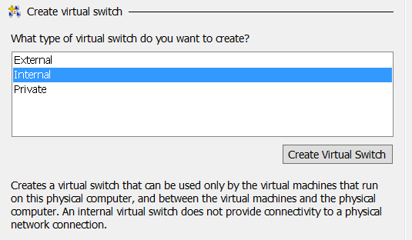

* 1. Configure the new virtual switch with the following properties:
     1. **Name**: Internal
     2. **Connection Type**: Internal network.

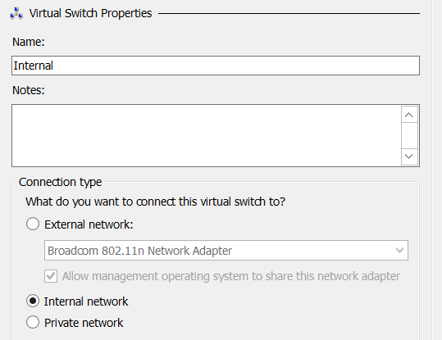

* 1. Click **OK** to save your changes.

In the next step you will create an external virtual switch that will be used to connect the VM to the Internet. You can create this external network switch by using either a network adapter with a network cabled plugged in or a wireless connection on your host computer. All that is required is that you create the virtual switch using a network adapter on your host computer that can connect to the Internet. The Internet connection is an essential part of the setup for this VM because it's required when running the Prerequisite Installer utility of SharePoint Server 2016.

1. Create a new virtual switch named **External** for an external network adapter:
   1. In the **Actions** pane on the right-hand side of the screen, click **Virtual Switch Manager**.



* 1. In the **Virtual Switch Manager** dialog, create a new virtual switch by selecting **External** and then clicking the **Create Virtual Switch** button.

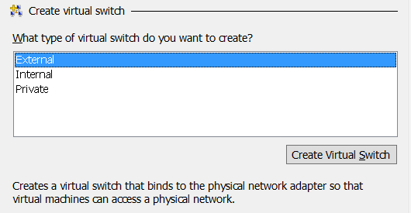

* 1. Configure the new virtual switch with the following properties:
     1. **Name**: External
     2. **Connection Type**: External network.
        1. Make sure to select a network adapter or wireless connection from the host computer in the dropdown menu under the **External network** radio button.

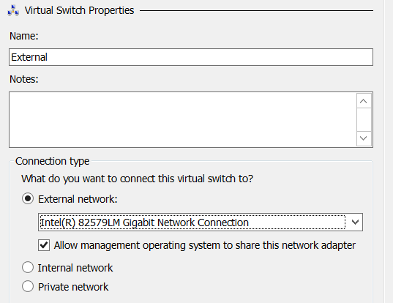

* 1. Click **OK** to save your changes.

### Task 3: Create a new Virtual Machine (VM) using Hyper-V

To complete this task, you will create a new VM using the Hyper-V environment.

1. If it is not open, launch **Hyper-V Manager**.
2. On the left-hand side of **Hyper-V Manager**, locate the node with the name of the local host computer and select it.
3. In the Actions pane select New 🡪 Virtual Machine.
   1. When you execute this menu command, the Hyper-V Manager will launch the **New Virtual Machine Wizard**.

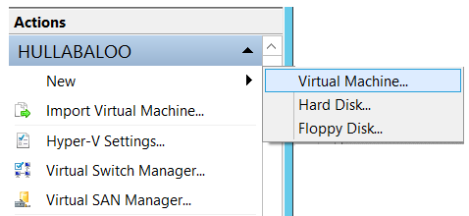

1. The New Virtual Machine Wizard begins with the Specify Name and location dialog.
   1. Enter a Name of WingtipServer.
   2. Select a folder path for the **Location** property where the virtual machine files will be stored. Ensure the **Location** path is hosted by a hard drive that has at least 100GB of free space. If possible, configure the **Location** path on a secondary hard drive that is different from the hard drive running the host operating system to improve the performance of your VM.
   3. Click **Next** to move to the next page of the New Virtual Machine Wizard.

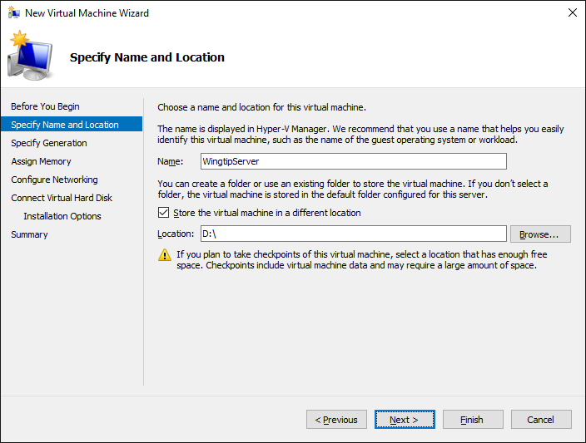

1. On the **Specify Generation** page, select **Generation 1** and then click **Next**.

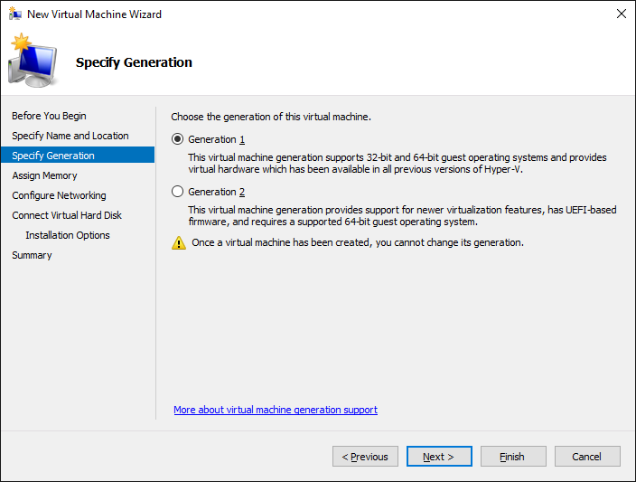

1. In the **Assign Memory** dialog, enter the amount of **Memory** to allocate to the virtual machine.
   1. Determine the amount of memory to use for the VM from the following table.

|  |  |
| --- | --- |
| **If host machine has this much RAM** | **Then configure the VM with this much RAM** |
| 16 GB or more | 14 GB - configure the VM with **14336 MB** of RAM. |
| 14 GB | 12 GB - configure the VM with **12288 MB** of RAM. |
| 12 GB | 10 GB - configure the VM with **10240 MB** of RAM. |
| 10 GB (not supported) | 8 GB - configure the VM with **8192 MB** of RAM. |
| 8 GB (not supported) | 6.5 GB - configure the VM with **6656 MB** of RAM. |

* 1. Enter the amount of RAM you calculated in the previous step as the **Startup** memory property. Make sure you enter the number in megabytes (e.g. **14336 MB**). Finally, make sure to leave the **Use Dynamic Memory for this virtual machine** checkbox unchecked. Click **Next** to continue.

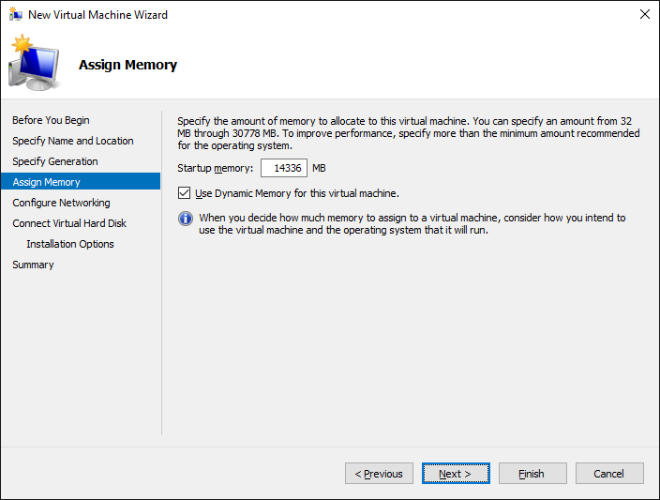

1. In the **Configure Networking** dialog, assign a **Connection** property of theInternal and click **Next**.

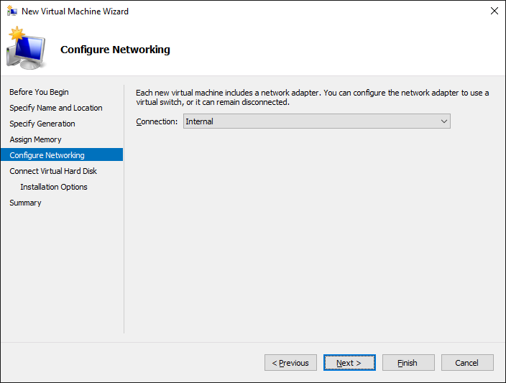

In the next step you will configure the file location for the files Hyper-V uses to store the VM. If possible, configure the VM file location on a separate physical drive that is different than the drive which holds the host computer’s operating system. This is one of the best way to increase the performance of a VM.

1. In the **Connect Virtual Hard Disk** dialog, accept the default option of **Create a virtual hard disk**. Make sure the **Location** is set to a directory in a local hard drive on our host computer that has at least 120 GB of free space. Click **Next**.

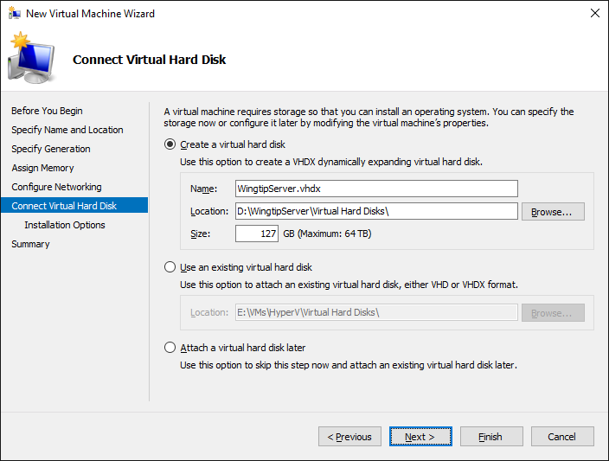

1. In the **Installation Options** dialog, accept the default option which is **Install an operating system later** and click **Next**.

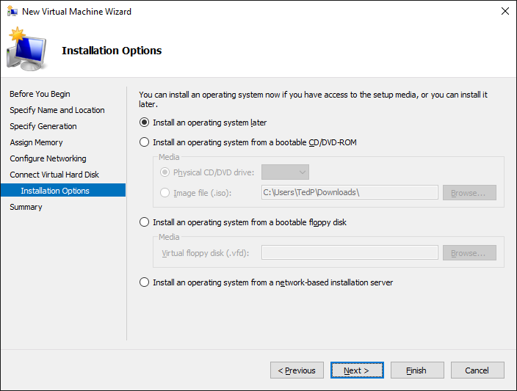

1. On the **Completing the New Virtual Machine Wizard** dialog, review the setting and verify that these settings are what you expected. Click **Finish** to create the new VM.

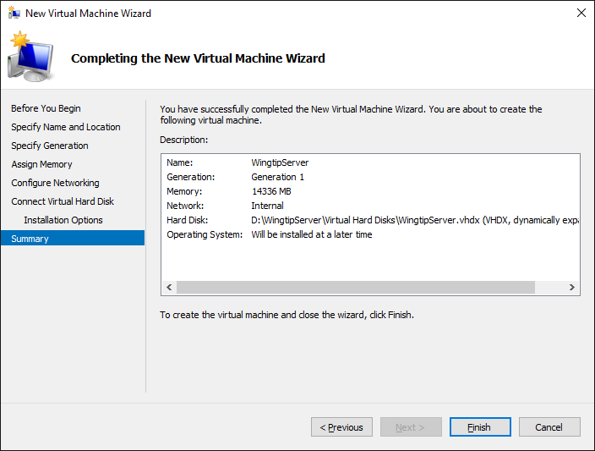

Even though you have finished going through the New Virtual Machine Wizard, there are still two more configuration changes you need to make on the VM before you are ready to install the Windows Server 2016 operating system.

1. In the **Hyper-V Manager** window, right-click the VM you just created and select **Settings**:

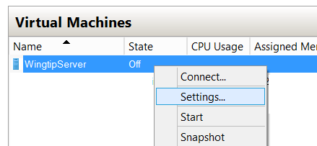

1. In the **Settings for WingtipServer** dialog, complete the following steps
   1. Select the **Processor** setting and increment the **Number of processors** property value from its default value of **1** to the maximum allowable number for your host machine. You can increment the **Number of processors** property value using the up arrow in the spinner control to its right. Depending on the processor capabilities of your host computer, you should be able to increase this property to a value of either **2**, **4** or **8**.

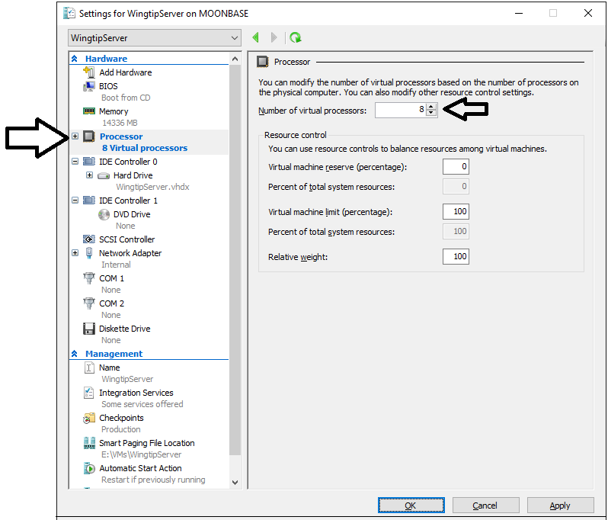

* 1. Click the **Apply** button to save your changes to the **Number of virtual processors** property while leaving the dialog open.

1. Create a second network adapter in the VM.
   1. In the Settings for WingtipServer dialog, select Add Hardware. Next, select Network Adapter and click Add:

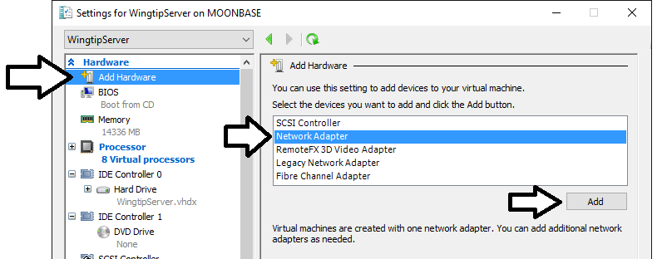

* 1. Once the new Network Adapter has been created, do **not** assign a **Virtual switch** yet. In an upcoming task later in this setup guide you will bind this network adapter to the **External** virtual switch. For now, however, you should leave the **Virtual switch** setting with its default value of **Not connected**.

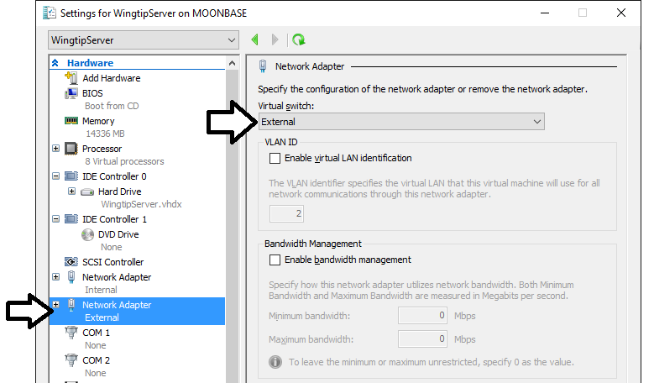

* 1. Click **OK** to save the changes you have made to the VM.

At this point you have created and configured a new VM. You are now ready to install Windows Server 2016.

### Task 4: Install the Windows Server 2012 R2 Operating System

You will begin this task by acquiring the installation files and optionally a product key for Windows Server 2012 R2. After that you will move through the steps of installing the operating system and configuring the VM as a server computer named **WingtipServer**.

1. Obtain a copy of the Windows Server 2012 R2 install binaries.
   1. Choose between using your own licensed copy of Windows Server 2012 R2 or using a free trial version.
      1. Note that downloading the free trial version will require that you have a TechNet or an MSDN subscription.
   2. If you plan to use a licensed copy, acquire the install image (*.iso) for of Windows Server 2012 R2 and the product key.
   3. If you plan to use a free trial copy of Windows Server 2012 R2, follow these steps:
      1. Navigate to the evaluation down page at **http://technet.microsoft.com/en-us/evalcenter/hh670538.aspx**.
      2. Find the **Download the Evaluation ISO** section and click the **Get Started Now** button underneath to begin the download.
      3. When prompted, log in using the credentials for your TechNet or MSDN subscription.
      4. Work through the instructions for downloading the Windows Server 2012 installation files in the .ISO file format.
      5. When you are done, you should have successfully downloaded the .ISO file with the Windows Server 2012 installation files to the hard drive of your host computer.
2. Mount the .ISO file so the **WingtipServer** VM recognizes it as a DVD.
   1. Navigate to Hyper-V Manager.
   2. Right-click the **WingtipServer** VM and select the **Connect…** command to display the Hyper-V console window for this VM.

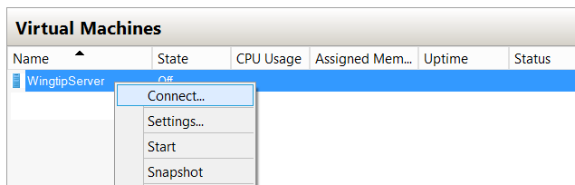

* 1. In the Hyper-V console windows for the **WingtipServer** VM, select the **Insert Disk…** command.

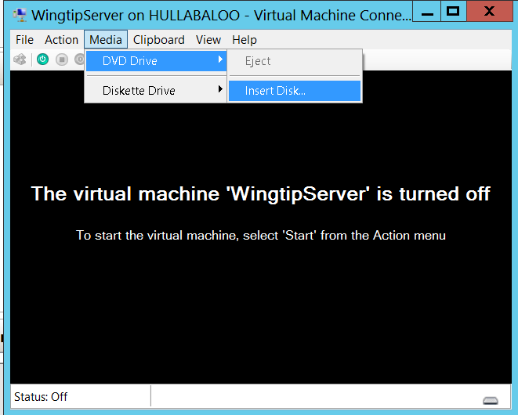

* 1. When the **Open File** dialog appears, enter the path to the .ISO file with the Windows Server 2012 installation files.
  2. Click **OK**.

1. Start the **WingtipServer** VM.
   1. In the Hyper-V console windows for **WingtipServer**, select the **Start** command from the **Action** menu to start up the VM.

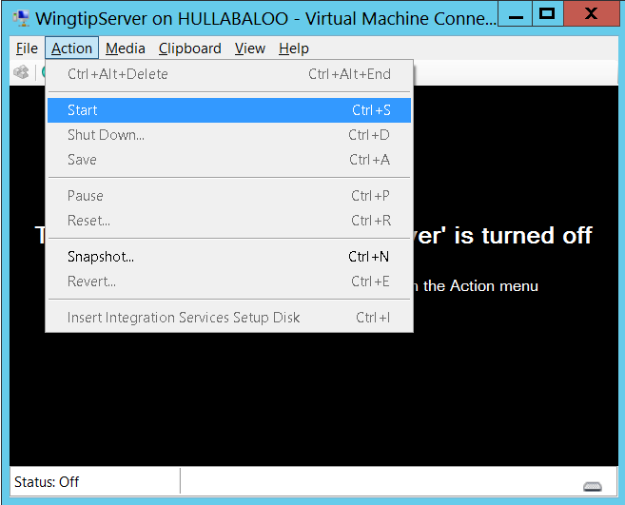

When the **WingtipServer** VM starts, it should automatically start the Windows Server 2012 installation program.

1. After the setup program for Windows Server 2012 loads, it will prompt you with a dialog asking you to select a language. Accept the default of **English** and click **Install** to continue.

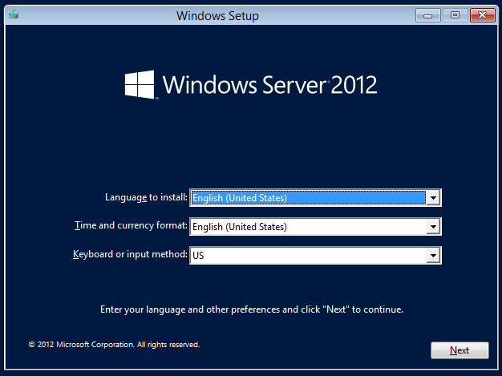

1. At the next dialog, click the **Install Now** button to begin the installation.

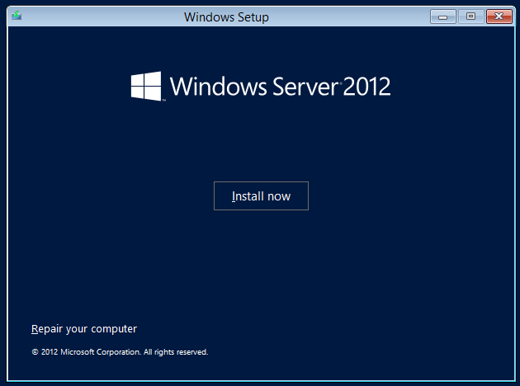

1. Depending on the type of installation files you have for Windows Server 2012, you might be prompted with a dialog which asks you to provide your Windows Server 2012 product key. If so, enter your product key and click **Next**.

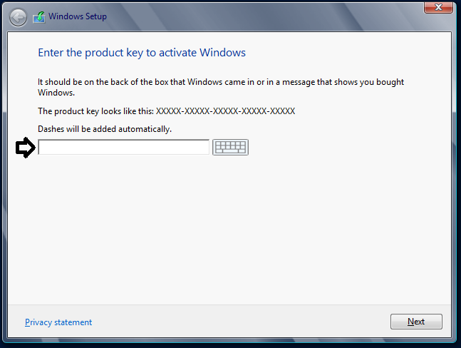

1. Depending on the type of installation files you have for Windows Server 2012, you might be prompted with a dialog which asks you to select the operating system you want to install. If so, select the **64-bit** edition of **Windows Server 2012 Standard Evaluation (Server with a GUI)** and click **Next**.

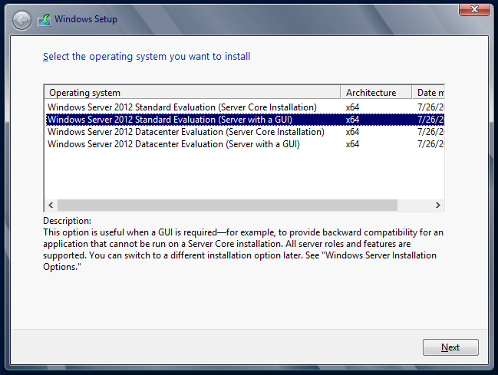

1. On the following dialog, agree to the licensing terms and click **Next**.
2. The next dialog prompts you with the question **Which type of installation do you want?**
   1. Select the installation type of Custom: Install Windows only (advanced)
   2. Click **Next**.

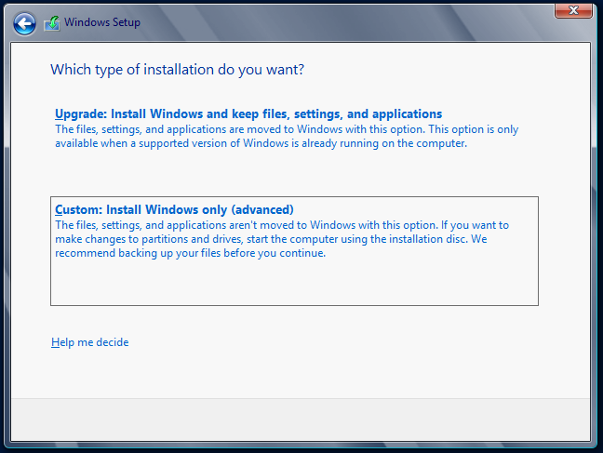

1. The next dialog asks you where you want to install Windows.
   1. Accept the default configuration which uses a location of **Disk 0 Unallocated Space** as shown below.
   2. Click **Next** to continue.

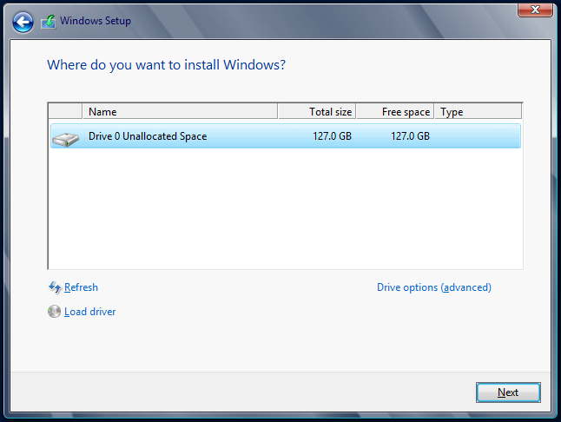

At this point you have given the Windows setup program enough information to install the basic operating system. The Windows Server 2012 setup program will now run for several minutes as it copies and expands files and installs Windows features. You now have a few minutes to get a cup of coffee or catch up on email.

1. Wait until the Windows Server 2012 setup program completes
2. When the setup program has completed, it will prompt you to assign a new password for the **Administrator** account.
   1. Click **OK** to continue and reset the administrator password.
   2. Set the password for the **Administrator** account to **Password1**.

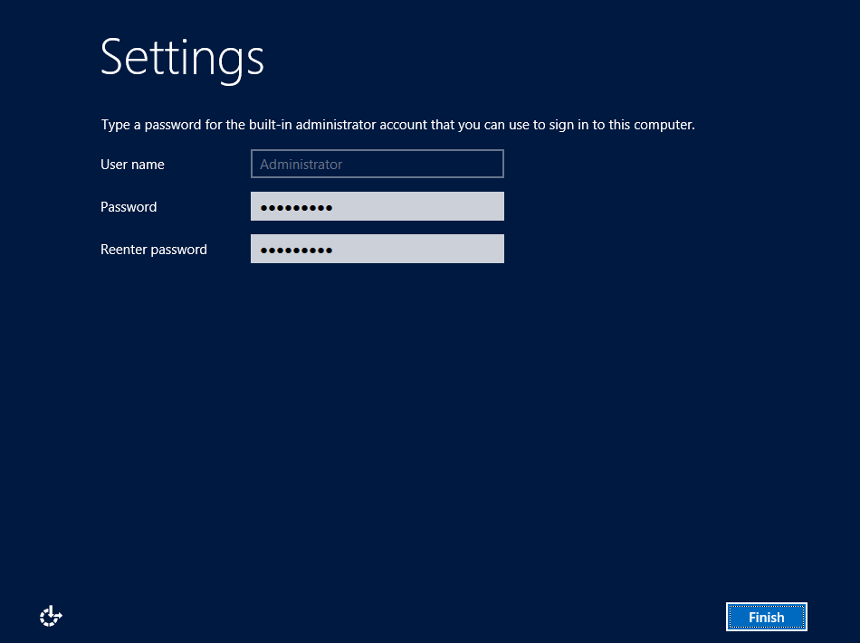

* 1. After you have updated the **Administrator** password, you will get a confirmation that the update was successful.
  2. Click **OK** to complete the basic installation of the operating system.
  3. When you click **OK** in the previous step, you will be logged off of the VM and the Hyper-V console window will then display the current date and time as well as the message **Press Ctrl + Alt + Delete to sign in**.



At this point, you have installed the basic operating system for Windows Server 2012 but there are several more configuration changes that you must make. Over the next few steps you will complete the required configuration by changing the computer name of the VM and making a few additional changes to the configuration of the operating system.

1. Log onto the VM using the local **Administrator** account.
   1. Do **not** attempt to log on by pressing the **Ctrl + Alt + Delete**.This keyboard combination will be sent to the host computer instead of the VM running inside Hyper-V.
   2. Log on to the VM by pressing the **Ctrl + Alt + End** keyboard combination or by selecting the **Ctrl + Alt + Delete** menu command inside the **Action** menu of the Hyper-V console window. When prompted to log on to the **Administrator** account, provide a password of **Password1**.

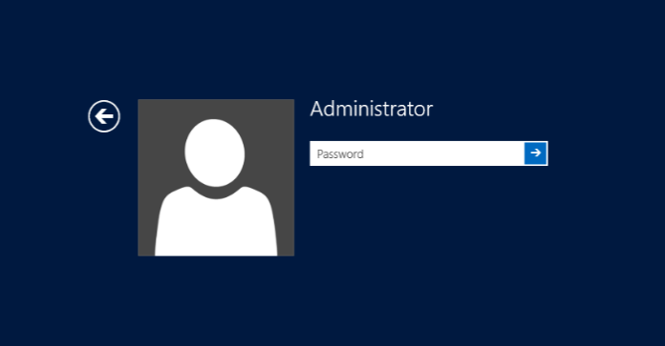

1. When you log in, Windows Server 2012 automatically displays the **Dashboard** page of the **Server Manager**. If you look at the left-hand portion of the screen, you will notice several navigation links including **Dashboard**, **Local Server**, **All Servers** and **File and Storage Services**.

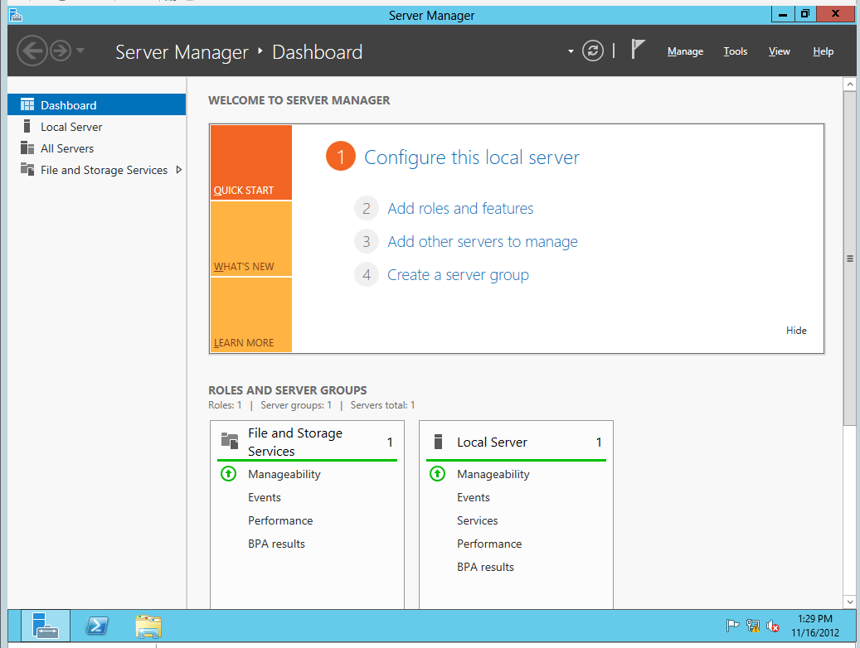

1. Click on **Local Server** link to navigate the main page used to update configuration properties of the local machine. You can see on the right-hand side of the screen there is a large section with a title of **Properties** which displays selected properties of the local machine.

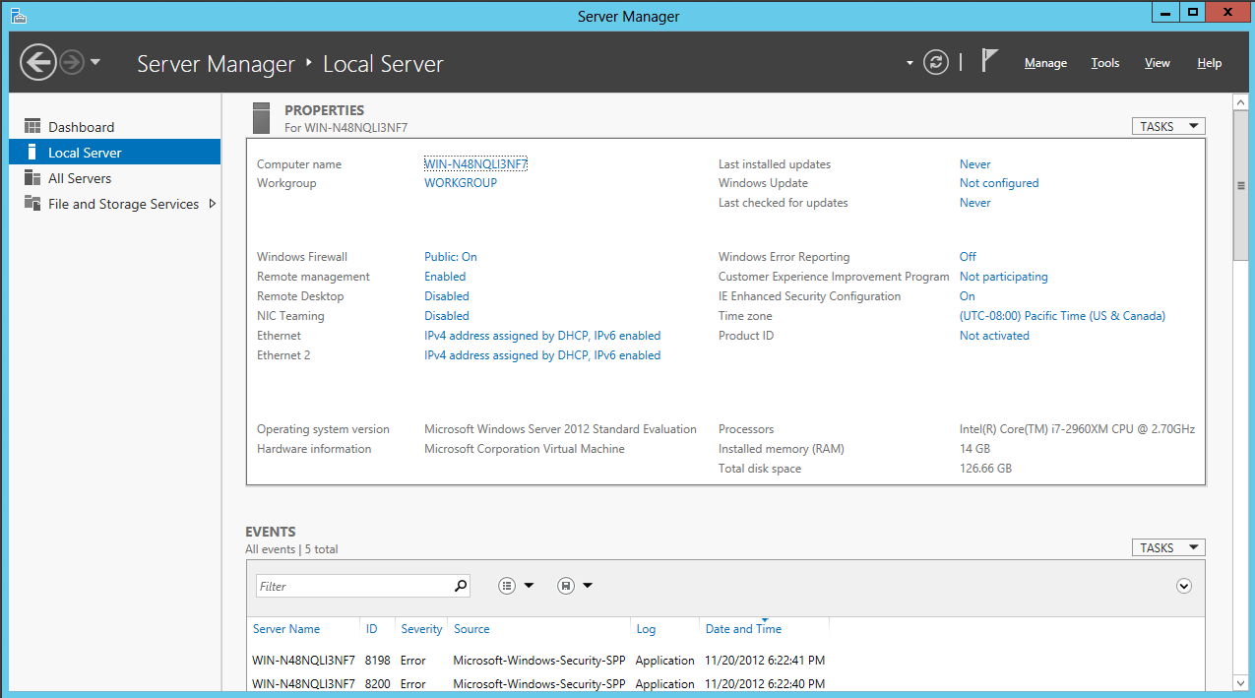

1. Change the **Computer name** of the VM to **WingtipServer**.
   1. Locate the **Computer name** property which is listed first in the **Properties** section. The current computer name was created by the Windows installation program as part of the initial setup of the operating system. Click on the value of the **Computer name** property to modify it.

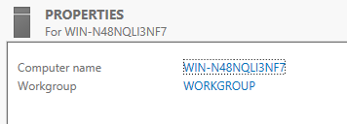

* 1. At this point you should be at the **Computer Name** tab of the **System Properties** dialog. Click on the **Change** button to update the **Computer name** property.

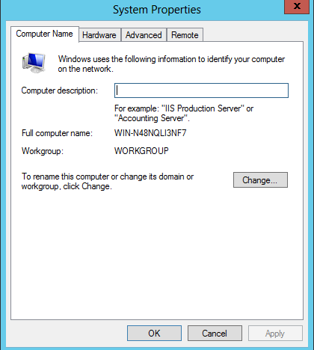

* 1. In the **Computer Name/Domain Changes** dialog, change the **Computer name** property to **WingtipServer**. Click **OK** to save your changes.

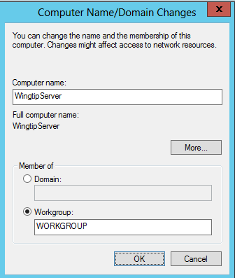

* 1. When you modify the **Computer name** property, Windows prompts you with a dialog that that tells you the machine needs to be restarted to apply the change. Choose **OK** to restart.
  2. After the VM has restarted, log in again using **[Administrator | Password1]** *(username | password)*.

1. Once you have logged back onto the VM, navigate back to the **Server Manager** and click the **Local Server** node. At this point, you should be able to see the **Properties for WingtipServer** section in the **Server Manager**.

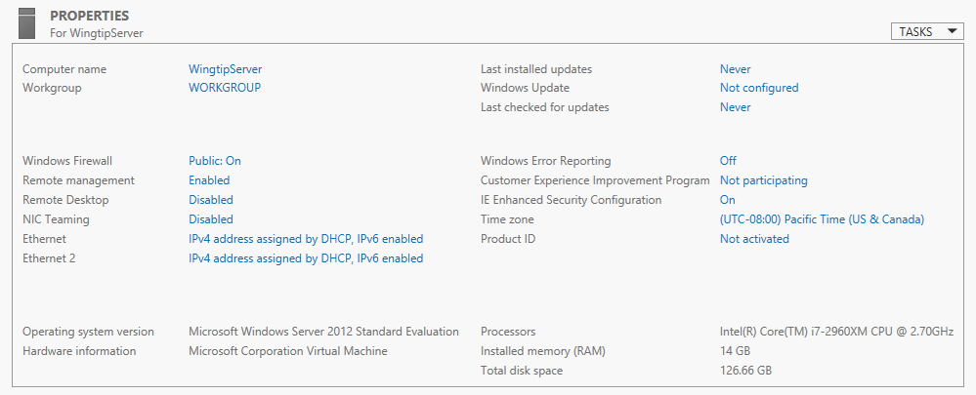

1. Disable Enhanced Security Configuration.
   1. In the Properties for WingtipServer section of the Server Manager, locate the IE Enhanced Security Configuration property in the right-hand column.
   2. You should be able to see that the **Enhanced Security Configuration** mode is configured to be on by default.
   3. Click on the value of On to display the Internet Explorer Enhanced Security Configuration dialog. This will display the Internet Explorer Enhanced Security Configuration dialog.
   4. In the Internet Explorer Enhanced Security Configuration dialog, disable Enhanced Security Configuration for both Administrators and Users by selecting the Off radio buttons as shown below and then click OK.

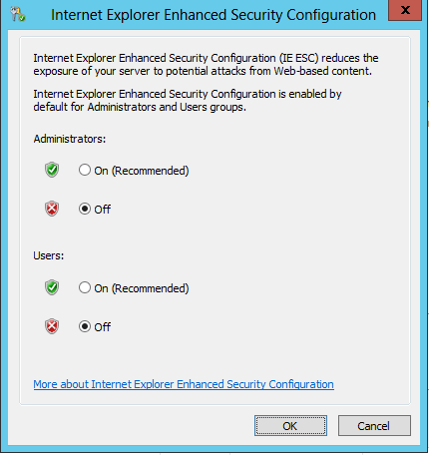

1. Disable the Windows Firewall.
   1. In the **Properties for WingtipServer** section of the **Server Manager**, locate the **Windows Firewall** property which shows an initial value of **Public: On**. Click on the value of **Public: On** to display the **Windows Firewall** dialog.
   2. In the Windows Firewall dialog, locate and click the Advanced Settings link to display the Windows Firewall Advanced Settings dialog.

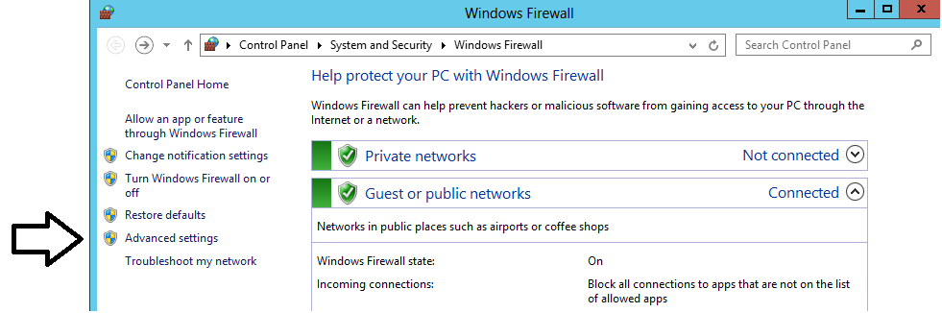

* 1. In the **Windows Firewall Advanced Settings** dialog, you should be able to see that the Windows Firewall for the **Domain Profile**, the **Private Profile** and the **Public Profile** are all enabled. Locate and click the **Windows Firewall Properties** link at the bottom of the **Overview** section to display a tabbed dialog with the title of the **Windows Firewall with Advanced Security on Local Computer**.

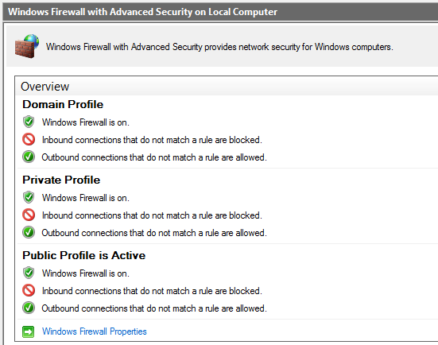

* 1. In the **Domain Profile** tab of the **Windows Firewall with Advanced Security on Local Computer** dialog, change the **Firewall state** property setting from **On** to **Off**. Click **Apply** to save your changes while leaving the tabbed dialog open.

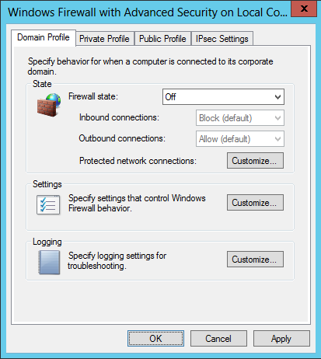

* 1. Once you have configured the **Firewall state** property to **Off** on the **Domain Profile** tab, go to the **Private Profile** tab and then the **Public Profile** tab and follow the same steps to disable the firewall for these profiles as well.
  2. Once you have turned off the firewall for all three profiles, click **OK** to dismiss the dialog. You should be able to verify in the **Overview** section of the **Windows Firewall Advanced Settings** dialog that the Windows Firewall has been turned off for the **Domain Profile**, the **Private Profile** and the **Public Profile**.

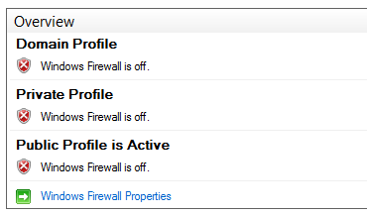

1. Enable Remote Desktop for your VM:
   1. Navigate back to the **Server Manager** and click the **Local Server** node. At this point, you should be able to see the **Properties for WingtipServer** section in the **Server Manager**.
   2. Look inside the **Properties for WingtipServer** section and locate the **Remote Desktop** property which an initial value of **Disabled**.

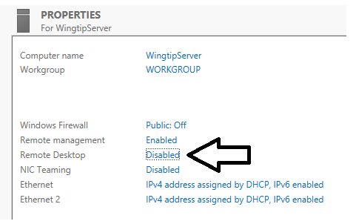

* 1. Click on the **Remote Desktop** property value of **Disabled.** This willdisplay the **Remote** tab of the **System Properties** dialog.
     1. Select the radio button option **Allow for remote connections to this computer**.
     2. Check **Allow connections only from computers running Remote Desktop with Network Level Authentication**.
     3. Click **OK** to save changes and dismiss the **System Properties** dialog.

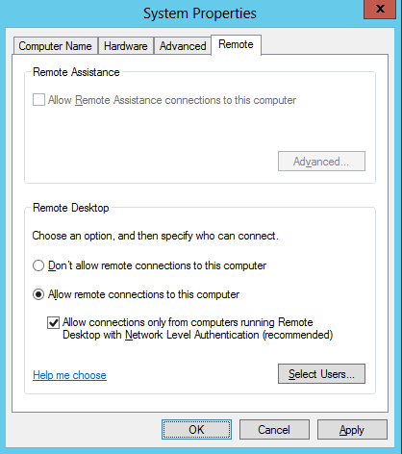

1. Configure the local **Administrators** account so the password never expires.
   1. Navigate to the Properties for WingtipServer section of Server Manager > Local Server.
   2. Look at the top-right corner of the **Properties for WingtipServer** section and locate the **Tasks** menu. Drop down the **Tasks** menu and select the **Computer Management** menu command to display the Windows server **Computer Management** utility.

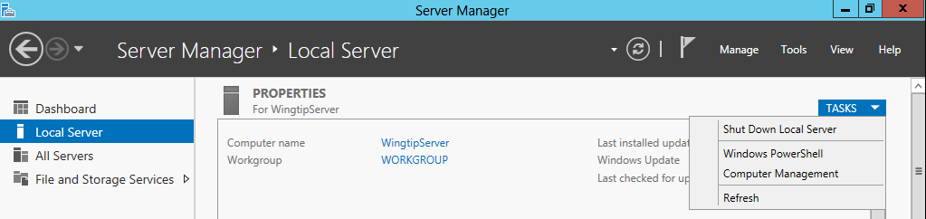

* 1. When the **Computer Management** utility appears, you can see that it provides a tree view control of nodes that represent various configurable components and services on the local machine. Within this collection of nodes, you should be able to locate the **Local Users and Groups** node.

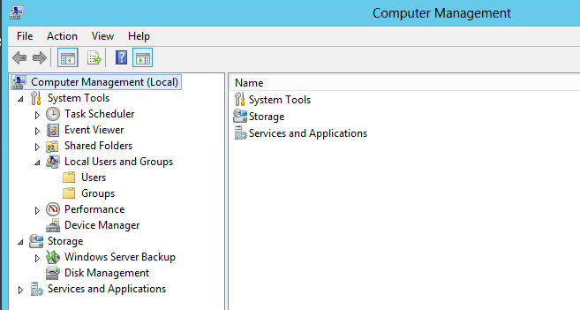

* 1. Navigate to **Local Users and Groups 🡪** **Users** and locate the local **Administrator** account.
  2. Right-click on the **Administrator** account and click **Properties**.

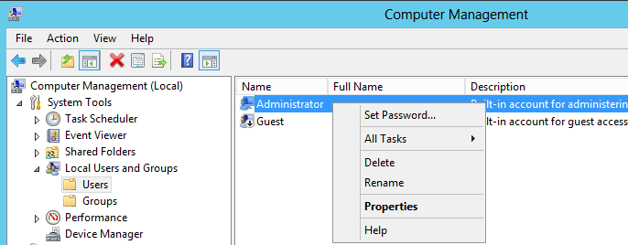

* 1. In the Administrator Properties dialog, select the option for Password never expires.

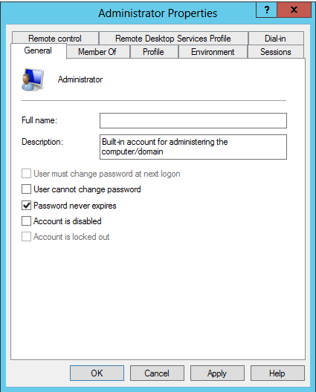

* 1. Click **OK** to save your changes and close the **Administrator Properties** dialog.
  2. Return to the **Local Server** page of the **Server Manager**.

1. Rename the two network connections so you can tell them apart.
   1. Press the **Windows** key on the keyboard to bring up the Windows Server 2012 **Start page**.
   2. Your **Start page** should appear as the one shown below.

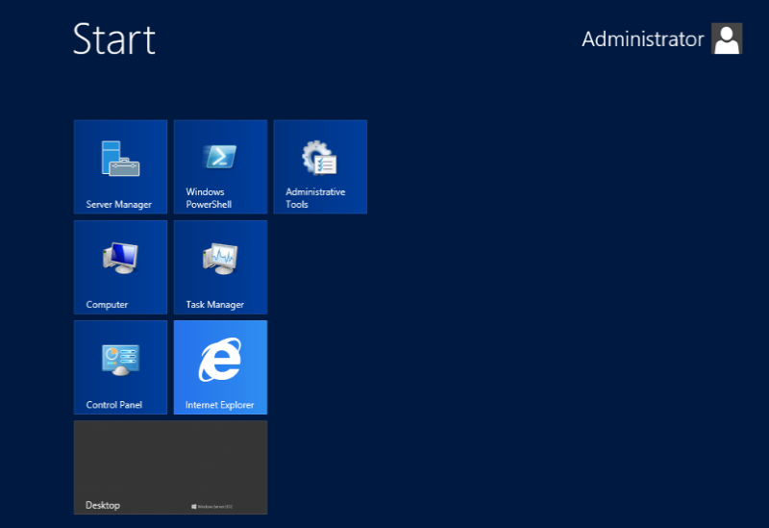

* 1. With the **Start page** showing, go to the keyboard and type in **"View Network Connections"**. Click on the **Settings** link on the right as shown in the following screenshot. You should see that Windows found the **View network connections** page. Click on **View network connections** to navigate to that page.

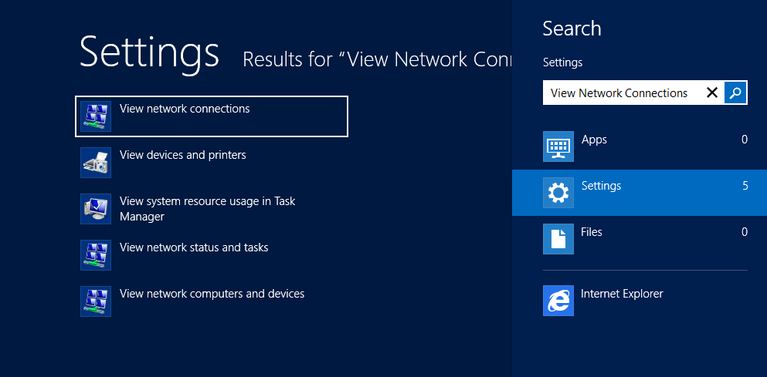

* 1. On the **View network connections** page, you should see that the VM has two network connections. You should also be able to see that one of them is connected and the other one with the big red X is disconnected.

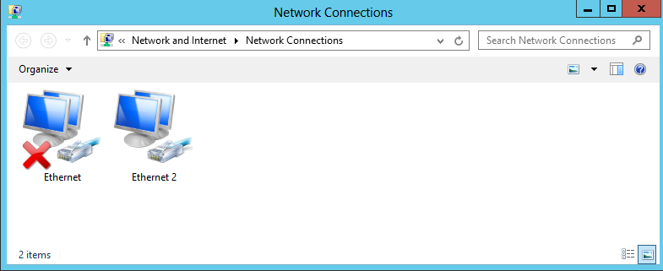

The network connection which is connected is based on network adapter for the VM which is assigned to the virtual switch named **Internal**. The other network connection which is disconnected (e.g. unplugged) has a network adapter that is not currently assigned to a virtual switch. The reason we had you leave the second network adapter unassigned earlier in the setup guide is that it makes it easier to see which network connection is which when initially configuring the VM.

* 1. Right-click the network connection which is connected and select **Rename**. Give it a name of **Internal**.
  2. Right-click the network connection which is disconnected and select **Rename**. Give it a name of **External**.

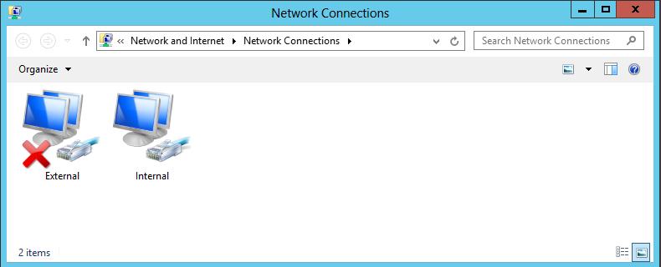

1. Configure a static IP address on **Internal** network connection.
   1. Right-click the **Internal** network connection and select **Properties**.
   2. Uncheck the item Internet Protocol Version 6 (TCP/IPv6)
   3. In the Internal Properties dialog, select the Internet Protocol Version 4 (TCP/IPv4) item and click Properties.

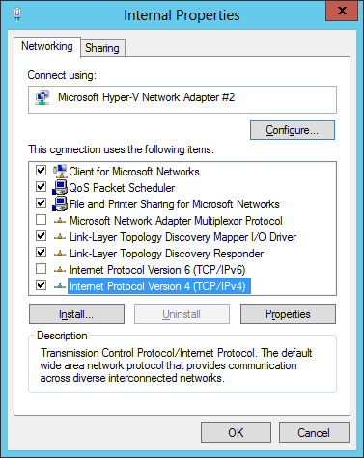

* 1. In the **Internet Protocol Version 4 Properties** dialog, select the option **Use the following IP address** and enter the following configuration settings:
     1. IP Address: 192.168.150.1
     2. Subnet mask: 255.255.255.0
  2. In the **Internet Protocol Version 4 Properties** dialog, select the option **Use the following DNS Server Addresses** and enter the following configuration setting:
     1. Preferred DNS Server: 192.168.150.1

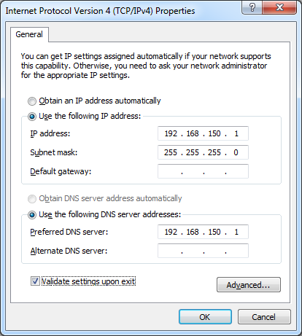

* 1. Click **OK** to accept the IP settings and **Close** the **Internet Protocol Version 4** dialog.

1. Configure the **External** network connection inside the VM to connect to the Internet:
   1. Open the **Network Connections** window if it is not still open using the same steps from the previous step.
   2. Right-click the **External** network connection and select **Properties** to display the **External Properties** dialog.
   3. Uncheck the item Internet Protocol Version 6 (TCP/IPv6)
   4. Select the Internet Protocol Version 4 (TCP/IPv4) item and click Properties.
   5. Enter the following information into the resulting dialog to configure the network connections IP settings:
      1. Select the radio button option **Obtain an IP Address Automatically**
      2. Select the radio button option **Use the following DNS server addresses**.
      3. Set the **Preferred DNS Server** to **127.0.0.1**.
      4. Set the **Alternate DNS Server** to **4.2.2.4**.

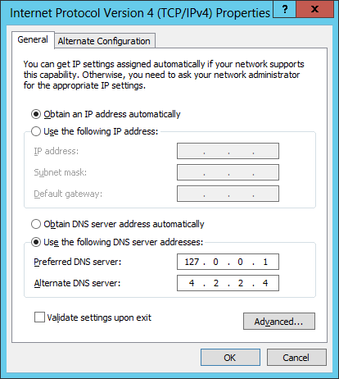

* 1. Click **OK** to accept the IP settings and **Close** the **Internet Protocol Version 4** dialog.

Setting the DNS server addresses for the **External** network connection is important. These settings will ensure that the VM always looks to its local DNS service first when attempting to resolve an Internet domain name to an IP address. The second IP address of **4.2.2.4** is a well-known address of a DNS server on the Internet. This configuration ensures that the VM will always have a secondary DNS service to look up domains on the Internet that the local DNS service cannot find.

1. Reconfigure the VM's network adapter in Hyper-V to bind it to the **External** virtual switch.
   1. Go back to the host computer and open the Hyper-V Manager.
   2. In the Hyper-V Manager window, right-click the VM named **WingtipServer** and select **Settings**.
   3. Select the second Network Adapter, the one that is not connected.
   4. For the **Virtual switch** setting, select **External** and click **OK**. This will effectively connect the **External** network connection in the **WingtipServer** VM to your local LAN and your local DHCP service.

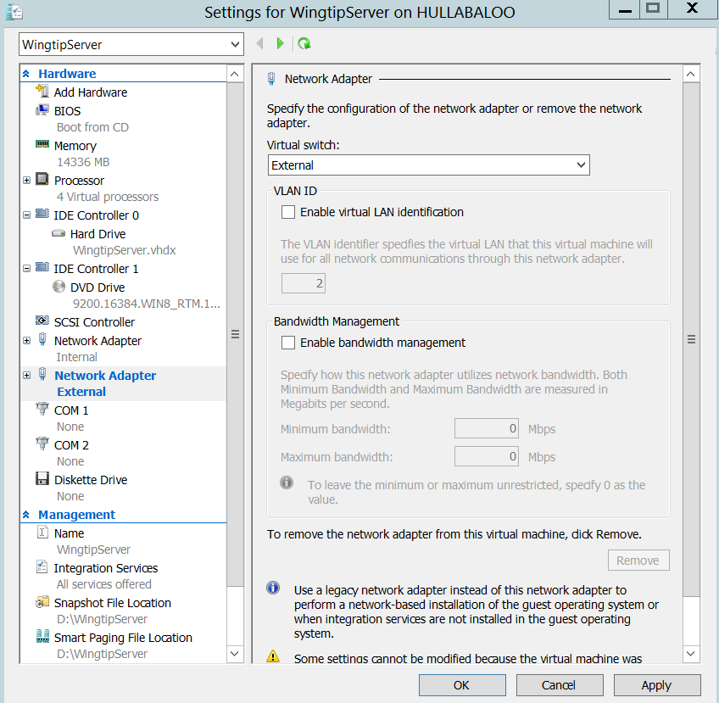

* 1. Return back into the user interface of the **WingtipServer** VM.
  2. Navigate back to the **View network connections** page. You should now see that both network connections show they are connected. In other words, the big red X should have disappeared.

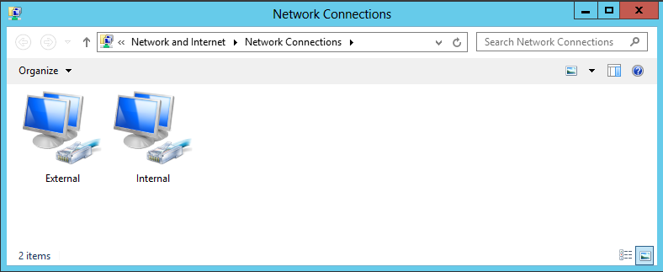

* 1. Refresh the **External** network connection
     1. Select the **External** network connection you just plugged in
     2. With the **External** network connection selected, click the **Disable this Network Device** button in the toolbar.
     3. With the **External** network connection selected, click the **Enable this Network Device** button in the toolbar
     4. When the network connection is re-enabled, Windows uses the **External** network connection to call out to the local DHCP service to acquire an IP address that will make it possible for the **WingtipServer** VM to access the Internet.
     5. Open the Internet Explorer and browse to a site on the Internet such as **http:www.bing.com**. You should be able to browse sites on the Internet without any problems.

1. Run the **ipconfig.exe** utility to verify that the VM's IP addresses have been configured properly.
   1. Press the **Windows** key + **R** key keyboard combination to bring up the Windows **Run** menu.
   2. In the **Run** dialog, type in **cmd** and click **OK** to bring up a standard Windows command prompt.

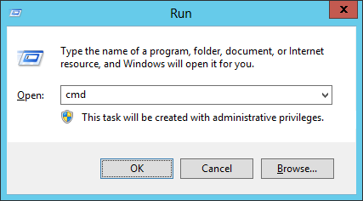

* 1. In the command prompt, run the **ipconfig** command to view the IP addresses that have been assigned to the **WingtipServer** VM. You should be able to verify that that the **Internal** network connection has the static IP address you assigned which is **192.168.150.1**. You should also be able to verify that that the **External** network connection has been assigned a dynamic IP address by your local DHCP service.

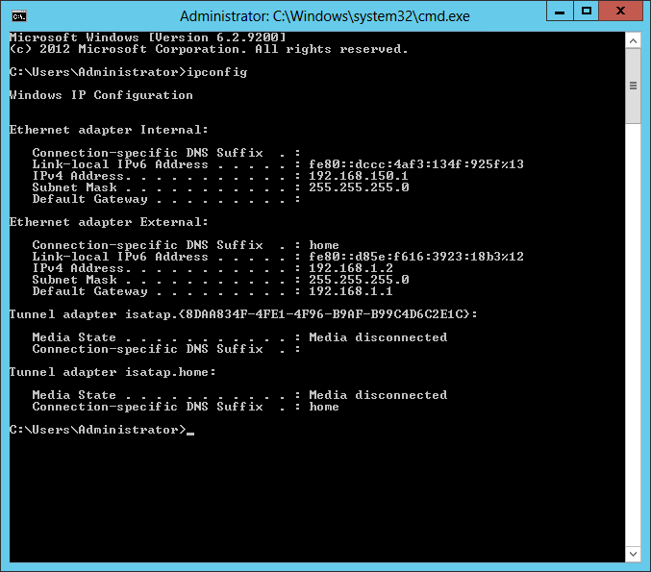

1. Enable the Windows Server Desktop Experience feature in the Wingtip Server VM.
   1. Open the **Server Manager**; If necessary, Click the **Server Manager Icon** in the lower left corner of the Windows Server 2012 screen.



* 1. On Server Manager in the right side of the dialog box click **Add roles and features** then Click **Next 🡪Next**

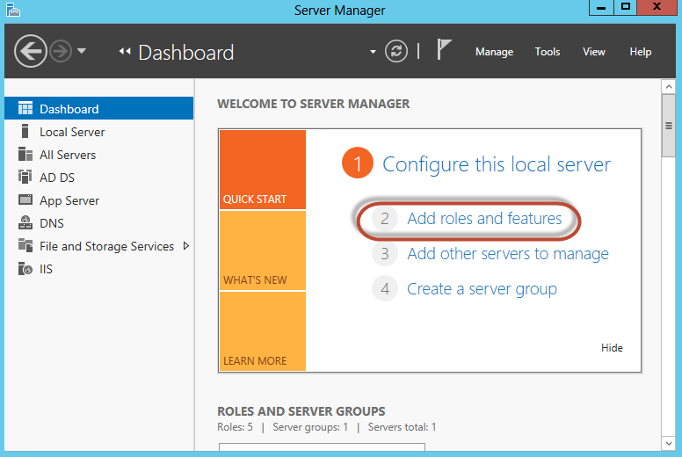

* 1. In the Add Roles and Features Wizard:
     1. Click on **Features** in the left-hand side Select features area
     2. In the Features list expand User interfaces and infrastructure (Installed)
     3. Place a check in **Desktop Experience** and then click **Add Features** to the required features dialog box that appears.

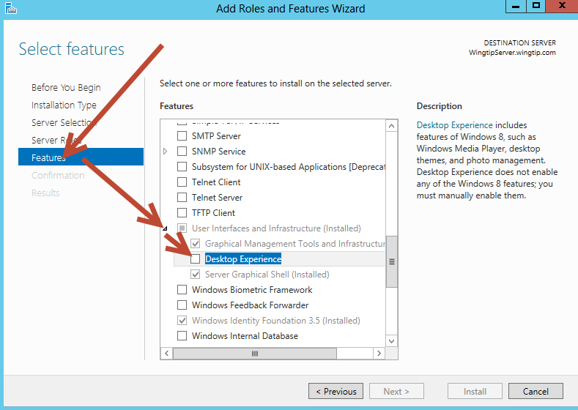

* + 1. Click **Next** then click **Install**
  1. Restart Windows server when prompted:
     1. Windows Keyboard key
     2. **Hover** the mouse in the **bottom right hand corner** of the screen to bring up the “Charm Bar” then click **Settings**.



* + 1. Click Power 🡪 Restart.

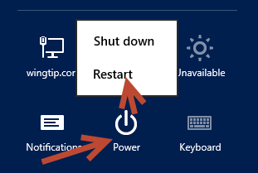

* + 1. When the Server restarts log back in using the same password (**Password1**)

1. Configure the Windows Update settings for the **WingtipServer** VM.
   1. Click on the **Windows** key on the keyboard to bring up the Windows Server 2012 **Start menu**.
   2. With the **Start menu** showing, go to the keyboard and type in **"automatic updating"**. Click on the **Settings** link on the right as shown in the following screenshot. You should see that Windows found the **Turn automatic updating on or off** page. Click on **Turn automatic updating on or off** to navigate to the **Choose your Windows Update settings** page.

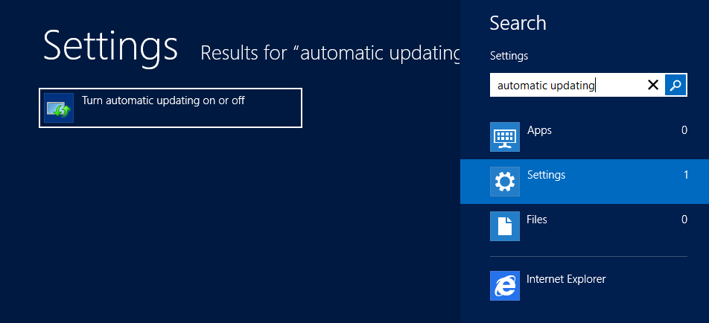

* 1. The **Choose your Windows Update settings** page shown below provides a dropdown menu that allows you to configure how the **WingtipServer** VM will deal with getting Windows Updates. Select the option for **Never check for updates (not recommended)** as shown in the screenshot below and then click **OK** to close the dialog.

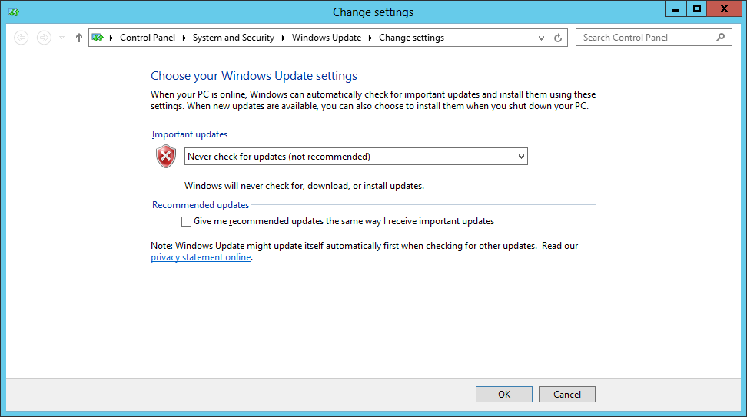

Configuring a computer with a setting of **Never check for updates** isn’t what you should use in a production environment. However, it is usually the good choice for a VM which has been created to provide a lab environment because you don't want to be taken by surprise by Windows updates that change the local computer configuration or interrupt the network connection. Instead of configuring Windows to apply updates automatically, you will now run Windows update manually a single time to apply all the important updates and recommended updates to get the **WingtipServer** VM up to date.

1. Update the **WingtipServer** VM with the latest updates using **Windows Update**
   1. Click on the **Windows** key on the keyboard to bring up the Windows Server 2012 **Start menu**.
   2. With the **Start menu** showing, go to the keyboard and type in **"install updates"**. Click on the **Settings** link on the right as shown in the following screenshot. You should see that Windows found the **Install optional updates** page. Click on **Install optional updates** to navigate to the **Windows Update** page.

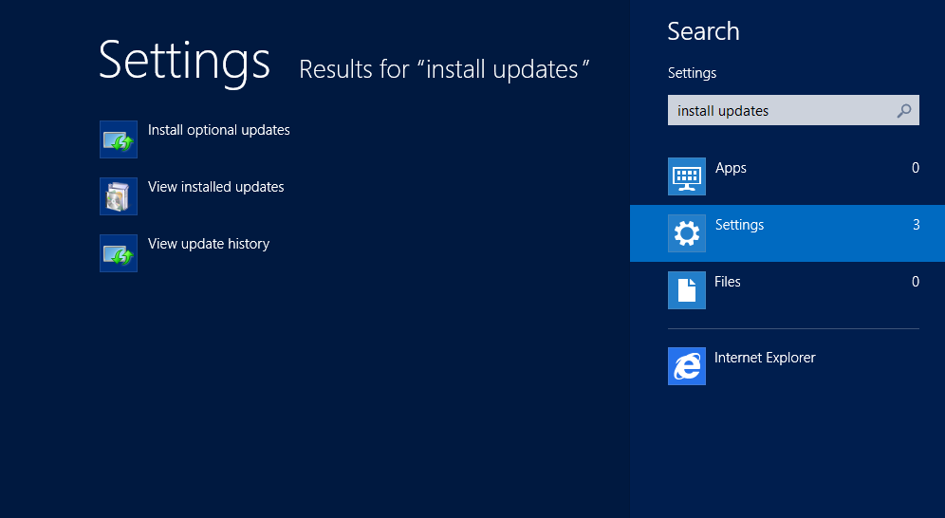

* 1. On the Windows Update page, click the **Check for** **Updates** button. When you click this button, the Windows operating system will communicate with the Windows Update service on the Internet to determine which Windows updates are available for installation.

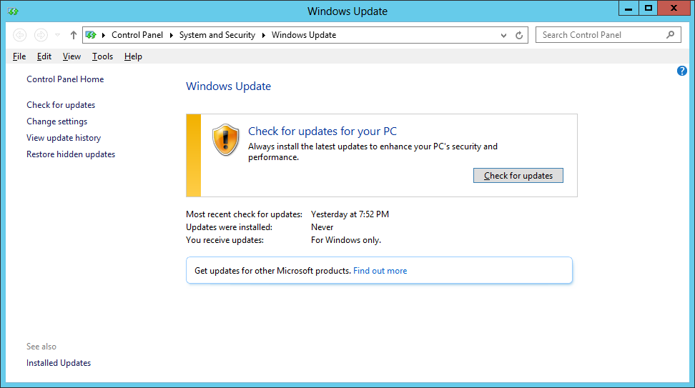

* 1. The **Windows Update** page will prompt you to install any available updates. Click the **Install updates** button to install all important and recommended updates. If you are prompted, select **I accept the license terms** for any updates that require it.

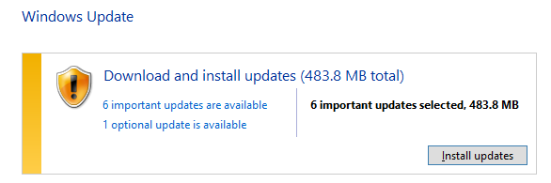

This step can take quite a bit of time so be patient.

* 1. If you are prompted to restart your PC during the Windows Update process, click **Restart now** and wait for the VM to restart. Once the VM restarts, log in as **Administrator** and navigate back to the **Windows update** page as you did earlier in this step by searching for **"install updates"** on the Windows Start page.

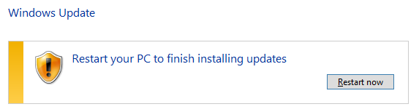

* 1. Once the first round of updates have been installed, click on **Check for updates** button again on the **Windows Update** page. Repeat the process of running Windows Update, checking for updates and installing them (rebooting if required) until the **Windows Update** page reports that **Your PC is up to date** as shown in the following screenshot.

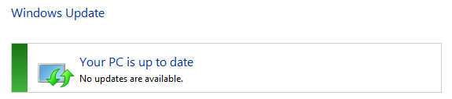

* 1. On you have applied all the important and recommended updates, close the **Windows Update** page.

1. If you have a Windows Server 2012 product key, activate the Windows operating system.
   1. If you are using the trial version of Windows Server 2012, you should skip this step and move ahead to the next step.
   2. Click on the **Windows** key on the keyboard to bring up the Windows Server 2012 **Start menu**.
   3. With the **Start menu** showing, go to the keyboard and type in **"Windows Activation"**. Click on the **Settings** link on the right as shown in the following screenshot. You should see that Windows found the **Windows Activation** page. Click on **Windows Activation** to navigate to the **Windows Activation** page.

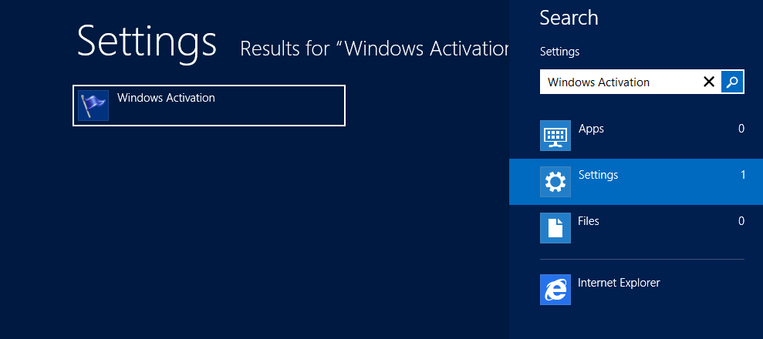

* 1. On the **Windows Activation** page, follow the step to activate your copy of Windows Server 2012.
  2. Once you have activated the Windows operating system, close the **Activate Windows** page.

At this point you have configured the **WingtipServer** VM with a fully updated version of Windows Server 2012. In the next task you will move ahead by configuring the **WingtipServer** VM to act as the Active Directory domain controller.

### Task 5: Install Active Directory and Create a new Domain

Now you will promote the **WingtipServer** VM to a domain controller and create a new domain named **wingtip.com**

1. Navigate back to the **Dashboard** page of **Server Manager**.
   1. Press the **Windows** key to display the Windows **Start page**.
   2. Click the **Server Manager** tile to start up and navigate to the **Server Manager**.

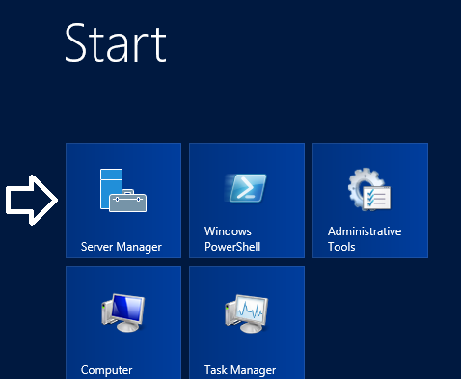

1. You should now be on the **Dashboard** page in the **Server Manager** where you can start the **Add Roles and Features Wizard**.
   1. On the right-hand side of the **Dashboard** page, locate the **Add roles and features** link.
   2. Click the Add roles and features link to start the Add Roles and Features Wizard.

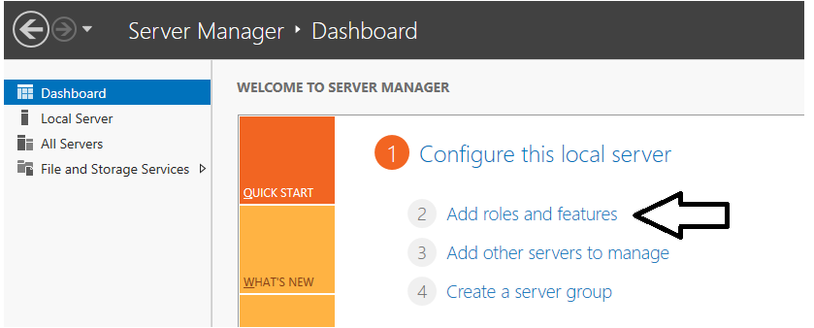

* 1. On the first page of the **Add Roles and Features Wizard**, check the box titled **Skip this page by default** and click **Next**.

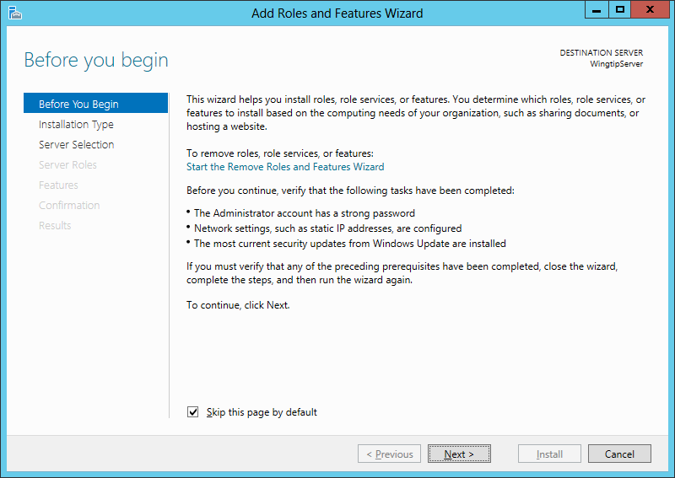

* 1. On the Select installation type page of the Add Roles and Features Wizard, do the following:
     1. Select the option **Role-based or feature-based installation**.
     2. Click **Next** to advance to the next page of the wizard.

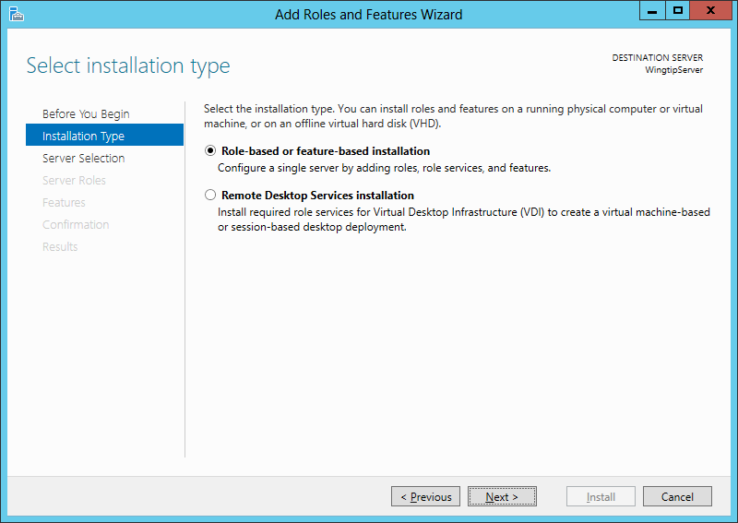

* 1. Do the following on the Select destination server page of the Add Roles and Features Wizard.
     1. Select the option **Select a server from the server pool**.
     2. Select **WingtipServer** from the **Server Pool**.
     3. Click **Next** to move to the next page.

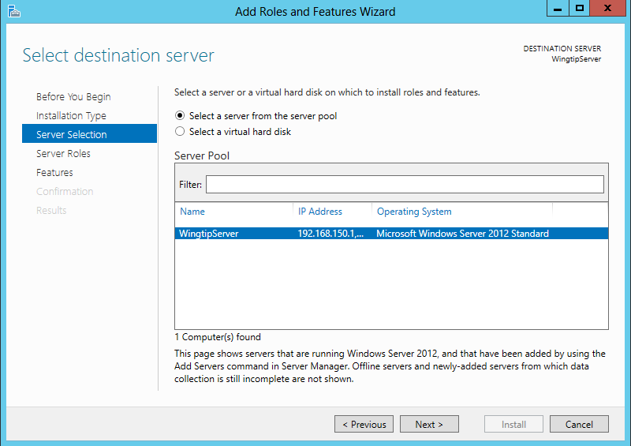

* 1. On the **Select server roles** page, select the role of **Active Directory Domain Services**. When you select this role, the wizard prompts you with the following dialog asking you to confirm you want to add the perquisite features required for this role.

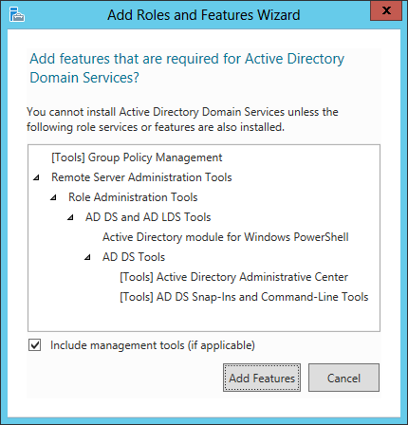

* 1. Respond to this dialog by clicking the **Add Features** button to confirm it is OK to install the perquisite features.
  2. Click **Next** on the **Select server roles** page to move on to the next page of the wizard.

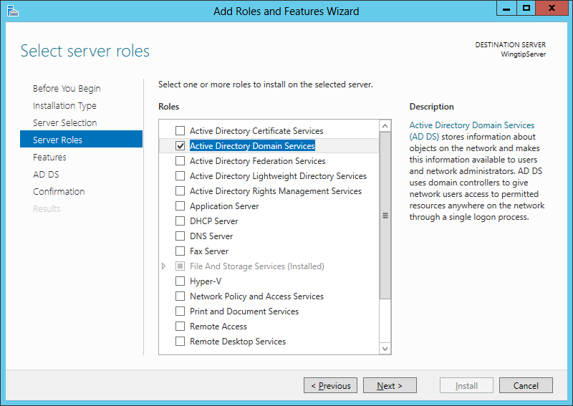

* 1. On the **Select features** page of the **Add Roles and Features Wizard**, make sure .NET Framework 3.5 is selected as shown in the following screenshot. Click **Next** advance to the next page in the wizard.

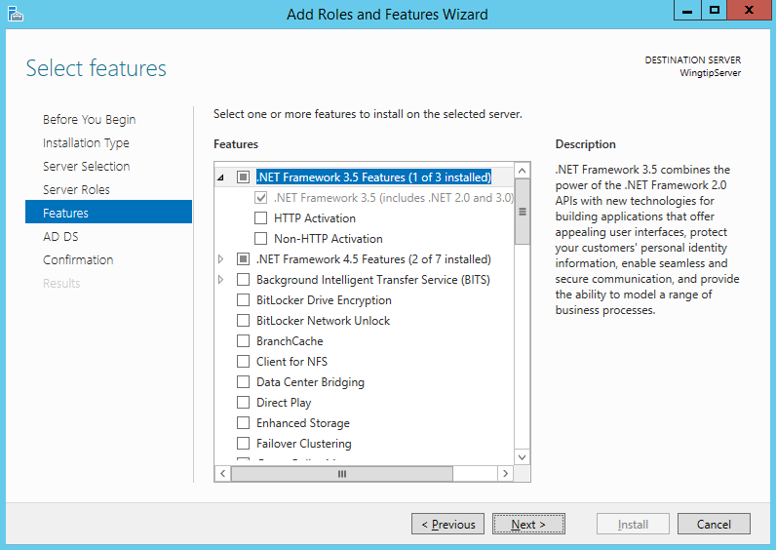

* 1. The next page provided by the wizard displays information about how Active Directory Domain Service will be installed.
     1. Click **Next t**o move to the next page of the wizard**.**
  2. The next page in the Add Roles and Features Wizard is the Confirm installation selections page. Complete these steps to start the installation of Active Directory Domain Services.
     1. Click the checkbox to enable the option **Restart the destination server automatically if required**.
     2. In the **Add Roles and Features Wizard** dialog box, click the **Yes** buttonto confirm you wish to allow automatic restarts.
     3. Click the **Install** button.

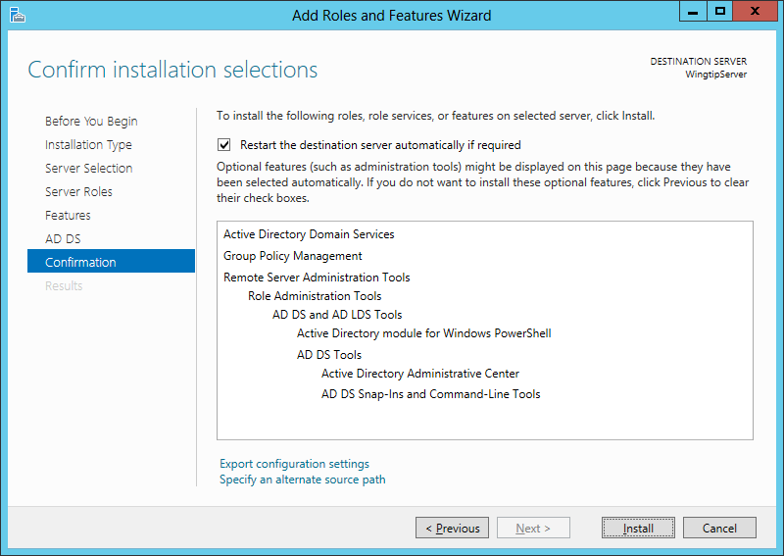

* 1. Installation will take several minutes and you will see its progress in the **Installation progress** page. After **Active Directory Domain Services** have been installed, the wizard displays a **Results** view which should indicate that the installation succeeded but additional configuration is required. Do **not** close the windows for the **Add Roles and Features Wizard** yet. You will need this window to remain open with the **Results** view showing to complete the next step.

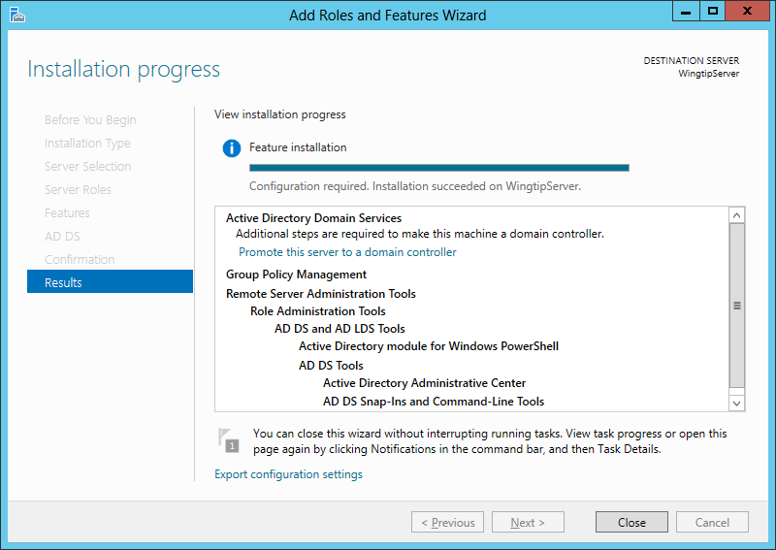

* 1. Look in the **Results** view of the dialog shown above and locate the **Promote this server to a domain controller** link.
  2. Click Promote this server to a domain controller to launch the Active Directory Domain Services Configuration Wizard.
  3. Move on to the next step to move through the details of using the **Active Directory Domain Services Configuration Wizard**.

With previous versions of Windows Server, you use a utility named **dcpromo.exe** when you need to create new Active Directory domain and to promote a server to be a domain controller. However, the **dcpromo.exe** utility is now deprecated with Windows Server 2012. The **dcrpomo.exe** utility has been replaced by the **Active Directory Domain Services Configuration Wizard** which is part of **Server Manager**.

1. Use the **Active Directory Domain Services Configuration Wizard** to create a new Active Directory domain and promote the **WingtipServer** VM to be a domain controller.  
   (Note: when clicking the **Next** button to advance between screens in this wizard it may take up to several minutes before the next screen becomes functional (due to background configuration from prior screen). Please be patient.
   1. The first page of the **wizard** is the **Deployment Configuration** page.
      1. Select the radio button option **Add a new forest**
      2. Enter a **Root domain name** of **wingtip.com**.
      3. Click **Next** to move to the next page in the wizard.

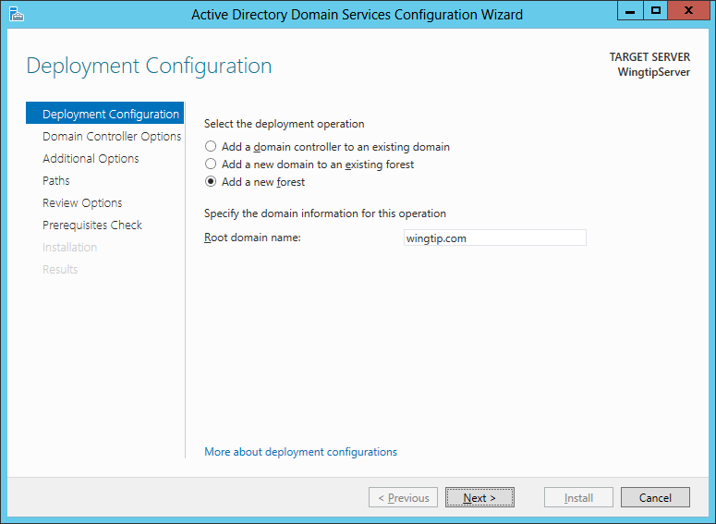

* 1. The next page is the **Domain Controller Options** page:
     1. Leave the default settings for **Forest function level** and **Domain functional level.**
     2. Leave the default settings for checkbox options for **Specify domain controller capabilities**.
     3. Locate the section with the caption **Type the Directory Services Restore Mode (DSRM) password** and type a password of **Password1** in the **Password** textbox and the **Confirm Password** textbox.
     4. Click **Next** to move to the next page.

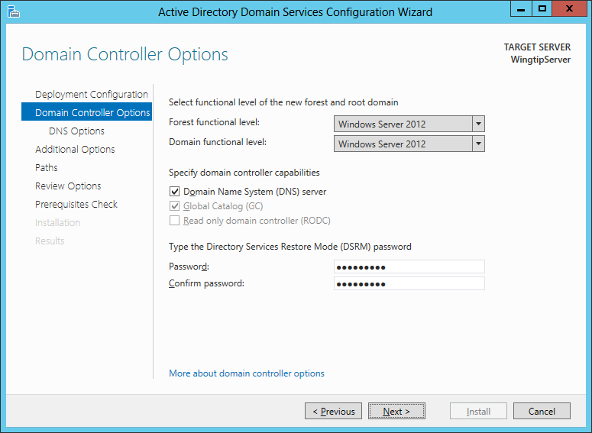

* 1. On the **DNS Options** page of the **Active Directory Domain Service Configuration Wizard** you will be prompted with a warning that Windows cannot find a delegation for this DNS server. You can ignore this warning because you will configure the **WingtipServer** VM to act as a top-level DNS server which needs no delegation. You don't need to do anything on this page other than clicking **Next** to continue to the next page in the wizard.

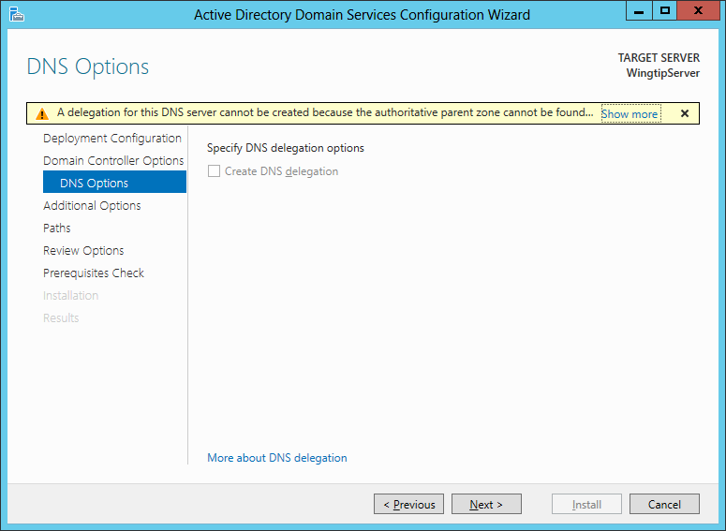

* 1. On the **Additional Options** page you are asked to verify that the NetBIOS domain name is **WINGTIP**.
     1. Accept the default value and click **Next** to continue to the next page in the wizard.

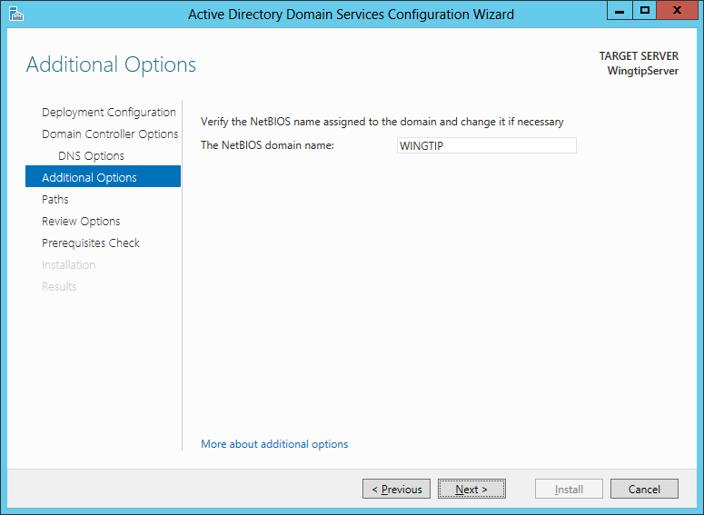

* 1. On the **Paths** page you should accept the default settings and click **Next** to continue to the next page in the wizard.

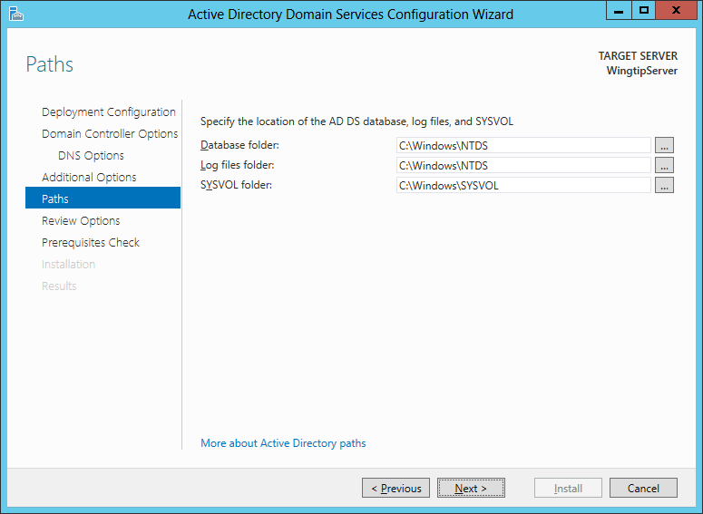

* 1. The **Review Options** page shows the wizard settings you selected. Click **Next** to continue to the next page in the wizard.

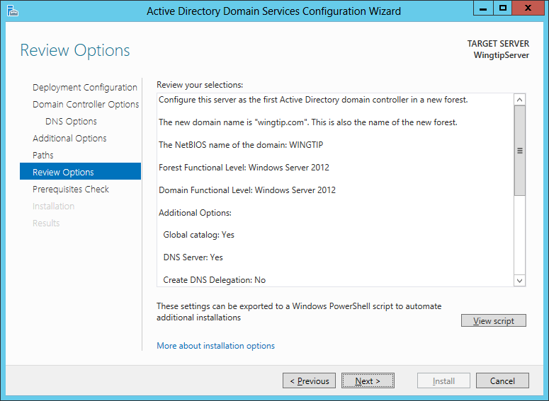

* 1. The last page of the **Active Directory Domain Service Configuration Wizard** is the **Prerequisites Check** page. This page will run a test which takes about minute. The purpose of the test is to verify that the **WingtipServer** VM meets the requirements of a domain controller computer.
  2. After the tests completes, click the **Install** button to begin the process of creating the new Active Directory domain and promoting the **WingtipServer** VM to become a new domain controller.

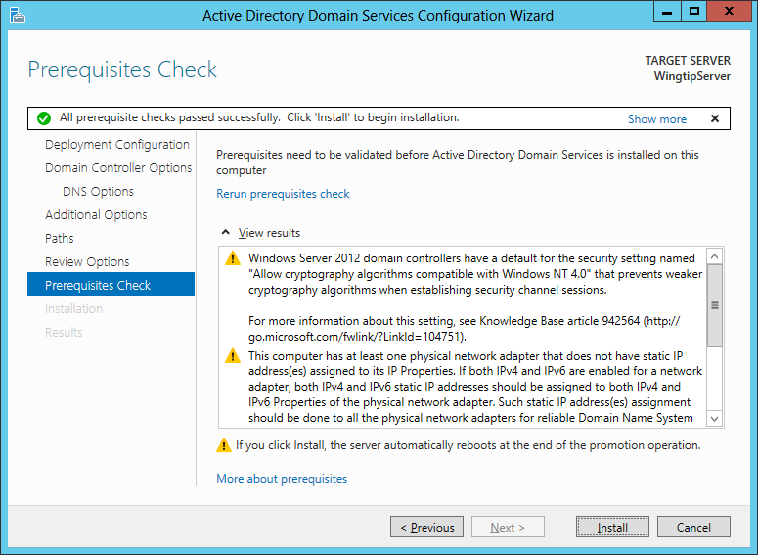

* 1. During the installation process, the **WingtipServer** VM will automatically restart. After the **WingtipServer** VM has restarted, log back in using the domain account **WINGTIP\Administrator**.

1. Launch the Active Directory Users and Computer administrative tool.
   1. Click on the **Windows** key to display the **Windows Start** page.
   2. Type Active Directory in the Search box.
   3. Locate and click on the **Active Directory Users and Computer** tile as shown in the following screenshot.

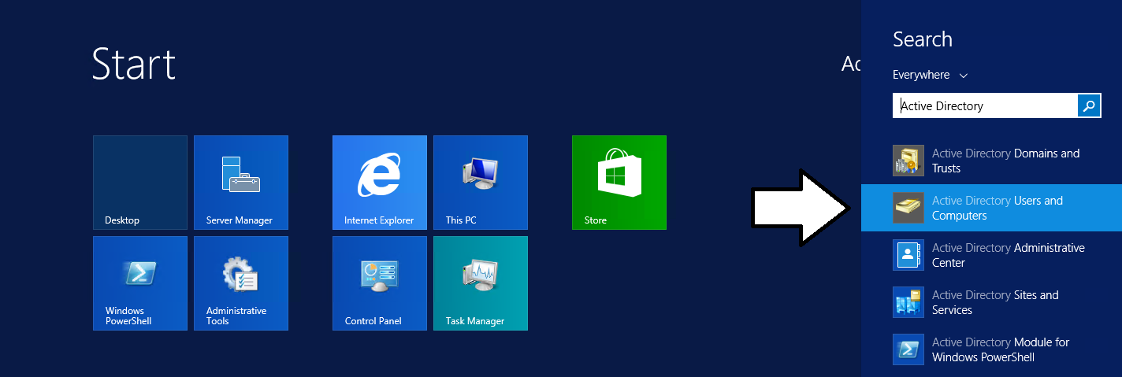

* 1. The **Active Directory Users and Computer** administrative tool should not be started.

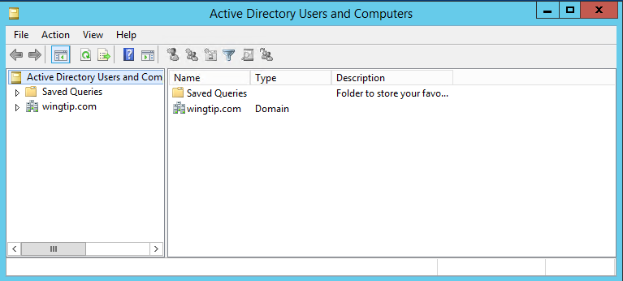

1. Use the **Active Directory Users and Computer** administrative tool to inspect the **wingtip.com** domain
   1. In the **Active Directory Users and Computer** administrative tool, you should see a node for **wingtip.com**.
   2. Expand the **wingtip.com** node and select the **Users** node inside.
   3. You should be able to see all the user and group accounts that Windows automatically adds to a new domain.

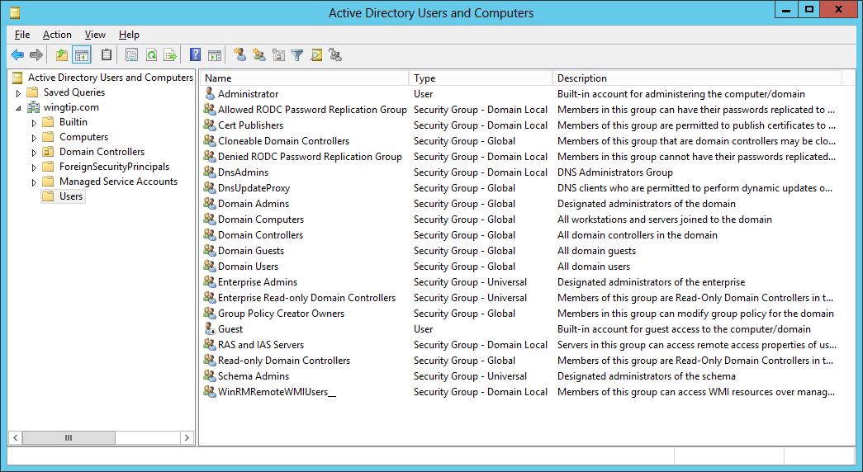

* 1. You have now verified that the **wingtip.com** domain has been properly created and that the **WingtipServer** VM has been promoted to be a domain controller.
  2. Close the Active Directory Users and Computer administrative tool.

### Task 6: Install SQL Server 2016 CTP 3.3

You will begin this task by acquiring the installation files and optionally a product key for SQL Server 2016. After that you will move through the basic steps of installing SQL Server 2016 and configuring it for basic usage within a SharePoint 2016 farm.

*Note that this version of the setup guide is using the CTP 3.3 prerelease version of SQL Server 2016. This setup will be updated for the RTM version of SQL Server 2016 when it becomes available.*

1. Obtain a copy of the 64-bit installation binaries for SQL Server 2016 Community Technology Preview 3.3.
   1. If you need to download the files, you can obtain them from the following link.

https://www.microsoft.com/en-us/evalcenter/evaluate-sql-server-2016

This download is several gigabytes in size so it will take some time to download. The amount of time it takes to download will depend upon the speed of your Internet connection.

1. Navigate to the Hyper-V Manager. Right-click the **WingtipServer** VM and select the **Connect…** command to display the Hyper-V console window for this VM.



1. In this step you will configure the VM to load the .ISO file with the SQL Server 2016 installation files as a DVD drive.
   1. In the Hyper-V console windows for the **WingtipServer** VM, select the **Insert Disk…** command.

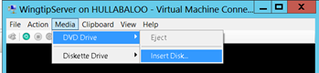

* 1. When the **Open File** dialog appears, enter the path to the .ISO file with the SQL Server 2016 installation files.
  2. Click **OK**.

1. Navigate back into the user interface of the **WingtipServer** VM.
2. Depending on your configuration, the SQL Server installation program in the DVD might or might not start automatically.
   1. If the **AutoPlay** dialog box is open, click run **setup.exe**.
   2. If the **AutoPlay** dialog box is not open, use Windows Explorer to navigate to the DVD drive and execute the **setup.exe** file in the root of the DVD drive.
   3. Wait for the SQL Server installation program to initialize and display the **SQL Server Installation Center** dialog.
3. In the **SQL Server Installation Center** dialog, complete the following steps:
   1. Click the **Installation** link on the left-hand side.
   2. Click the New SQL Server stand-alone installation or add features to an existing installation link on the right-hand side.

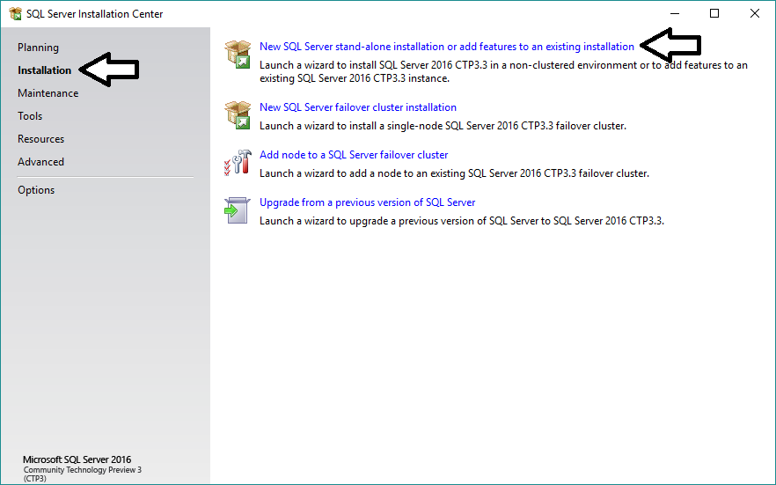

1. On the **Setup Support Rules** page, the installer will check for potential issues before installing.
2. Click **Next** on the **Product Key** page.

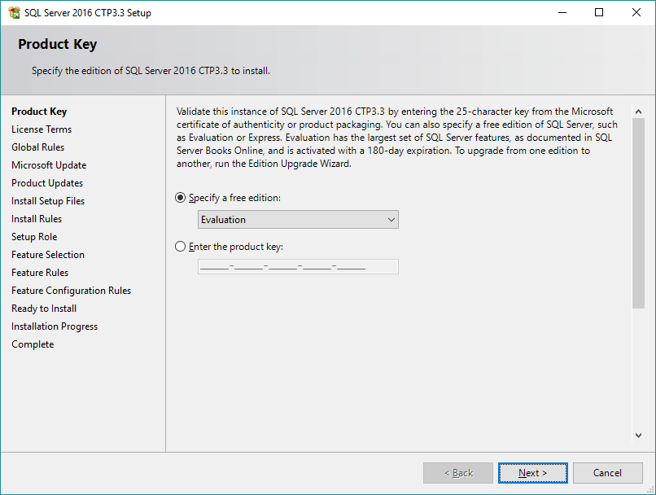

1. On the **License Terms** page, agree to the terms and select **Next**.

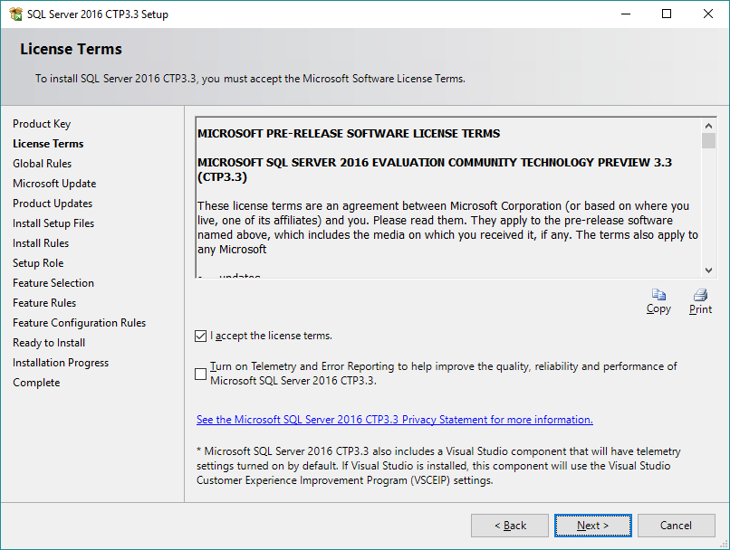

* 1. On the Microsoft Update page, unselect Use Microsoft Update to check for updates and click Next.

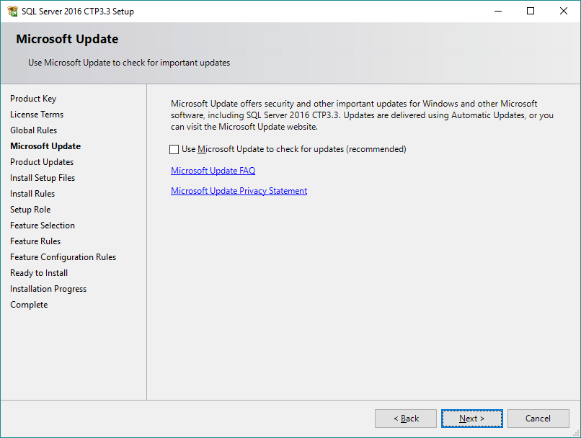

1. On the **Install Rules** page, you should see the test results for a set of setup rules. You should expect to see a single warning indicating that the current machine is a domain controller. All other rules should show success. Click **Next**.

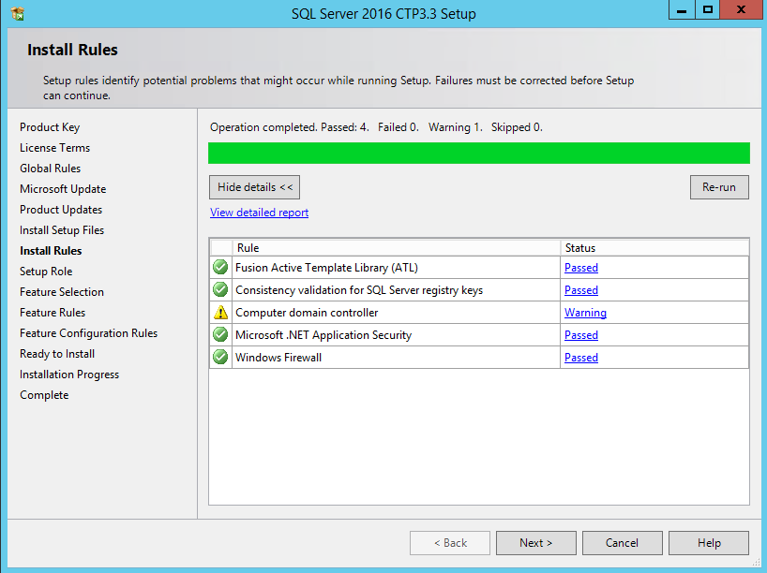

1. On the **Set Role** page, accept the default setting of **SQL Server Feature Installation** and click **Next**.

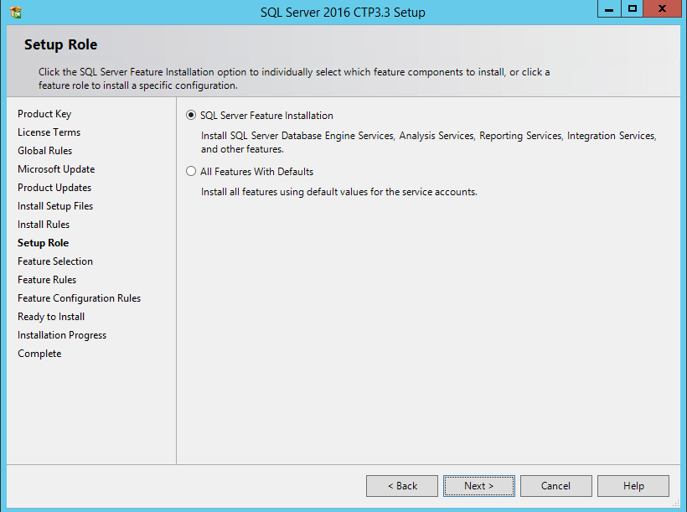

You will begin by installing a default installation of the SQL Database Engine, SQL Server Analysis Services and SQL Server Reporting Services. After you complete the initial installation of SQL Server 2016, you will then re-run the SQL Server 2016 installer program to create a second instance of the SQL Database Engine named **SharePoint** which will be used to create all the databases used by SharePoint, Service Bus and Workflow Manager. The default instance of the SQL Database Engine is intended for you to create and load sample databases.

1. On the **Feature Selection** page, check the following options and click **Next**:
   1. Instances Features:
      1. Database Engine Services
      2. Analysis Services
      3. Reporting Services - Native
   2. Shared Features:
      1. SQL Server Data Tools
      2. Management Tools – Basic
      3. Management Tools – Complete

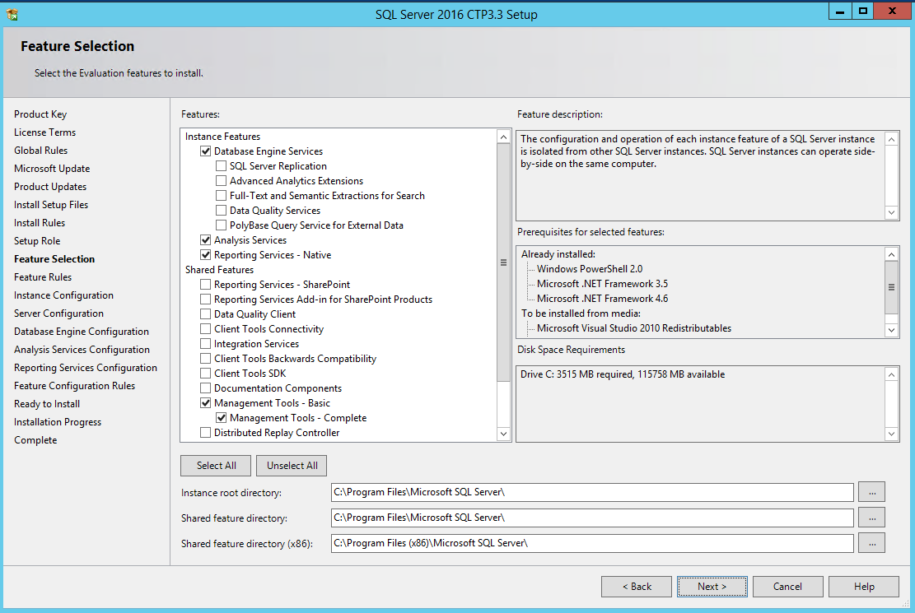

1. On the Installation Rules page, click Next.
2. On the **Instance Configuration** page, accept all the default settings and click **Next**.

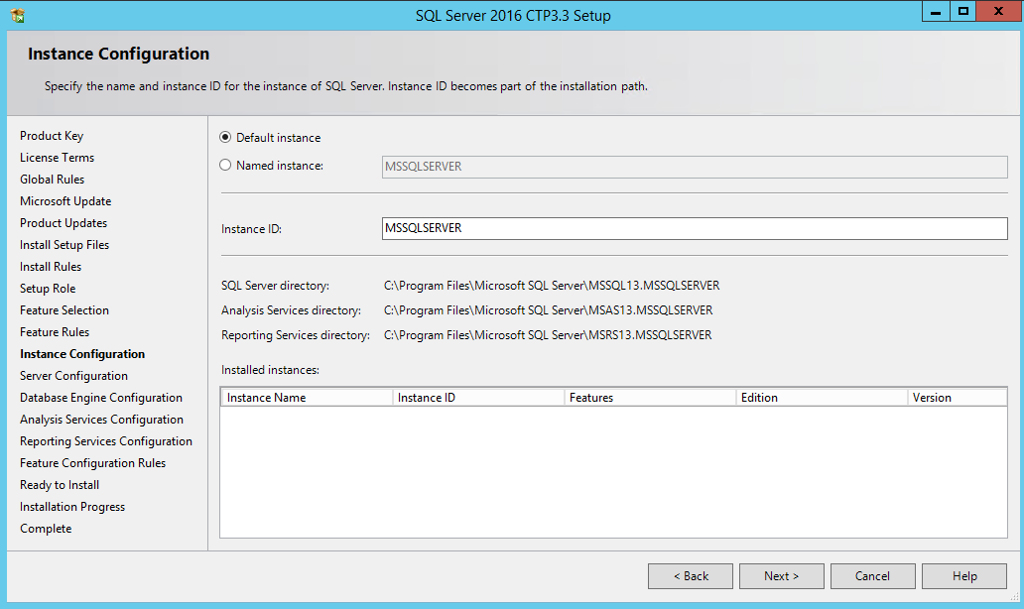

1. On the Disk Space Requirements page, click Next.
2. On the **Service Account** tab of the **Server Configuration** page, do the following:
   1. Change the Startup Type for the SQL Server Agent to Automatic.
   2. Change the Account Name for the SQL Server Database Engine to NT AUTHORITY\SYSTEM.
   3. Change the Account Name for the SQL Server Analysis Services to NT AUTHORITY\SYSTEM.
   4. Change the Account Name for the SQL Server Reporting Services to NT AUTHORITY\SYSTEM.
   5. Click **Next** to move to the next page.

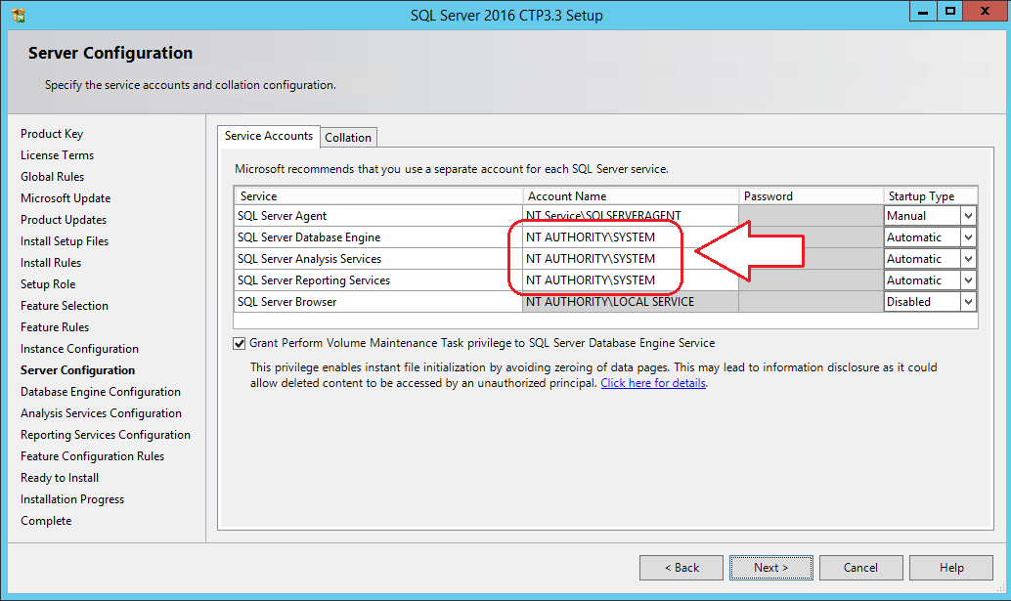

In a real-world installation of SQL Server in a production environment, you should consider using dedicated user accounts to provide the identity for the SQL Server services instead of using the SYSTEM account. This setup guide is using the SYSTEM account for the SQL Server worker processes to simplify the installation of SQL Server which is acceptable in a lab environment.

1. On the **Database Engine Configuration** page, do the following:
   1. On the **Server Configuration** tab, click the **Add Current User** button to configure the **WINGTIP\Administrator** account as a system administrator for this SQL Server instance.

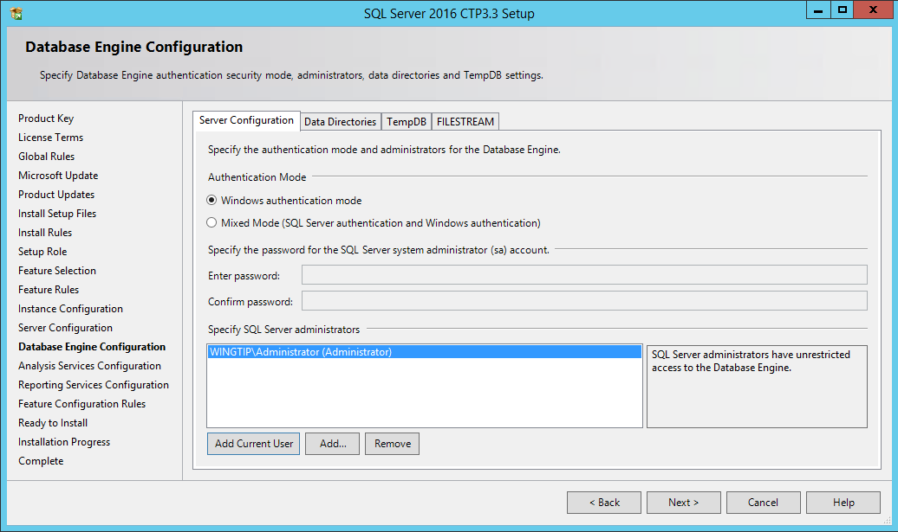

* 1. On the FILESTREAM tab, check Enable FILESTREAM for Transact-SQL access and also check Enable FILESTREAM for file I/O access.

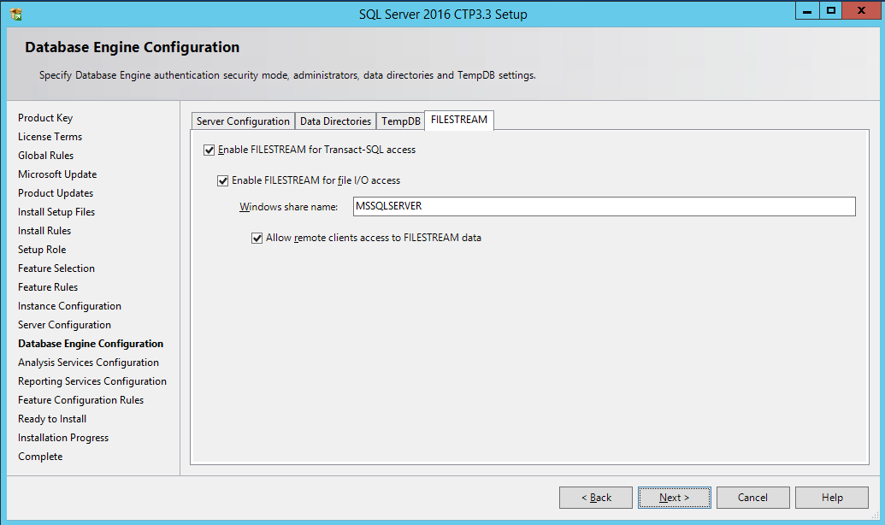

* 1. Click **Next** to move to the next page

1. On the Server Configuration tab of the Analysis Services Configuration page:
   1. Click **Add Current User** to configure the **WINGTIP\Administrator** account with administrative permissions.
   2. Click **Next** to move ahead to the next page.

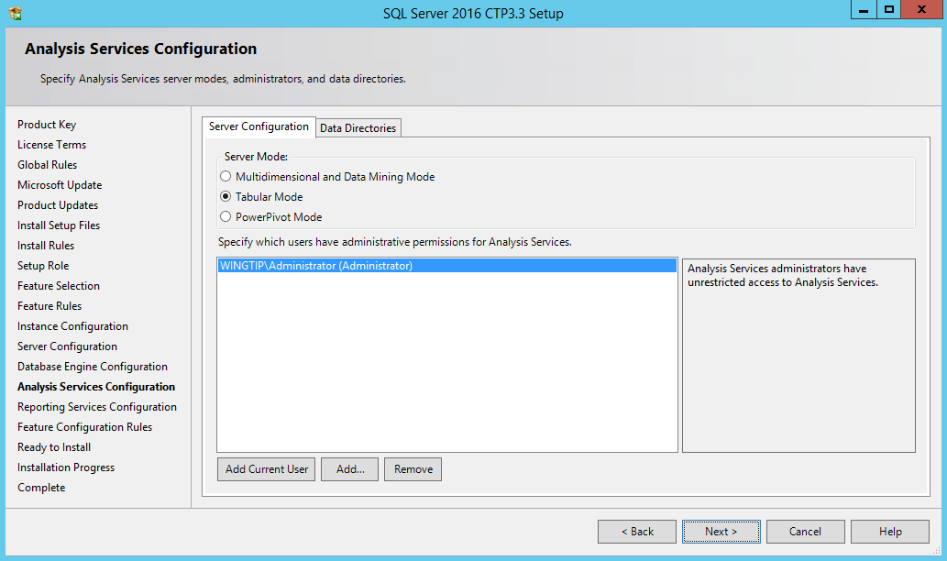

1. On the Reporting Services Configuration page, select the Install Only option in the Reporting Service Native Mode section and click Next to move ahead.

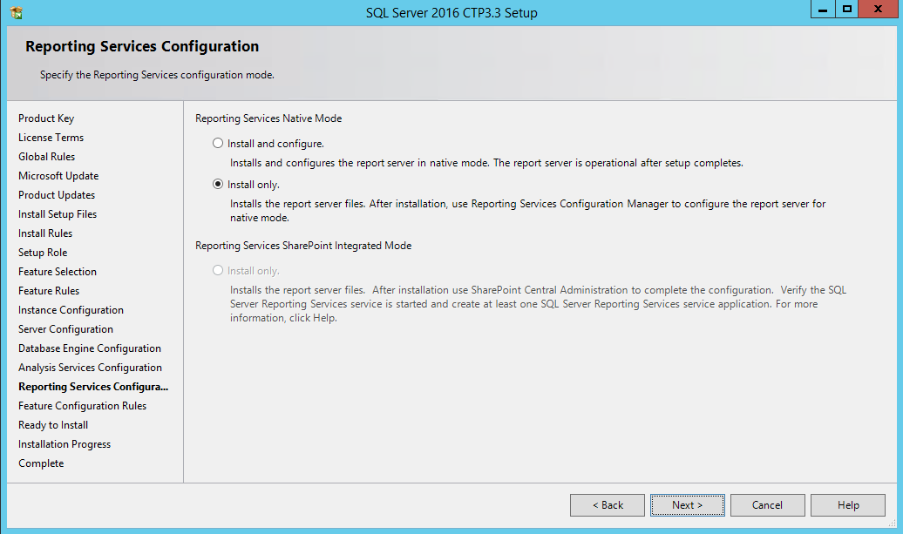

1. On the **Error Reporting** page, accept the default values and click **Next**.
2. On the Installation Configuration Rules page, click Next.
3. When you get to the **Ready to Install** page, you are finally at the point where you can begin the installation. Click the **Install** button and wait for the SQL Server installation program to complete. This process will likely take about 10-15 minutes to complete.

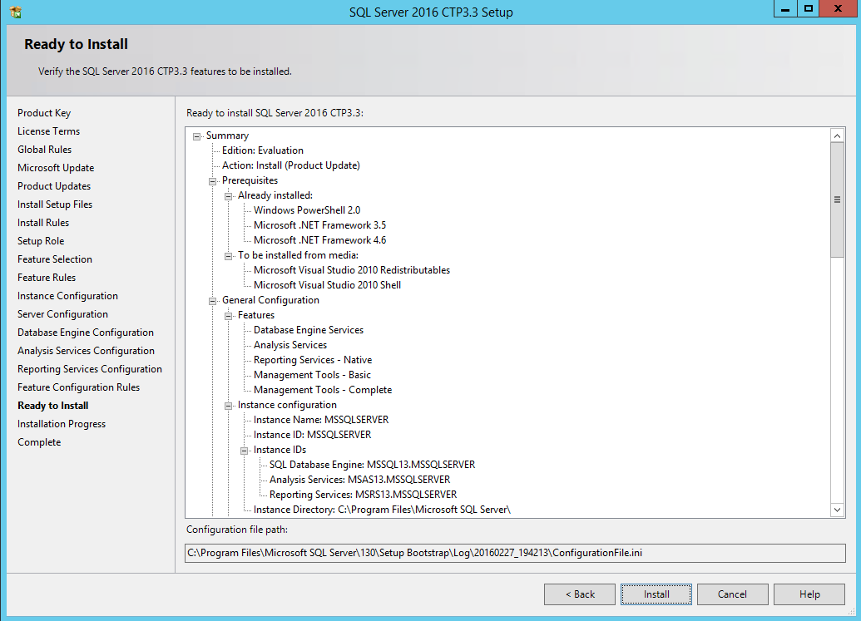

1. When the installation finishes, the **Complete** page is displayed showing the features that were successfully installed.

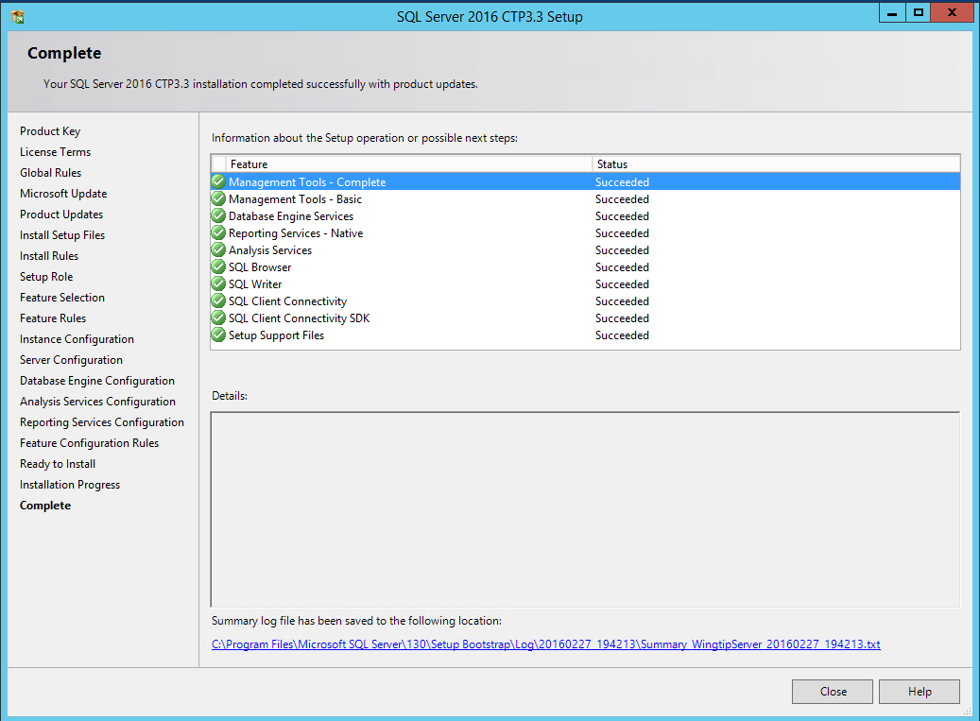

1. Click **Close** to complete the installation.

You have now successfully installed SQL Server 2016 with a default instances for the SQL Server Database Engine, SQL Server Analysis Services and SQL Server Reporting Services. Now it is time to rerun the SQL Server setup program so you can add a second instance of the SQL Server Database Engine named SharePoint.

1. In the **SQL Server Installation Center** dialog, complete the following steps:
   1. Click the **Installation** link on the left-hand side.
   2. Click the New SQL Server stand-alone installation or add features to an existing installation link on the right-hand side.
   3. Move through the pages of the SQL Server 2016 Setup wizard until you reach the **Installation Type** page.
   4. Select Perform a new installation of SQL Server 2016 and click Next.

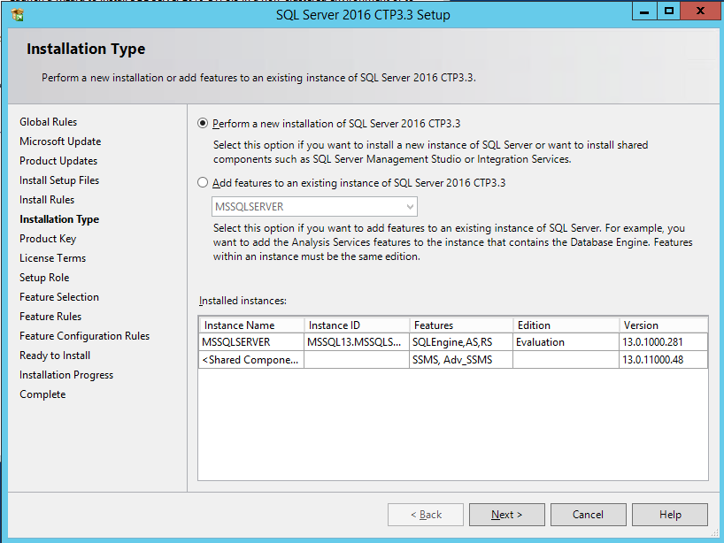

* 1. On the Setup Role page, select SQL Server Feature Installation and click Next.

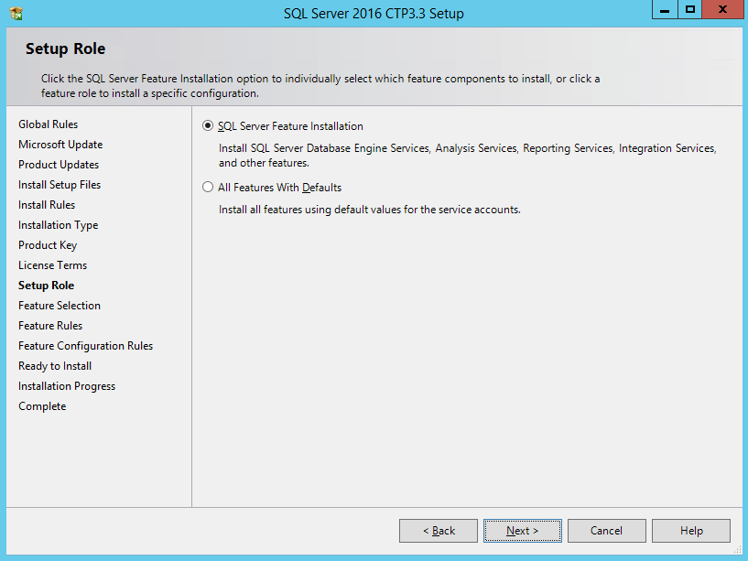

* 1. On the **Feature Selection** page, select the option for **Database Engine Service** as shown in the following screenshot and then click **Next**.

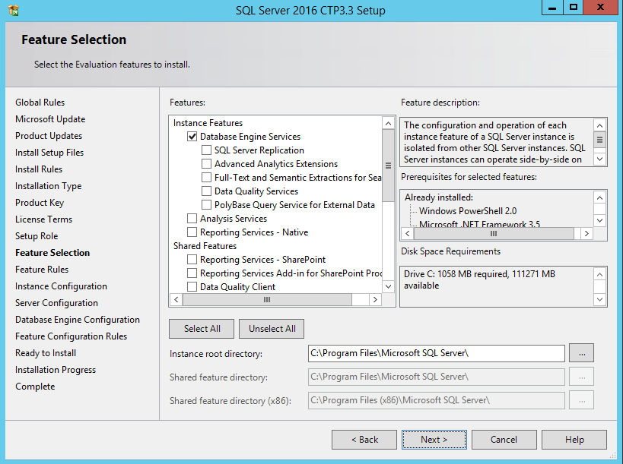

* 1. On the **Instance Configuration** page, select **Named instance**, enter a name of **SharePoint** and then click **Next**.

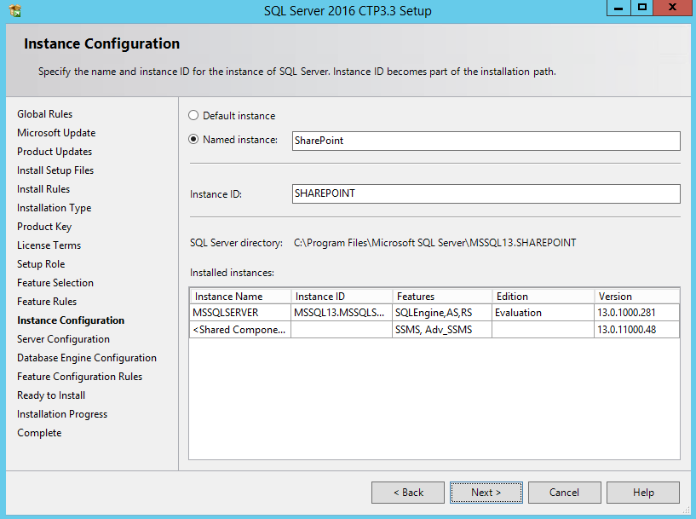

* 1. Inside the **Service Account** tab of the **Server Configuration** page, change the **Account Name** for the **SQL Server Database Engine** to **NT AUTHORITY\SYSTEM** and then click **Next** to move to the next page.

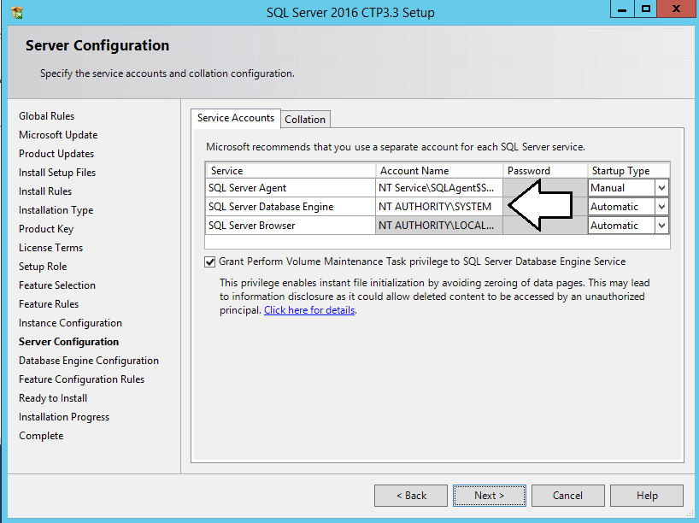

1. On the **Database Engine Configuration** page, do the following:
   1. On the **Server Configuration** tab, click the **Add Current User** button to configure the **WINGTIP\Administrator** account as a system administrator for this SQL Server instance.

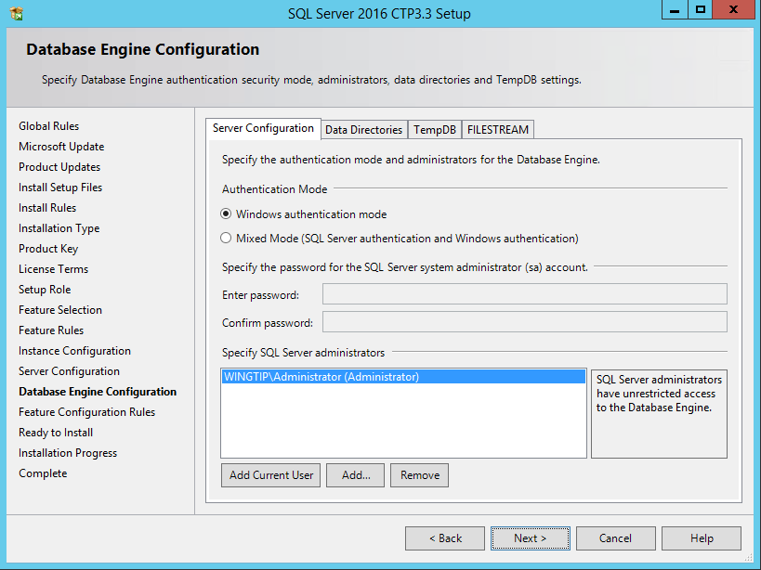

* 1. On the FILESTREAM tab, check Enable FILESTREAM for Transact-SQL access and also check Enable FILESTREAM for file I/O access.
  2. Click **Next** to move ahead until you reach the **Ready to Install** Page.
  3. Click **Install** to begin the installation process.
  4. After several minutes the installation should complete and you should see the Complete dialog as shown in the following screenshot.

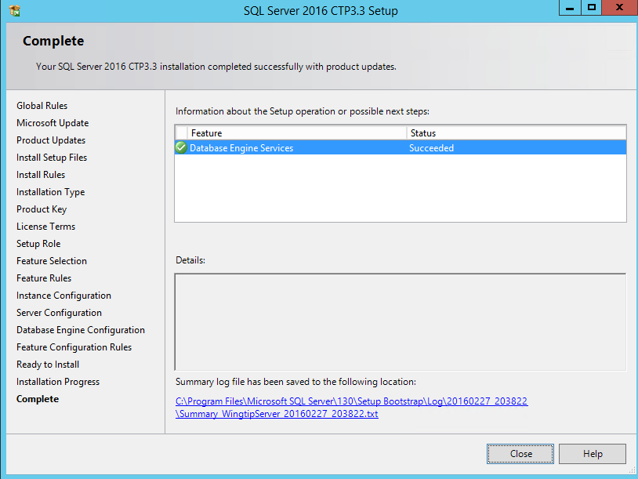

* 1. Click Close to complete the installer program and close the SQL Server 2016 setup dialog.

Next, you will configure SQL Server to enable the use of Named Pipes as a communications protocol.

1. Configure the Named Pipes protocol using the SQL Server Configuration Manager.
   1. Press the **Windows** key to navigate to the Windows Start page.
   2. Locate and click the SQL Server Configuration tile to launch the SQL Server Configuration Manager.

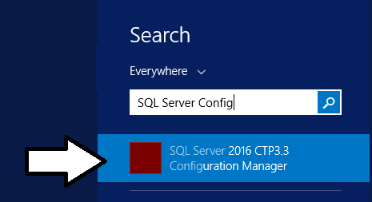

* 1. In the SQL Server Configuration Manager, expand the nodes of the tree view control on the left to display the path of **SQL Server Configuration Manager >> SQL Server Network Configuration >> Protocols for MSSQLSERVER**.
  2. On the right-had side, locate the property setting for the **Named Pipes** protocol. This protocol is initially in a disabled state.
  3. Right click on the **Named Pipes** property and select the **Enabled** command.

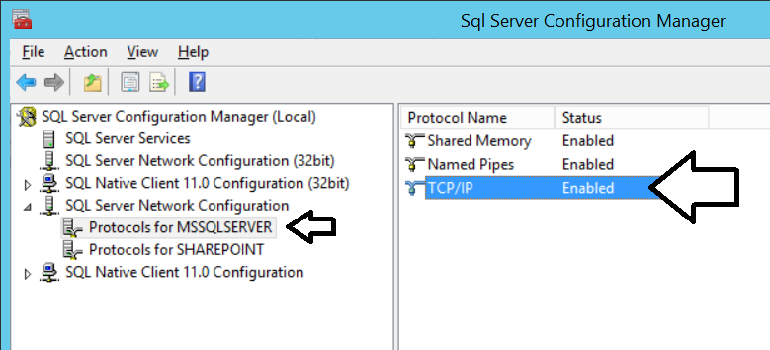

* 1. Repeat the same set of steps to enable **Named Pipes** for the **Protocols for SHAREPOINT** instance.

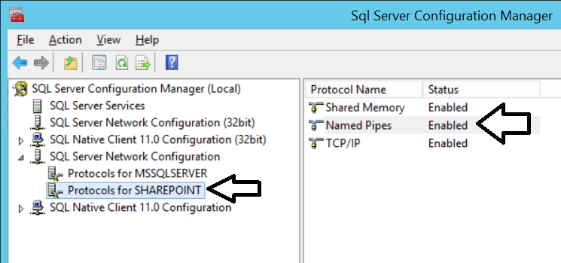

* 1. Close the SQL Server Configuration Manager.

1. Launch SQL Server Management Studio and connect to the default instance of the SQL Server Database Engine.
   1. Press the **Windows** key to navigate to the Windows Start page.
   2. Locate and click the SQL Server Management Studio tile to launch SQL Server Management Studio.

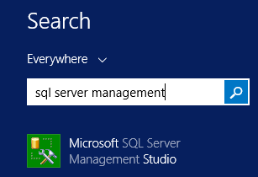

* 1. When you are prompted with the **Connect to Server** dialog, enter a server name of **WINGTIPSERVER** to connect to the default instance. Make sure **Windows Authentication** is selected for the **Authentication** setting and click the **Connect** button.

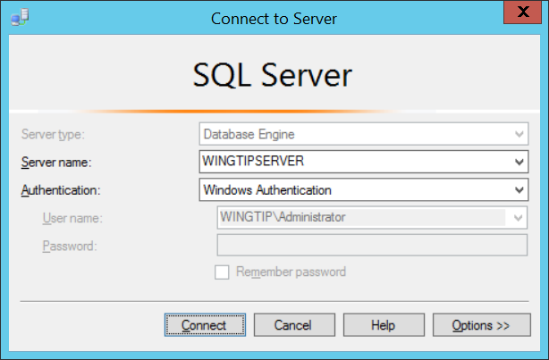

* 1. Once **SQL Server Management Studio** has connected to the **SQL Server Database Engine**, you should see the **Object Explorer** with a tree view control with **WINGTIPSERVER** as its top-level node. Expand the **Databases** node and then the **System Databases** node.

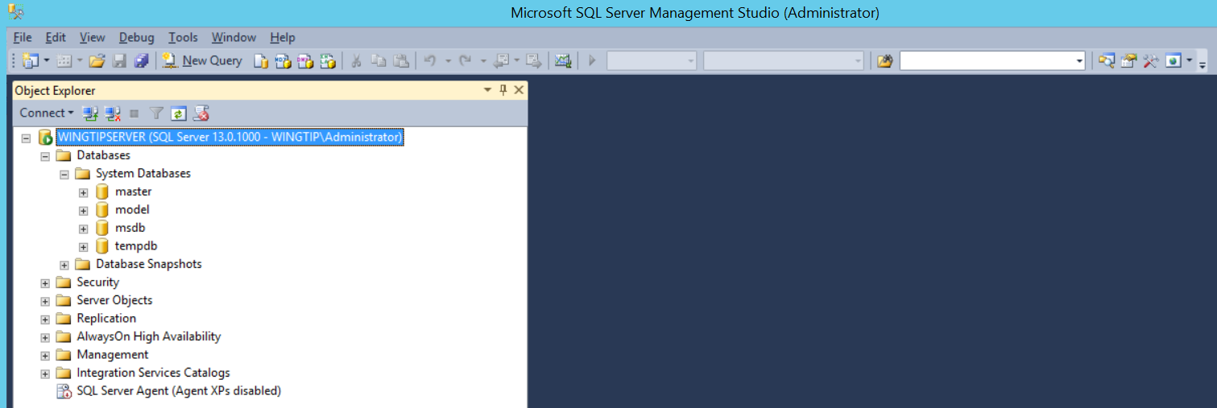

You should be able to see the system database such as master model and tempdb. However, there are no user-created databases yet. You can create or import whatever SQL Server databases you would like to load on this VM.

1. Connect to the named **SharePoint** instance of the **SQL Server Database Engine**.
   1. Drop down the **Connect** menu in the **Object Explorer** and select the **Database Engine…** command.
   2. When you are prompted with the **Connect to Server** dialog, enter a server name of **WINGTIPSERVER\SHAREPOINT** to connect to the named **SharePoint** instance. Make sure **Windows Authentication** is selected for the **Authentication** setting and click the **Connect** button.

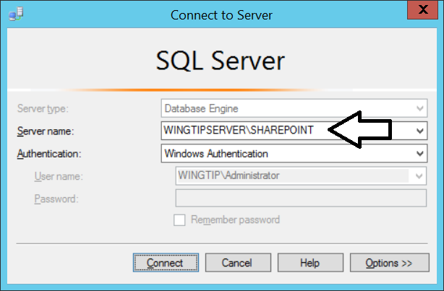

* 1. You should be able to connect to and examine the **WINGTIPSERVER\SHAREPOINT** named instance.

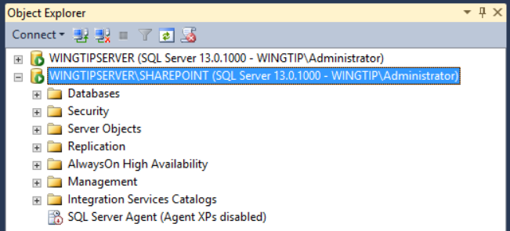

Currently, there are no databases in the SharePoint named instance. However, this is the place where databases will be created as you are installing and configuring SharePoint 2016. As you work your way through this setup guide, SharePoint will create as many as 18 databases in this named instance. There are additional databases that will be created in the SharePoint named instance when you install and configure Workflow Manager to add support for SharePoint 2013 workflows.

1. Close SQL Server Management Studio.

### ****Task 7: Download and Run the PowerShell Scripts for this Setup Guide****

In this task you will download the installation files for **SharePoint Server 2013**, **SharePoint Designer 2013,** and **Fiddler** and make them available on the local hard drive of the **WingtipServer** VM.

1. Copy the setup scripts to your VM.
   1. Locate the zip archive named **VmSetupGuideScripts.zip** that was distributed along with this setup guide.
   2. Extract all files from **VmSetupGuideScripts.zip** to a new folder on the VM at the path **C:\Setup**.
   3. Use the Windows Explorer to verify the files extracted properly and that the **c:\setup** folder. The **Setup** folder should contain two child folders name **CreateWingtipUsers** and **Scripts**.
2. Enable the execution of PowerShell scripts.
   1. Launch a PowerShell console window using the **Run as Administrator** command.
   2. Type the following command into the PowerShell console window and press ENTER to execute it.

Set-ExecutionPolicy Bypass

* 1. Confirm your action by typing 'Y' and pressing ENTER.

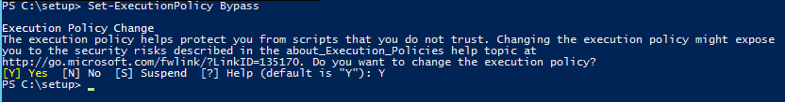

1. Create a sample set of Active Directory user accounts in the local Active Directory domain.
   1. Return to the Windows Explorer and navigate to the folder at **C:\Setup\CreateWingtipUsers**. You should be able to see that there is a Windows PowerShell script named **CreateWingtipUsersInActiveDirectory.ps1**.

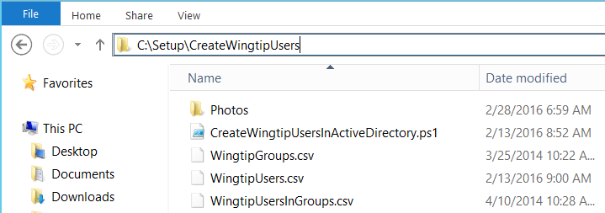

* 1. Right-click on CreateWingtipUsersInActiveDirectory.ps1 and select Run with PowerShell to run this script.

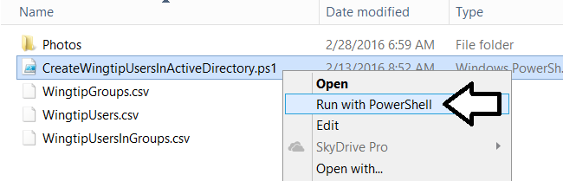

1. Use the **Active Directory Users and Computer** administrative tool to inspect the new users added to the **wingtip.com** domain
   1. In the **Active Directory Users and Computer** administrative tool, you should see a node for **wingtip.com**.
   2. Expand the **wingtip.com** node and select the **Wingtip Users** node inside.
   3. You should be able to see all the user and group accounts that the PowerShell script added into the new Organization Group with a name of **Wingtip Users**. Maybe you recognize some of the user names of Critical Path Training instructors.

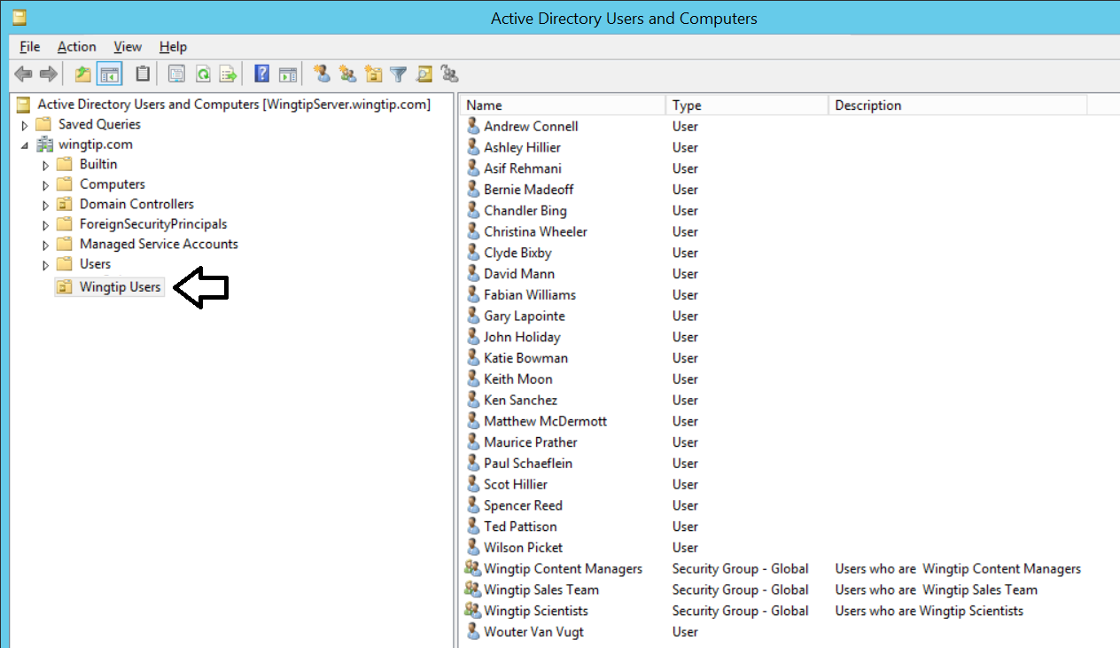

1. Create a set of Active Directory user accounts that will be used as SharePoint identities.
   1. Return to the Windows Explorer and navigate to the folder at **C:\Setup\Scripts**. You should be able to see that there are several PowerShell scripts including a script named **Script01_PrepServer.ps1**.

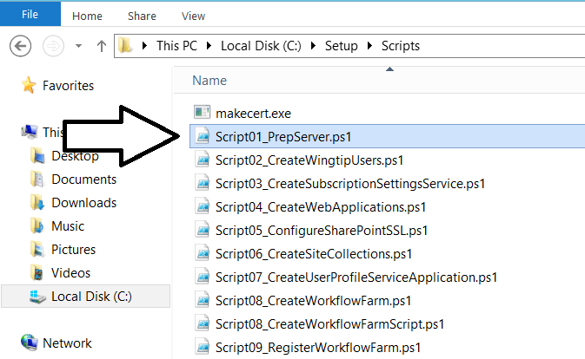

* 1. Right-click on **Script01_PrepServer.ps1** and select **Run with PowerShell** to run this script.

1. Use the **Active Directory Users and Computer** administrative tool to inspect the new SharePoint user accounts.
   1. In the **Active Directory Users and Computer** administrative tool, you should see a node for **wingtip.com**.
   2. Expand the **wingtip.com** node and select the **Wingtip Service Accounts** node inside.
   3. You should be able to see new users accounts that have been created with names such as **SP_Farm** and **SP_Services**.

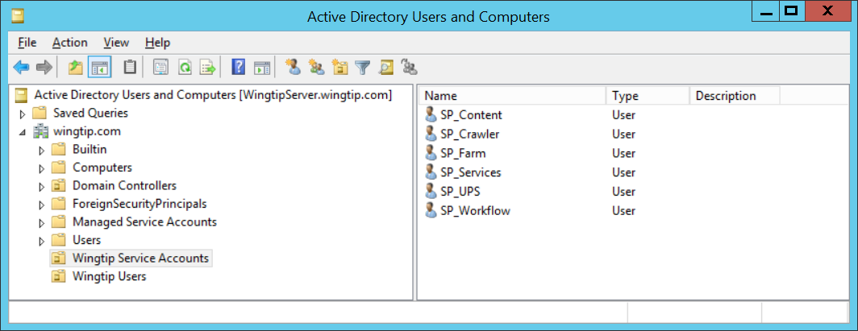

You will begin using these service accounts in later steps when you begin to create and configure the local SharePoint farm.

### Task 8: Update the Hosts File to Assist with DNS Resolution

This this task you will update the VMs LM Host file to redirect a set of DNS domain named to the local loopback address of 127.0.0.1.

1. Using Windows Explorer, navigate to the following path to find the LM Host file.

C:\Windows\System32\drivers\etc

1. You should see several files in the **C:\Windows\System32\drivers\etc** folder including a file name **hosts** without a file extension.

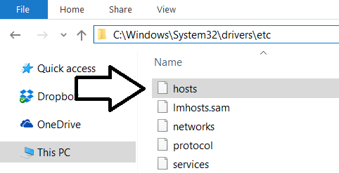

1. Open the **hosts** file in a text editor such as NOTEPAD.EXE.
2. Delete the existing content for the host file and replace it with the following content.

127.0.0.1 wingtipserver

127.0.0.1 wingtipserver.wingtip.com

127.0.0.1 wingtip.com

127.0.0.1 my.wingtip.com

127.0.0.1 intranet.wingtip.com

127.0.0.1 dev.wingtip.com

127.0.0.1 www.wingtip.com

127.0.0.1 search.wingtip.com

127.0.0.1 research.wingtip.com

127.0.0.1 disco.wingtip.com

127.0.0.1 bi.wingtip.com

1. Save and close the **hosts** file.

While this VM is running a local DNS server which contains a wildcard A record for **\*.wingtip.com**, it is best to also configure a development environment **hosts** file entries for tools such as Visual Studio which often cannot resolve a DNS name using the local DNS service. However, Visual Studio is able to resolve IP addresses for DNS entries in the local hosts file.

### **Task 9: Install SharePoint Server 2016 Beta 2**

In this task you will configure service accounts for SharePoint 2013 and then run the SharePoint 2013 Install to prepare the Wingtip Server for SharePoint.

1. Before installing SharePoint Server, it is recommended to install **Windows Update KB2898850**.
   1. Install the installation bits for this update using the following link

https://www.microsoft.com/en-us/download/details.aspx?id=42883

* 1. When prompted to **Choose the download you want**, select the version that ends with -x64.msu

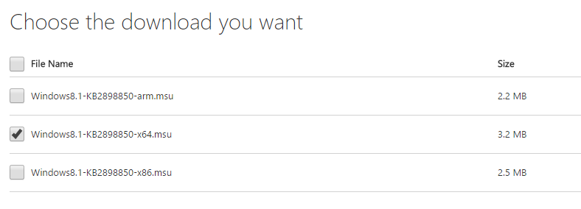

* 1. Download and run the installer file.
  2. When prompted, select **Yes** to run the update.

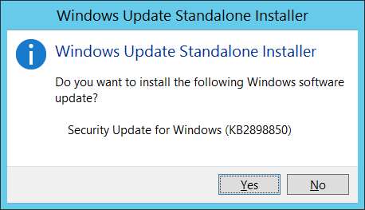

1. Obtain the installation files for **SharePoint Server 2016 Beta 2**.
   1. Navigate to <https://www.microsoft.com/en-us/download/details.aspx?id=49961>
   2. Click download to download the beta 2 installation files.

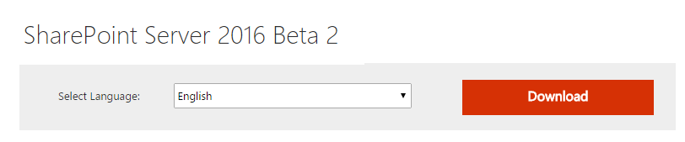

* 1. On the Choose the download you want page, select **SharePoint Server 2016 Beta 2 English.iso** and click **Next**.

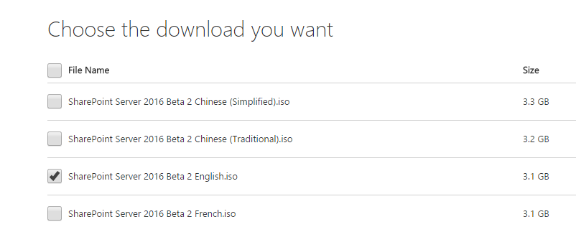

* 1. Download the ISO file named SharePoint Server 2016 Beta 2 English.iso.
  2. Double-click on the ISO file to mount it as the **D:\** drive.
  3. Navigate to the D:\ drive with the installation file and locate the file named **PrerequisiteInstaller.exe**.

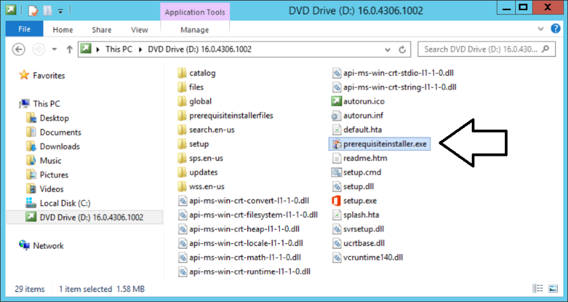

1. Run the SharePoint 2016 Prerequisite Installer for Beta 2.
   1. Double-click on **PrerequisiteInstaller.exe** to launch the Prerequisite Installer.
   2. Click **Next** at the welcome screen.

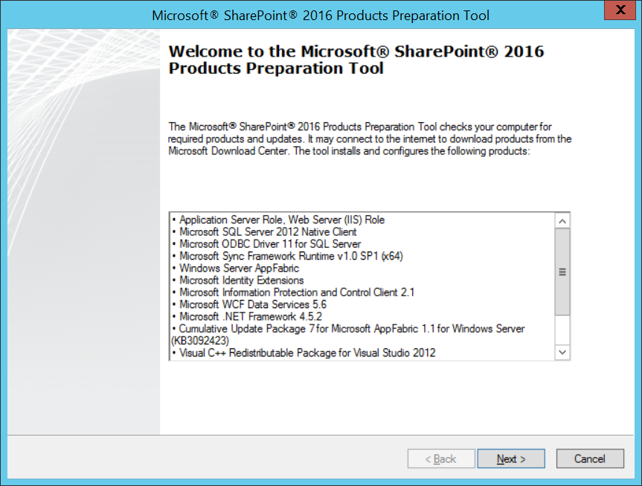

* 1. Clicking the I accept the terms of the Licence agreement(s) checkbox and then click Next.

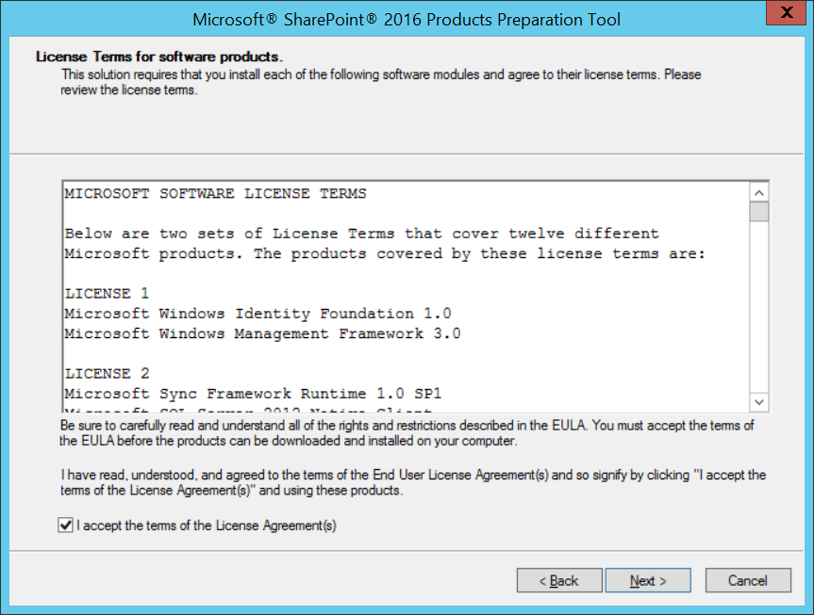

* 1. WaIt while the Prerequisite Installer runs.

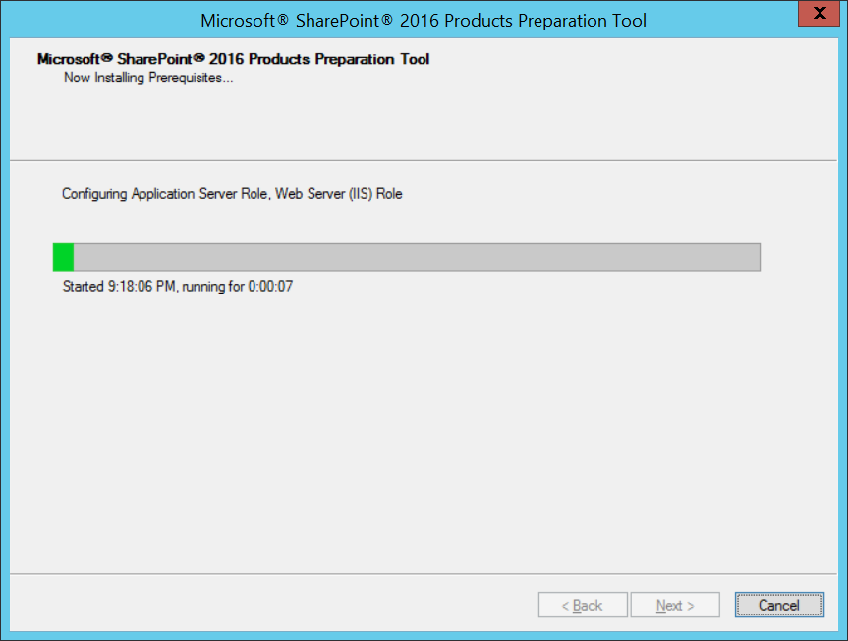

* 1. When you see the **Installation Complete** dialog, click **Finish** to close the Prerequisite Installer.

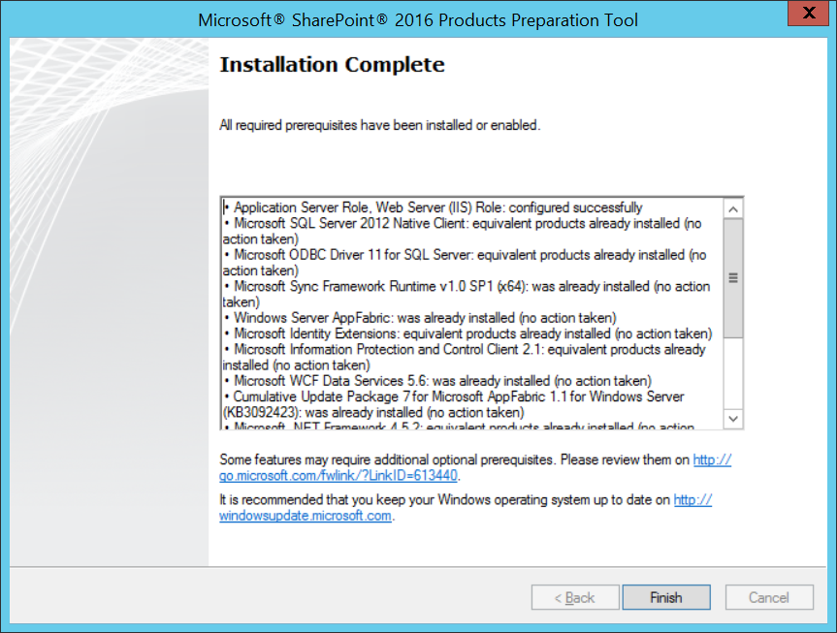

At this point all prerequisites required by SharePoint Server 2016 Beta 2 have been installed. Now it’s time to install the Beta 2 version of SharePoint Server 2016.

1. Navigate to the **D:\** drive with the installation file and locate the file named **setup.exe**.

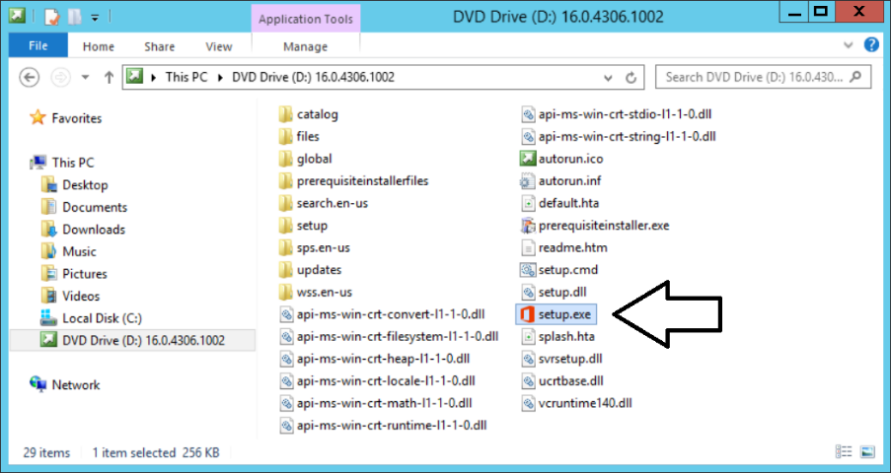

1. When prompted to Enter your Product Key, enter the trial key of NQGJR-63HC8-XCRQH-MYVCH-3J3QR to continue with the installation of the Microsoft SharePoint Server 2016. Click Continue.
2. On the Read the Microsoft Software License Terms page, check the I accept the terms of this agreement checkbox and click Continue.

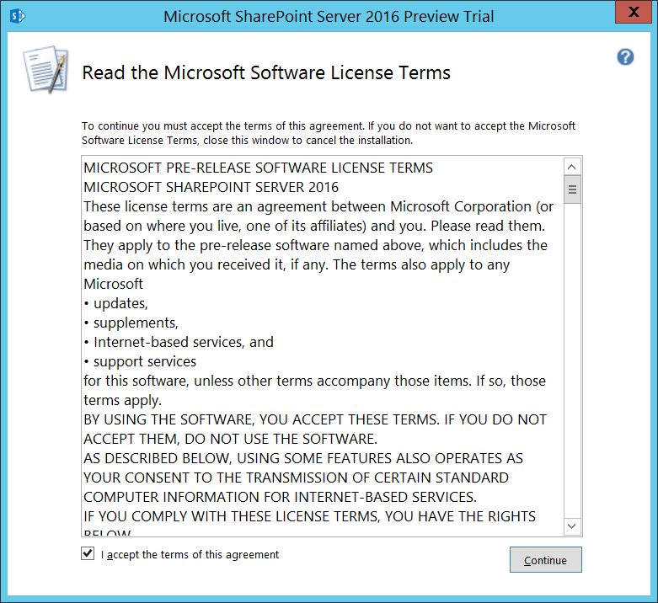

1. On the **Choose a file location** page, accept the default settings and click **Install Now**.

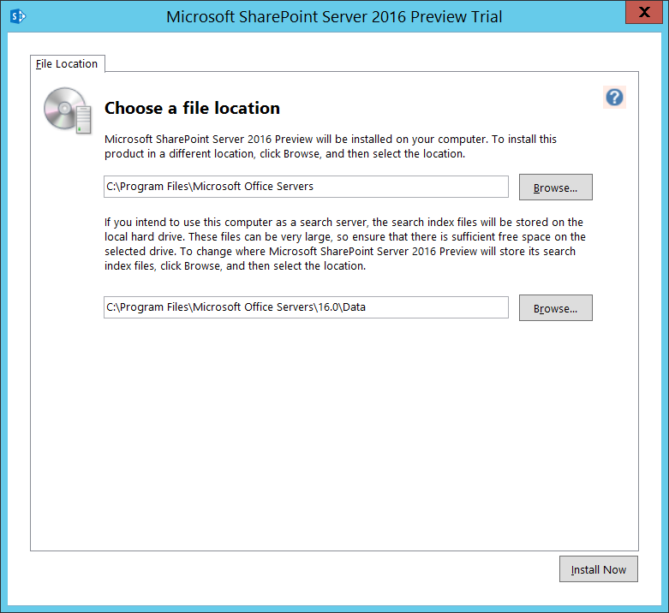

1. When the SharePoint Server 2016 installation program completes, it displays the **Run Configuration Wizard** page as shown in the following screenshot. Ensure the **Run the SharePoint Products Configuration Wizard** checkbox is **NOT** selected and click **Close**.

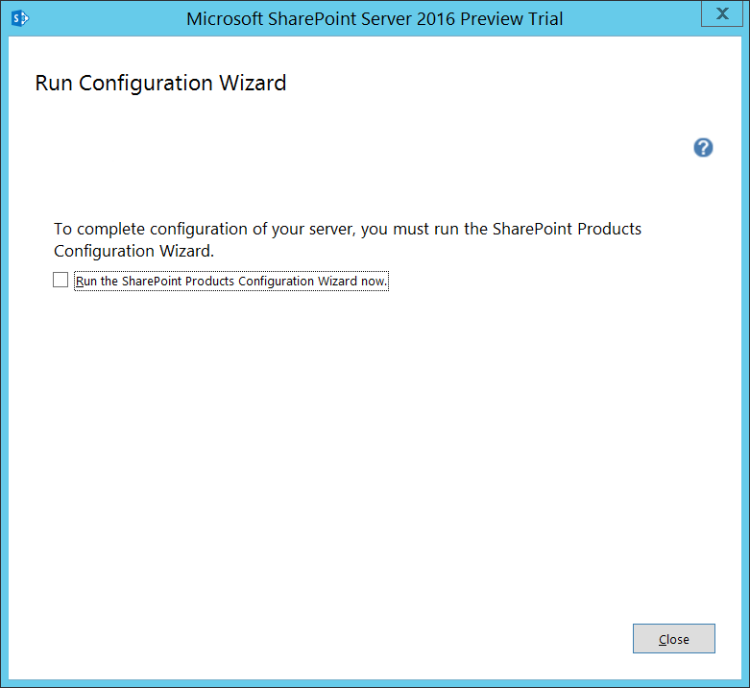

### Task 10: Install SharePoint Server 2016 Release Candidate

In this task, you will install the SharePoint 2016 release candidate on top of the SharePoint Beta 2 installation that you performed in the previous step.

1. Download the installation files for the SharePoint Server 2016 Release Candidate Patch.
   1. In a browser, navigate to the following URL.

<https://www.microsoft.com/en-us/download/details.aspx?id=50737>

* 1. Click the **Download** button.

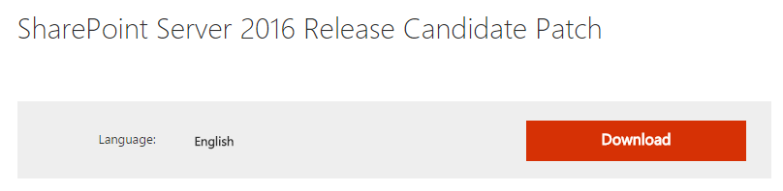

* 1. When promoted to **Choose the download you want**, select the following 2 files
     1. **SharePoint Server 2016 Release Candidate English Prerequisite Installer.zip.**
     2. **SharePoint Server 2016 Release Candidate Global Patch.zip**.

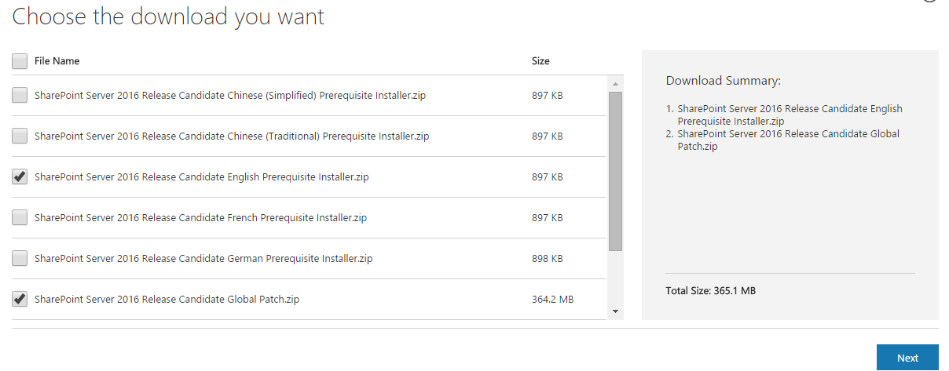

* 1. Click next to download these two files.

1. Run the SharePoint 2016 Release Candidate Prerequisite Installer.
   1. Extract the files for SharePoint Server 2016 Release Candidate English Prerequisite Installer.zip to a folder.
   2. Locate and double-click prerequisiteinstaller.exe to run the Prerequisite Installer.

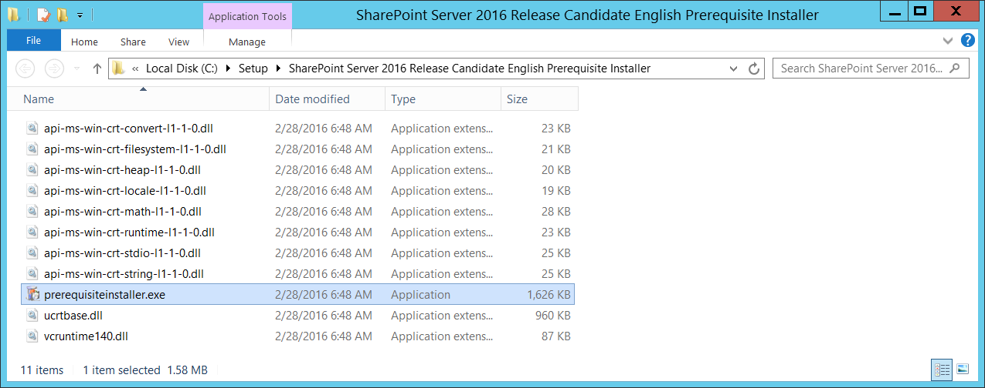

* 1. On the Welcome page, click **Next** to continue with the installation

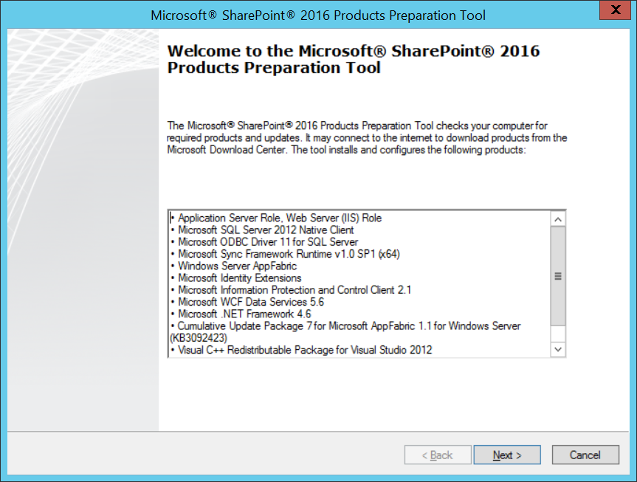

* 1. Accept the terms and click **Next**.
  2. Wait until you see the Installation complete dialog and then click **Finish**.

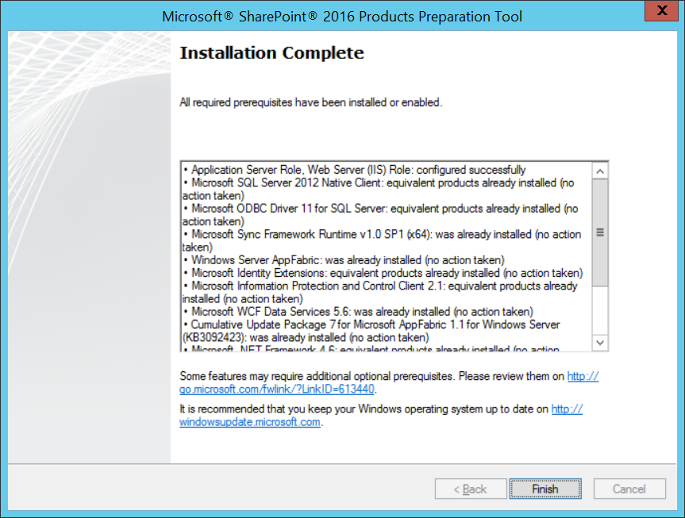

1. Install SharePoint 2016 Release candidate Global Patch.
   1. Extract the files for SharePoint Server 2016 Release Candidate Global Patch.zip to a folder.
   2. Locate and double-click sts.msp to run the Release Candidate Patch Installer.

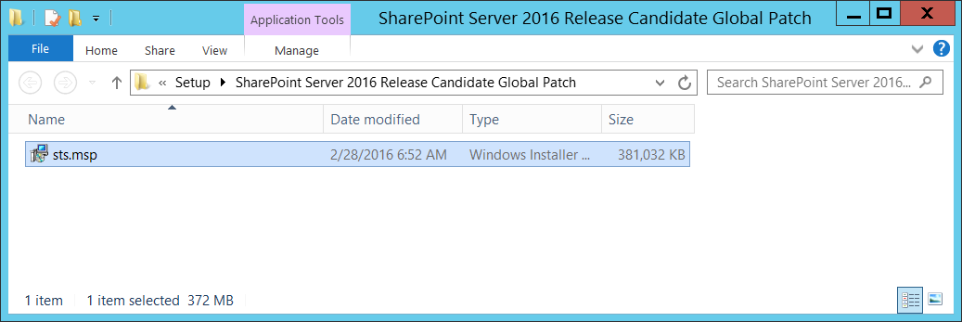

* 1. Wait until the installer program finishes.
  2. When you are prompted with the **Run Configuration Wizard** page, make sure to unselect the checkbox with the caption **Run the SharePoint Products Configuration now** and click Close.

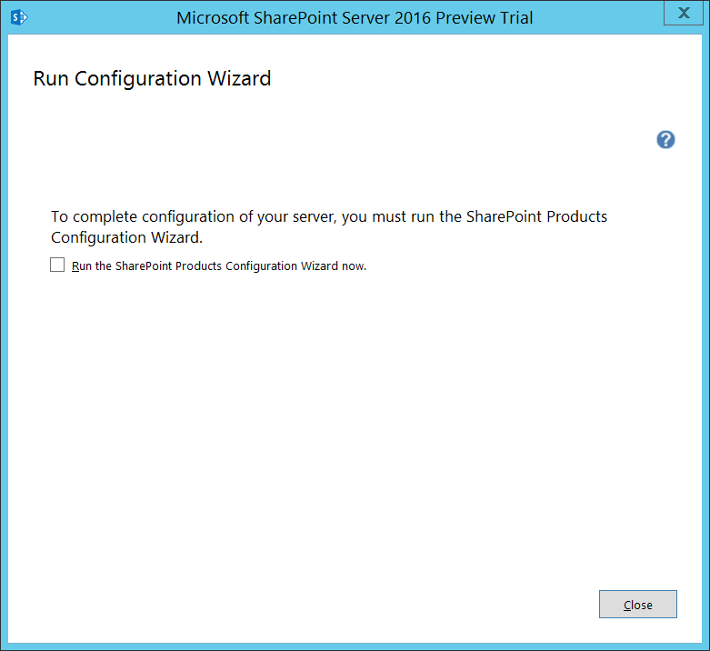

You have now completed the installation of the SharePoint Server 2016 Release Candidate. Next, you will install Workflow Manager and after that you will begin to create and configure a local SharePoint 2016 farm.

### Task 11: Install Workflow Manager

In this section you will install Workflow Manager to provide the required infrastructure support to enable SharePoint 2013 workflows.

1. Install and run the Microsoft Web Platform Installer
   1. Ensure you are logged into the **WingtipServer** VM using the account **WINGTIP\Administrator | Password1**.
   2. Open Internet Explorer and browse to the following address:

http://www.microsoft.com/web/downloads/platform.aspx

* 1. Click **Download** and run the installer.
  2. After the installation process, you should be able to launch the Web Platform Installer as shown in the following screenshot

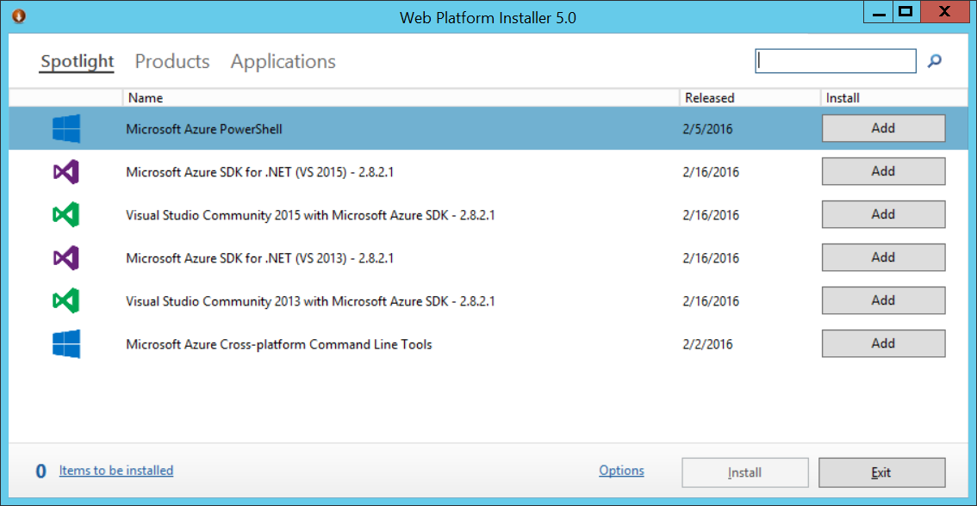

1. In the **Web Platform Installer 5.0** use the Search box at the top right to search for **Workflow**
   1. When searching for Workflow, you should find a product named **Workflow Manager 1.0 Refresh (CU2)**.
   2. Click Add for Workflow Manager 1.0 Refresh (CU2) and then click Continue.
   3. On the **Configure** page, click **Continue**.

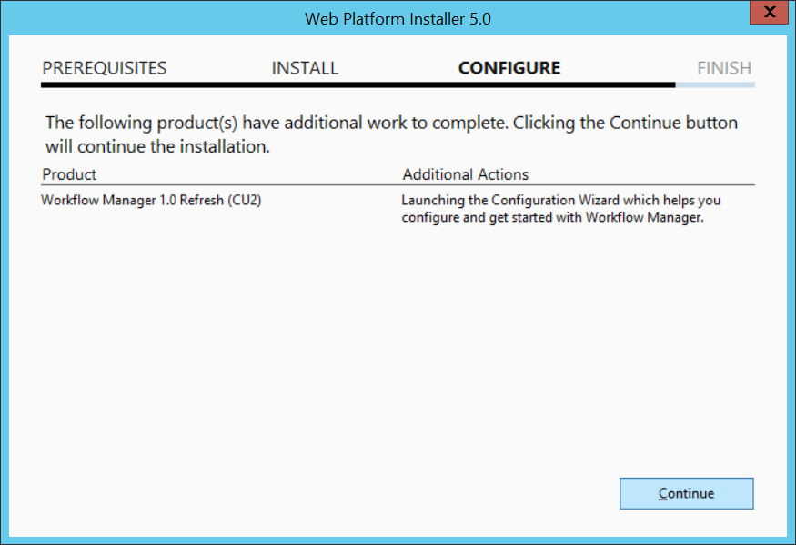

* 1. When installation is complete, you will see a **Welcome** page. At this point, you DO NOT want to select an option to configure Workflow Manager. Instead, close the **Welcome** page by clicking the **X** menu in the upper right corner.

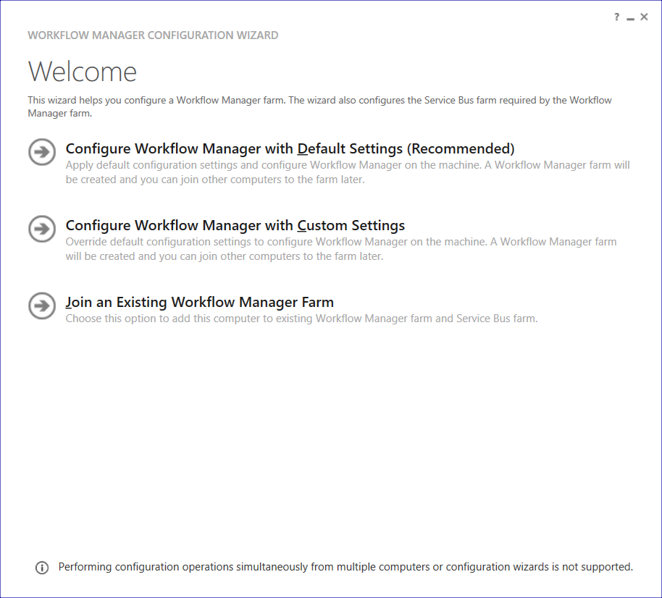

* 1. You should now see the **FINISH** page which displays a list of what has been installed including Workflow Manager and all its dependency components. Click **Finish** to close the Web Platform Installer.

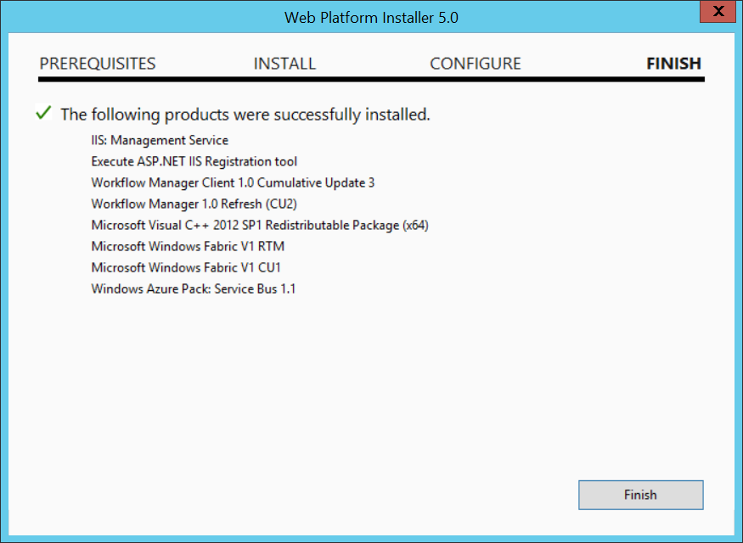

Finally, you have now installed all the software required to create and configure a new local SharePoint farm.

### Task 12: Create and Configure a Local SharePoint 2016 Farm

In this task, you will create a new SharePoint 2016 farm using the **SharePoint 2016 Products Configuration Wizard**. Next, you will use the Farm Configuration wizard to provision an initial set of service applications with the local farm. After that, you will run PowerShell scripts to provision the primary web application and to create a set of sample site collections. After that you will step through several steps to provision the user profile service and the SharePoint search service.

1. Create a new SharePoint farm using the SharePoint 2016 Products Configuration Wizard.
   1. Press the **Windows Key** to open the **Start** menu.
   2. On the Start menu find the SharePoint 2016 Products Configuration Wizard tile and click on it.



* 1. On the Welcome to SharePoint Products page, click Next.

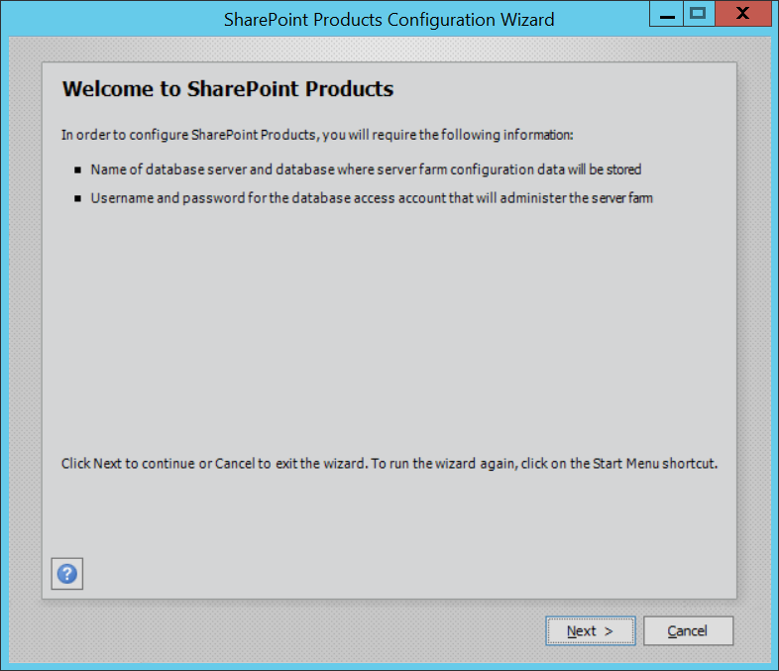

* 1. If prompted to start or reset services, click **Yes**.

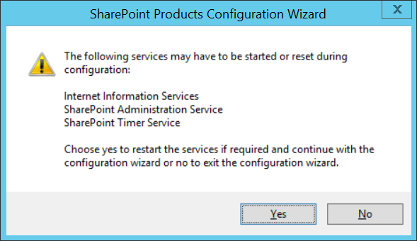

* 1. On the Connect to a server farm page, select Create a new server farm and click Next.

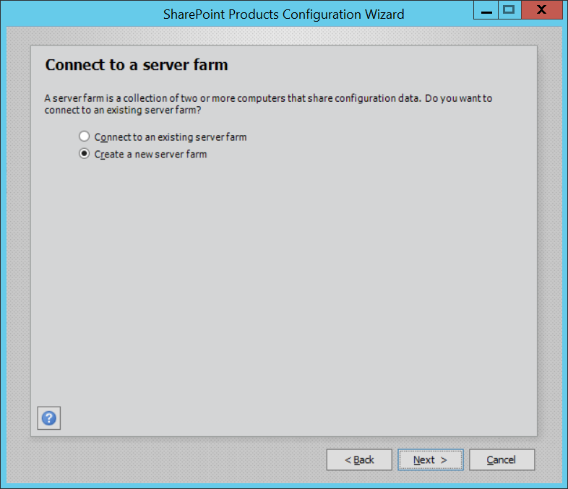

* 1. On the **Specify Configuration Database Settings** page, use the following to complete the page and click **Next**:
     1. Database server: **WingtipServer\SharePoint**
     2. Database name: **SharePoint_Config**
     3. Username: **WINGTIP\SP_Farm**
     4. Password: **Password1**

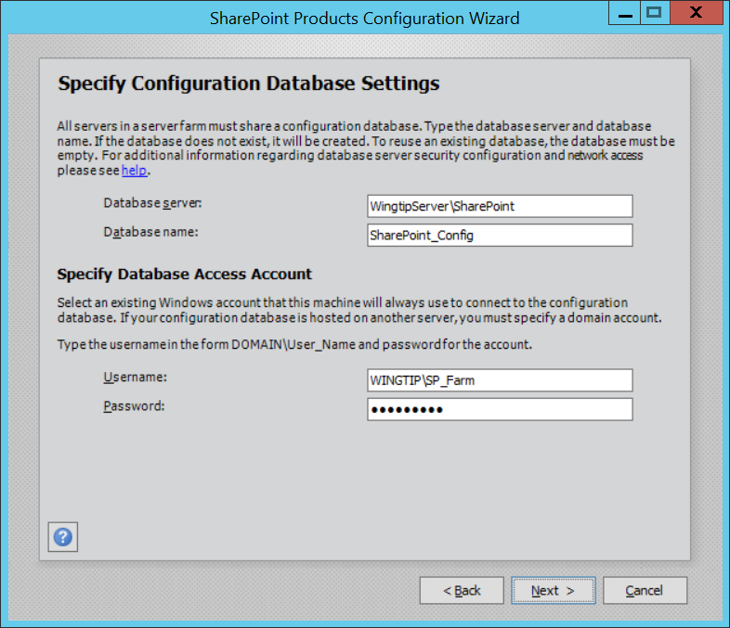

Make sure the **Database server** is set to **WINGTIPSERVER\SHAREPOINT** and not to just **WINGTIPSERVER**. That’s because you want all the databases that are created by SharePoint behind the scenes to be created in the **SharePoint** named instance of the SQL Server Database Engine and not in the default instance.

* 1. On the **Specify Farm Security Settings** page, enter **Password1** into both textboxes and click **Next**.

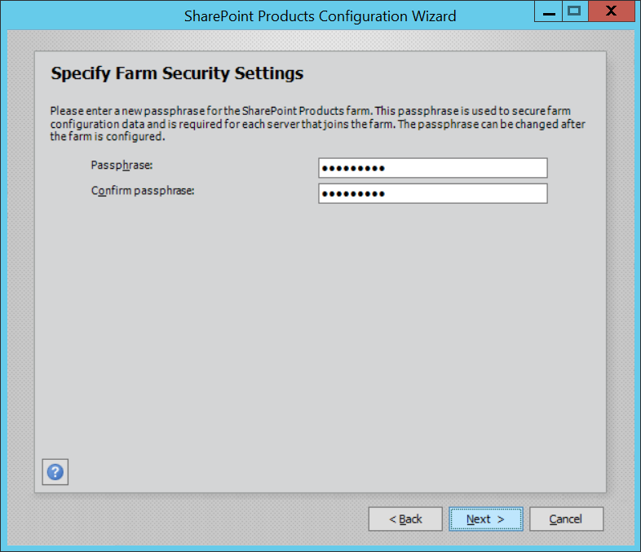

* 1. On the Specify Server Role page, select Single-server Farm and click Next.

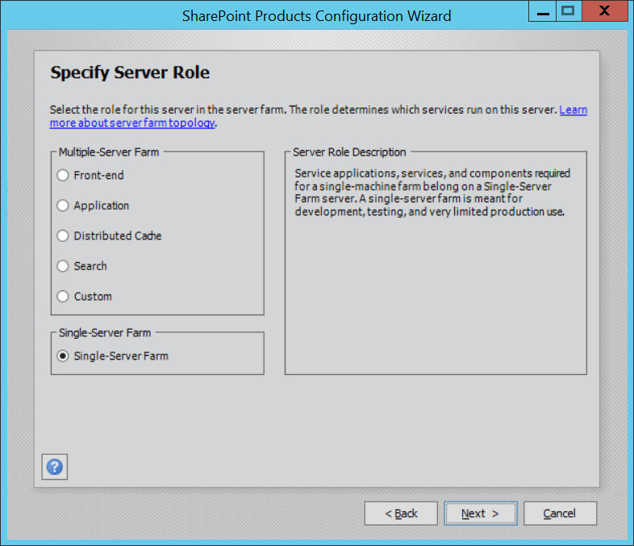

* 1. On the Configure SharePoint Central Administration Web Application page, check the Specify port number checkbox and enter a value of 9999, then Click Next.

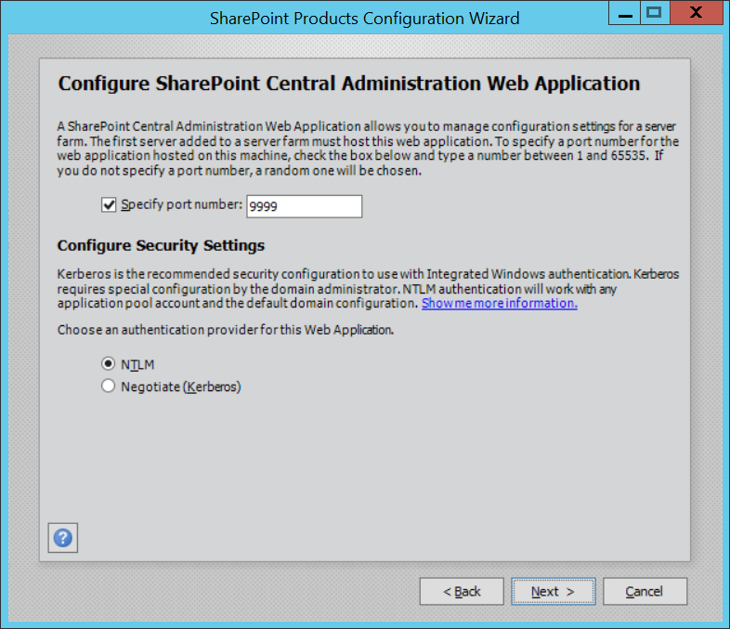

* 1. On the Completing the SharePoint Products Configuration Wizard page, click Next.

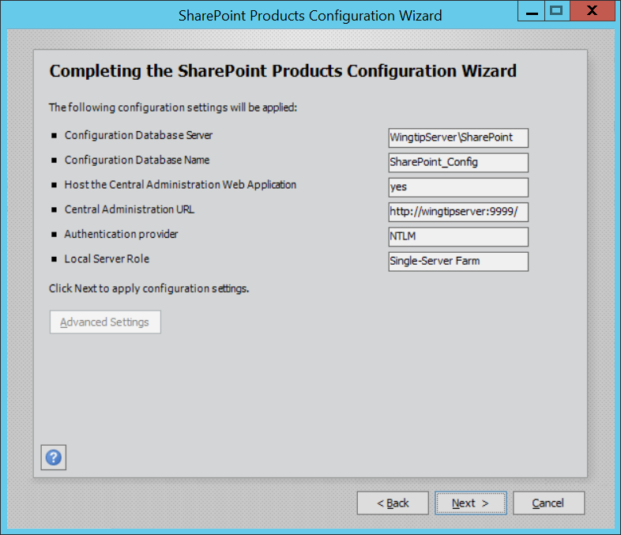

* 1. When the installer completes, it will display the **Confirmation Successful** page. Click **Finish** to close the **SharePoint Products Configuration Wizard**.

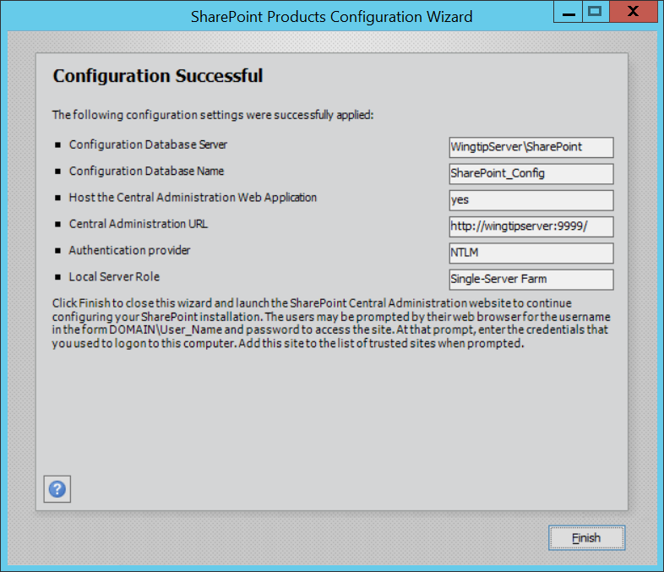

* 1. Note that when you click **Finish** to close the **SharePoint Products Configuration Wizard**, a session of the Internet Explorer is launched and you are directed to a page which will prompt you to continue the configuration process.
  2. Click **No, I don’t wish to participate** on the Customer Experience Improvement Program screen and click **OK**
  3. On the Welcome screen select Yes, walk me through the configuration of my farm using this wizard to start the Farm Configuration Wizard.

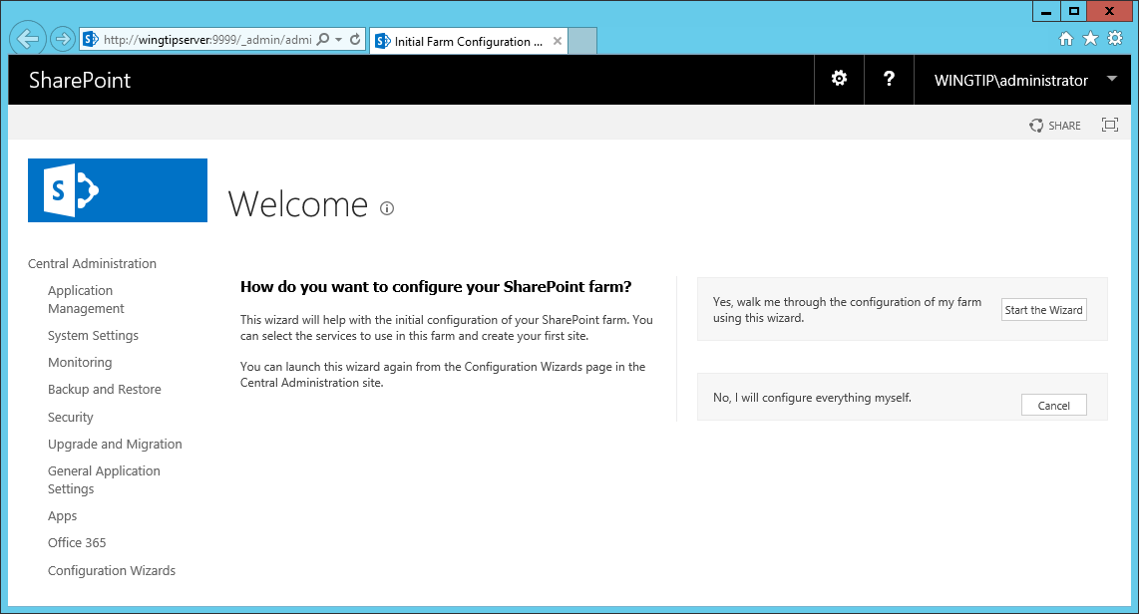

1. Run the Farm Configuration Wizard.
   1. When the Farm Configuration Wizard runs, it displays a page with a title of Service Applications and Services.
   2. In the Service Account section, select Create new managed account
   3. Enter a User name of WINGTIP\SP_Services
   4. Enter a Password of Password1

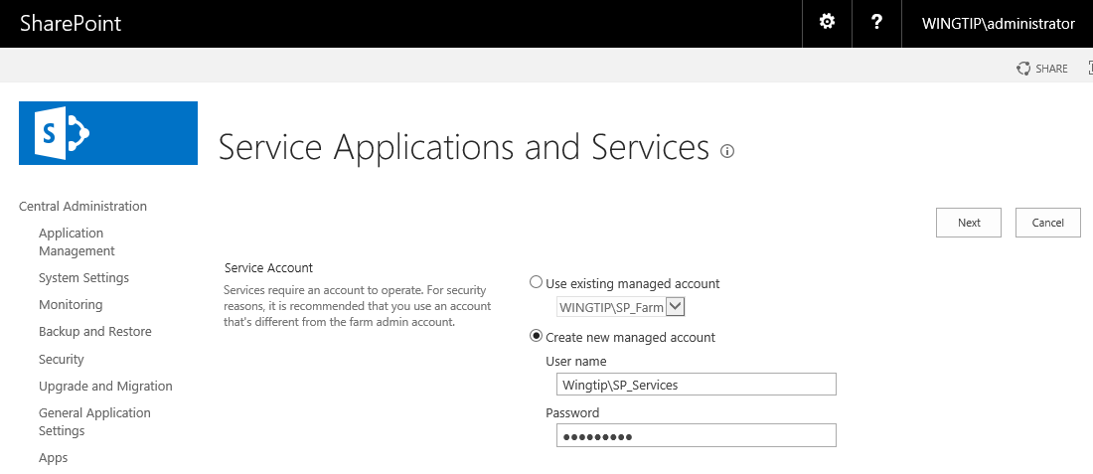

* 1. In the **Service Applications** section, select the following service applications and make sure all others are unselected.
     1. **App Management Service**
     2. **Business Data Connectivity Service**
     3. **Managed Metadata Service**
     4. **Secure Store Service**
     5. **State Service**
     6. **Usage and Health data collection**
     7. **Workflow Service Application**
  2. The set of service applications you have select should match the following screenshot.

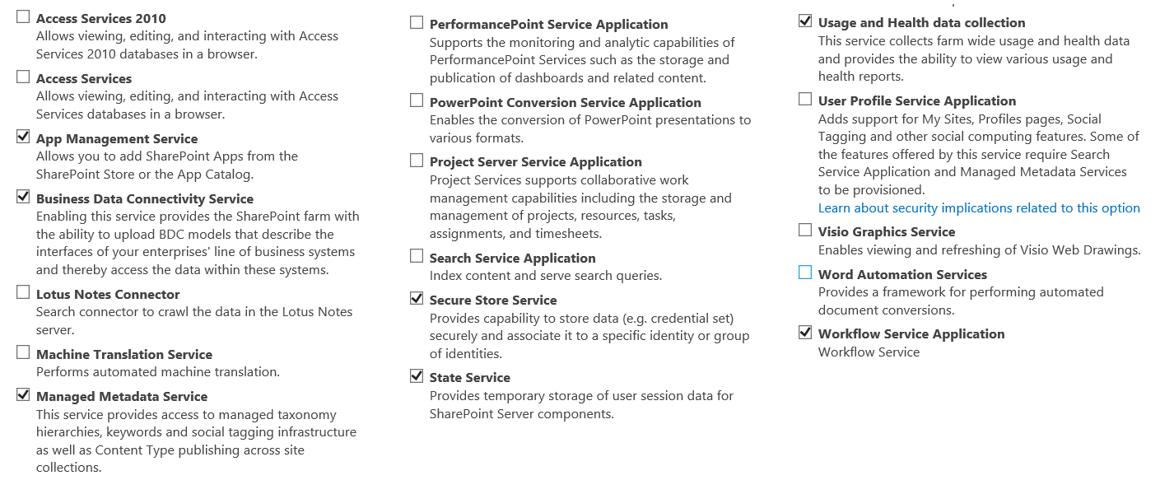

* 1. In the **Services** section, select the following services and make sure all other services are not selected.
     1. **Claims to Windows Token Service**
     2. **Distributed Cache**
     3. **Microsoft SharePoint Foundation Subscriptions Settings Service**
     4. **Microsoft SharePoint Foundation Workflow Timer Service**
  2. The services you have select should match the following screenshot.

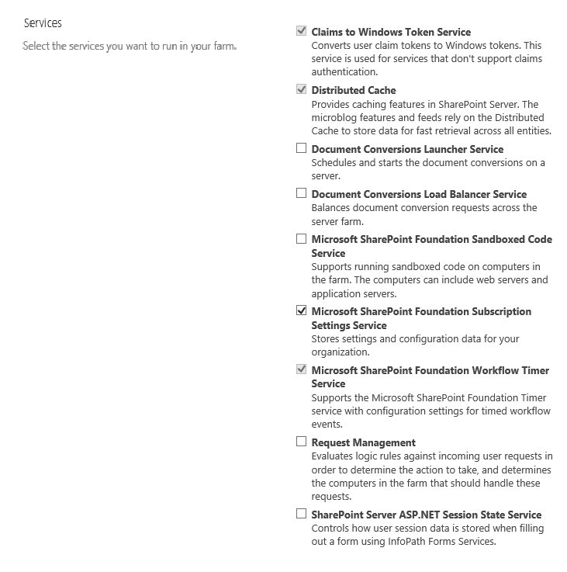

* 1. Click the **Next** button at the bottom of the page to begin the **Farm Configuration** wizard.
  2. Wait for the **Farm Configuration** wizard to complete its work.

The Farm Configuration Wizard will take several minutes to run. When it runs, it provisions all the SharePoint service applications you have selected. It also starts and initializes the SharePoint services you selected. After the Farm Configuration wizard completes its work provisioning service applications and starting services, it then provisions a new SharePoint Web Application. However, this Web Application is not created using best practices. Therefore, this setup guide will show you how to run a PowerShell script to delete this less-than-perfect and replace it with a new Web Application that is created and configured using SharePoint best practices.

When the **Farm Configuration Wizard** finishes it work, it displays the **Create Site Collection** page to create a site collection in the new Web Application it has created. However, it doesn’t make any sense to create a new site collection because you will be deleting this Web Application over the new few steps.

* 1. On the **Create Site Collection** page, click the **Skip** button to skip this step.

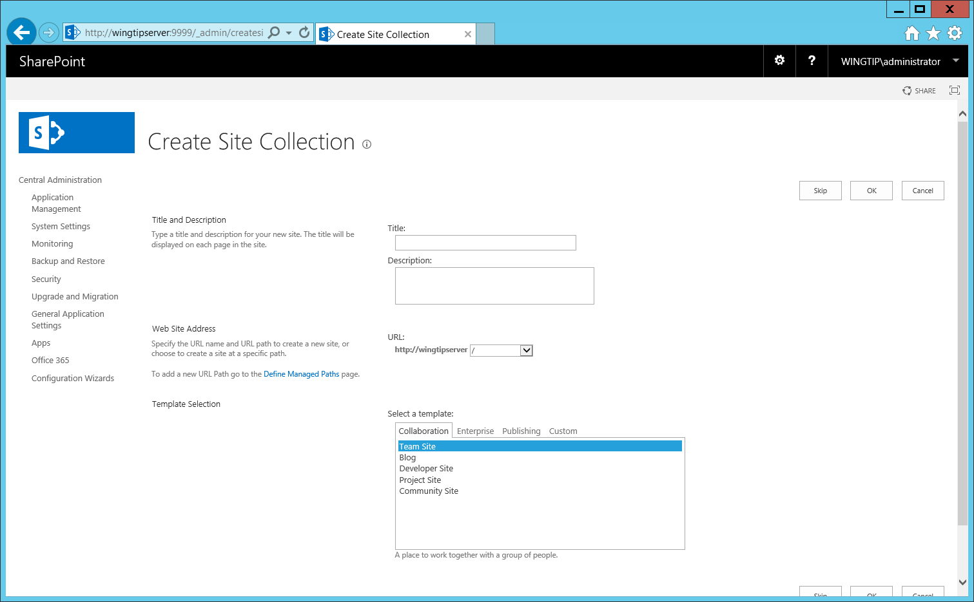

* 1. You should now see a page which displays the list of the work performed by the Farm Configuration wizard.

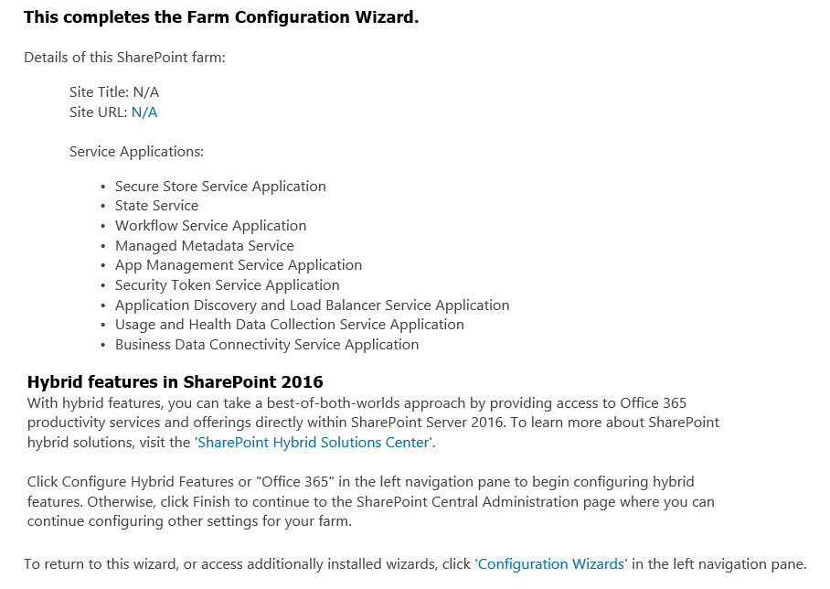

You have now completed the initial work to create a new SharePoint 2016 farm by running the SharePoint 2016 Products Configuration Wizard and then the Farm Configuration wizard. Next, you will run a series of PowerShell scripts to configure the local farm with a new SharePoint web application, samples site collections and a few more service applications.

1. Locate the PowerShell scripts of the SharePoint 2016 VM Setup Guide.
   1. Using Windows Explorer, navigate to the folder at **C:\Setup\Scripts**.
   2. Examine the set of PowerShell scripts inside the **Scripts** folder. You have already run the script named **Script01_PreServer.ps1**. Over the next few steps you will run the remaining scripts to build out the local SharePoint farm.

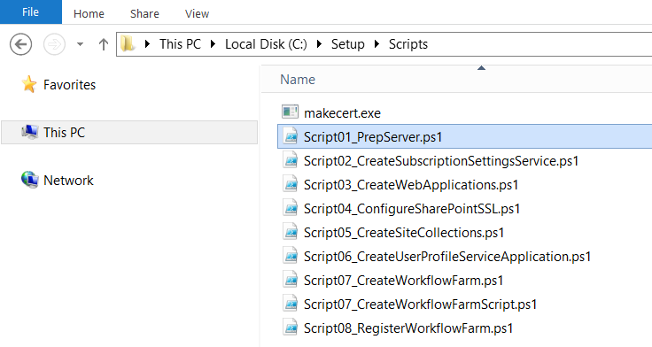

Note that earlier when running the Farm Configuration wizard, you selected the checkbox to create the service application named **Site Subscription Settings Service**. Now you will run a PowerShell script to create a service application instance of the **Site Subscription Settings Service**. The reason you are doing this is that you must create an instance of this service application to support SharePoint add-ins (aka SharePoint apps).

1. Run the PowerShell script to provision a service application and proxy for the **Site** **Subscription Settings Service**.
   1. Navigate to the **Scripts** folder in the Windows explorer.
   2. Right-click on Script02_CreateSubscriptionSettingsService.ps1 and select Run with PowerShell.
   3. Wait for the script to run and complete its work.
   4. Press ENTER or close the console window when complete.
2. Verify that the service application for the **Site** **Subscription Settings Service** has been successfully created.
   1. Return to the browser and navigate to the home page of **SharePoint Central Administration**.
   2. Locate and click the Manage service application link in the Application Management section.



* 1. Make sure you can see the Site Subscription Settings Service Application you just created.

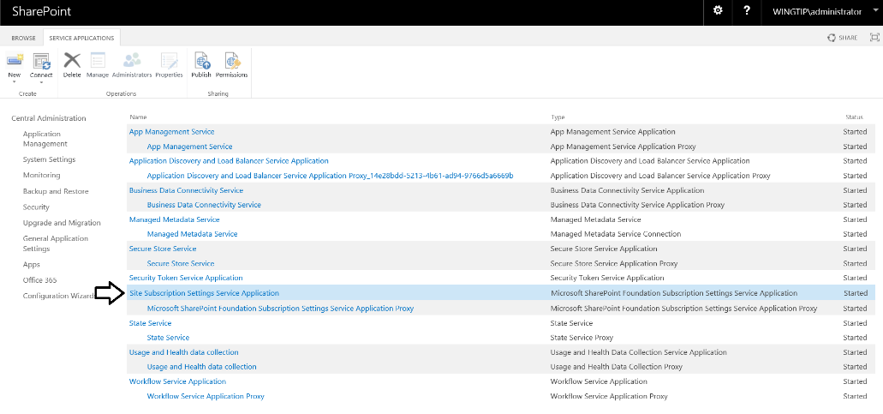

* 1. Return to the home page of Central Administration.
  2. Locate the **Apps** section at the bottom of the home page. Click on the **Apps** link to navigate to the **Apps** page.



* 1. On the **Apps** page, click the **Configure App URLs** link in the **App Management** section.



* 1. On the **Configure App URLs** page, verify that the **App domain** has a configured value of **wingtip.com** and also that **App prefix** has a configured value of **WingtipTenant**.



* 1. Return to the home page of Central Administration

1. Run the PowerShell script to create two new web application in the local farm.
   1. Navigate to the **Scripts** folder in the Windows explorer.
   2. Right Click on the **Script03_CreateWebApplications.ps1** script and select Run with PowerShell
   3. Wait for script to finish (this will take several minutes).
   4. Press ENTER or close the console window when complete

When you run **Script03_CreateWebApplications.ps1**, this script will begin its work by deleting the existing web application that was created by the farm Configuration wizard. Next, it will create a new Web Application Pool using the identity of **WINGTIP\SP_Content** and along with a new web application with a root URL of <http://wingtipserver>. This web application will serve as the primary web application in which you will create sample site collections. The run **Script03_CreateWebApplications.ps1**script will also create a second web application that will be used to host OneDrive sites for each user.

When the script finishes, it will launch a browser and navigate to a Team site that was created at the root URL of the primary web application which is <http://wingtipserver>.

1. Take a moment to examine the new Team Site that has been created at <http://wingtipserver>.



1. Run the PowerShell script to configure the primary web application with a wildcard SSL certificate.
   1. Navigate to the **Scripts** folder in the Windows explorer.
   2. Right Click on the Script04_ConfigureSharePointSSL.ps1 script and select Run with PowerShell.
   3. Wait for script to finish (this will take several minutes).
   4. Press ENTER or close the console window when complete
2. Run the PowerShell script to create a set of sample site collections.
   1. Navigate to the **Scripts** folder in the Windows explorer.
   2. Right-click on the Script05_CreateSiteCollections.ps1 script and select Run with PowerShell.
   3. Wait for script to finish (this will take several minutes).
   4. Press ENTER or close the console window when complete
3. Take a minute to quickly inspect the sample site collections that have just been created.
   1. Inspect the **Team Site** that has been created at <https://intranet.wingtip.com>.
   2. Inspect the **Search Center** site that has been created at <https://search.wingtip.com>.
   3. Inspect the **Discovery Center** site that has been created at <https://disco.wingtip.com>.
   4. Inspect the **Publishing Portal** site that has been created at <https://www.wingtip.com>.
   5. Inspect the **BI Center** site that has been created at <https://bi.wingtip.com>.
   6. Inspect the **Developer** site that has been created at <https://dev.wingtip.com>.
4. Run the PowerShell script to provision a service application for the SharePoint User Profile service.
   1. Navigate to the **Scripts** folder in the Windows explorer.
   2. Right Click on the Script07_CreateUserProfileServiceApplication.ps1 script and select Run with PowerShell.
   3. Wait for script to finish (this will take a minute or two to complete).
   4. Press ENTER or close the console window when complete.
5. Import User Profile Information from Active Directory.
   1. Return to the browser and navigate to Central Administration.
   2. Click User **Profile Service Application** to navigate to the administration page of the User Profile service.
   3. In the Synchronization section, select **Configure Synchronization Settings**.



* 1. On the Synchronization Connections page, select Create New Connection.



* 1. Enter the following values on this form:
     1. Connection Name: **Wingtip Users**
     2. Type: **Active Directory**
     3. **Connection Settings**:
        1. Fully Qualified Domain Name: **wingtip.com**
        2. Specify a domain controller: **selected**
        3. Domain controller name: **WingtipServer**
        4. Authentication Provider Type: **Windows Authentication**
        5. Account Name: **WINGTIP\SP_UPS**
        6. Password (and Confirm Password): **Password1**



* 1. Scroll down the page to the **Containers** section.
  2. Click the **Populate Containers** button. After the tree view control loads, expand the **WINGTIP** node and select the Organizational Unit named **Wingtip Users** by placing a checkbox as shown below.



* 1. Click **OK** to save the connection.
  2. You should now see the connection named **Wingtip AD users** on the **Synchronization Connections** page.

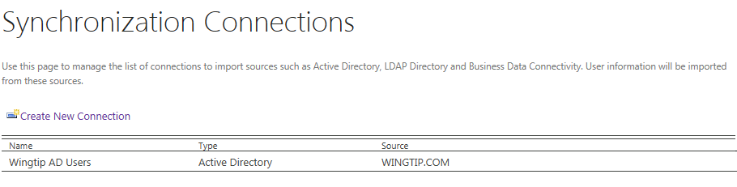

1. Return to the User Profile Service Application management page
   1. **Application Management** > **Manage Service Applications** > **User Profile Service Application**.
2. Finally, start a synchronization import:
   1. Under **Synchronization**, select **Start Profile Synchronization**.
   2. Select **Start Full Synchronization** and click **OK**
   3. Wait for this to finish
   4. You will be taken back to the **User Profile Service Application** page.
   5. Refresh the **User Profile Service Application** page to see the **Number of User Profiles**. Once the Active Directory import process completes, there should be between 20 to 25 user profiles.

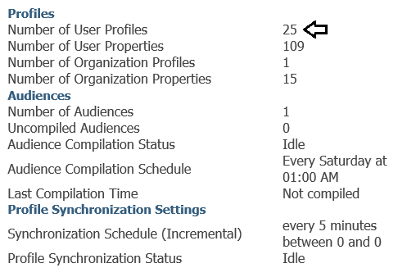

At this point you have configured the **User Profile Service Application** and you have also successfully imported profiles from the local Active Directory domain in the UPA database. Now, you will create and configure one more service application to provide support in your SharePoint farm to run searches with the SharePoint Search Service.

1. Create a new service application instance of the SharePoint Search Service.
   1. In a browser, navigate to the home page of Central Administration.
   2. Click Manage Service Applications in the Application Management section.
   3. On the Service Applications page, select the drop down under **New** in the ribbon and select the **Search** **Service Application** option.



* 1. On the **Create New Search Service Application** page set the following items:
     1. Service Application Name: **Search Service Application**
     2. Search Service Account: **WINGTIP\SP_Services**



* + 1. Application Pool for Search Admin Service: **Use existing application pool**
       1. Name: **SharePoint Web Services Default**
    2. Application Pool for Search Query and Site Settings Web Service
       1. Name: **SharePoint Web Services Default**



* + 1. Click **OK** at bottom of window and wait for the Search Service Application to be provisioned.
    2. When you see the **Manage Search Topology** screen with the success message, click **OK** to continue.

1. Configure the Search Service Application.
   1. Next we need to configure the identity of the Search Service Application Crawl Account
   2. In Central Administration Navigate to the main Search Administration page of the **Search Service Application**.
      1. Central Administration → Manage service applications → Search Service Application link

If you see an error on the search administration page stating that the search service is not able to connect to the machine that hosts the administration component you can try to reboot the server and try returning to the page.

* 1. Inspect the properties in the **System Status** section and locate the property named **Default content access account**.
  2. Currently, the **Default content access account** property should have a value of **WINGTIP\SP_Services**.
  3. Click on the link which shows the property value of **WINGTIP\SP_Services** to configure it to use a different account. A dialog will appear that allows you to add a new account and password. Add the **WINGTIP\SP_Crawler** account and a password / confirm password of **Password1** and then click **OK** to save your changes.
  4. The Default content access account should now be set to **WINGTIP\SP_Crawler**.



* 1. Update the Contact e-mail address for crawls setting to administrator@wingtip.com.
  2. Update the Global Search Center URL to https://search.wingtip.com/Pages/results.aspx.



* 1. Return to the main Search Administration page of the Search Service Application.

When you configure a new identity for the crawler account by updating the **Default content access account** property, SharePoint will automatically add a user policy to each existing web application to provide the account will Full-Read access. Therefore, you do not need to worry about configuring permissions for the crawler account to access SharePoint sites. However, SharePoint will not automatically configure permissions for the crawler account to properly access the User Profile Service Application. You will configure the permissions that are required in the following step.  
(Note: you would also need to provide access to any external content you wished to crawl)

1. Provide the **WINGTIP\SP_Crawler** account with access to the User Profile Service Application.
   1. Navigate to the Manage service applications page and select the User Profile Service Application
   2. **Central Administration → Manage service applications →** just select **User Profile Service Application** (but do not click the link (i.e. click anywhere on this line but the link itself to highlight/select this application))
   3. With the **User Profile Application Service** selected, click the **Administrators** button in the Ribbon.



* 1. In the Administrators for User Profile Service Application page, enter **WINGTIP\SP_Crawler** and then click Add.



* 1. Configure the **WINGTIP\SP_Crawler** account with the **Retrieve People Data for Search Crawlers** permission.



* 1. Click **OK** to save your configuration changes.

1. Run a full crawl of the Search Service Application.
   1. Return to **Manage Service Applications** page.
   2. Click on the **Search Service Application** link to navigate to the main Search Administration page.
   3. Click the **Content Sources** link in the **Crawling** section to navigate to the to the **Manage Content Source** page.



* 1. On the **Manage Content Source** page you should see a single content source named **Local SharePoint Sites**.



* 1. Use the drop down menu on **Local SharePoint sites content source** to start a full crawl of the content.



The full crawl process will likely take about 5 minutes or so to complete.

* 1. Click the Refresh link about once per minute to see if the crawl has completed. When the crawl is still underway, you should see the **Status** of this Content Source is set to **Crawling Full**.



* 1. Continue to click Refresh until you see that the crawling process has completed and the **Status** is set to **Idle**.



1. Run a search against the SharePoint Search Service to verify that it is working correctly.
   1. Navigate to the Search Center site at <https://search.wingtip.com>.
   2. Type in a search using the text value of **ContentClass:STS_SITE** and then click the search button.



Note that the search text **ContentClass:STS_SITE** is used to run a search that returns only top-level sites.

* 1. If the search application has been properly configured, you should see search results which include the site collections that you created earlier.



Congratulations! Search appears to be working correctly… but wait there’s more…

### Task 13: Configure Support for SharePoint 2013 Workflows

In an earlier step, you installed Workflow Manager which is required to add support for SharePoint 2013-style workflows. In this step you will configure Workflow Manager by running a PowerShell script to create a Workflow Manager farm. Next, you will run a second PowerShell script to register the Workflow Manager farm with the local SharePoint farm. After this, you will verify that that SharePoint 2013 workflow support is working by installing SharePoint Designer 2013 and creating and testing a workflow.

1. Using Windows Explorer, navigate to **C:\Setup\Scripts**.
2. Right Click on the **Script07_CreateWorkflowFarm.ps1** and select Run with PowerShell
   1. Wait for the script to start. If you are prompted by User Account Control and click **Yes.**
   2. A second PowerShell window will open and a subsequent script will be autorun under the identity of **WINGTIP\SP_Workflow** which is required to correctly create and configure the Workflow Manager farm. Note that this script will take a couple of minutes to run so be patient.
   3. When the script runs, it will configure the Service Bus and Workflow Management Services.
3. Right Click on the **Script08_RegisterWorkflowFarm.ps1** and select **Run with PowerShell**.
   1. Running this script will create a connection between the local SharePoint farm and the Workflow Manager farm to enable support for SharePoint 2013 workflows.
   2. The script should just take 10-15 seconds to complete.
4. Check the Workflow Management Service to verify
   1. Return to the **Manage Service Applications** page.
   2. Click on the **Workflow Service Application** link at the bottom of the page.

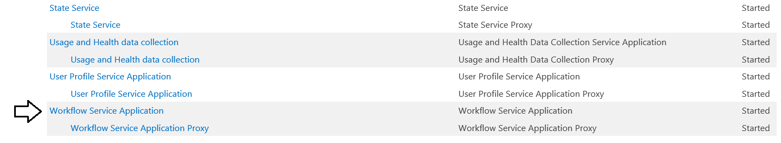

* 1. Verify that the **Workflow Service Status** page displays the message *“Workflow is Connected”*.

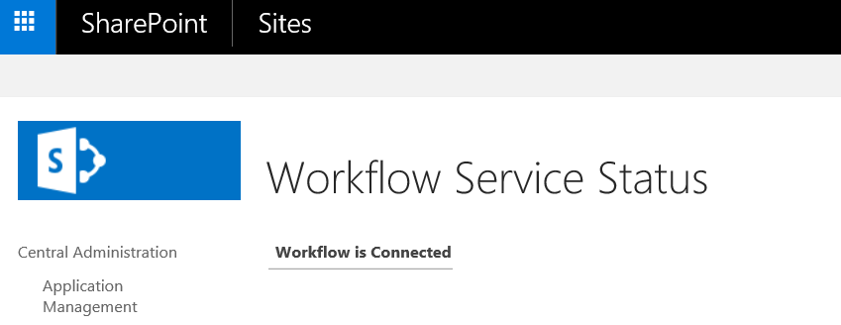

Now that you have configured support for SharePoint 2013 workflows, you will install the SharePoint Designer 2013 so you can create and run a simple SharePoint 2013 workflow for testing purposes.

1. Download and install SharePoint Designer 2013.
   1. In a browser, navigate to the page at the following URL.

<https://www.microsoft.com/en-us/download/details.aspx?id=35491>

* 1. Click the **Download** button.
  2. Select the installation file for the 64-bit version of SharePoint Designer 2013 named **sharePointdesigner_64bit.exe**.

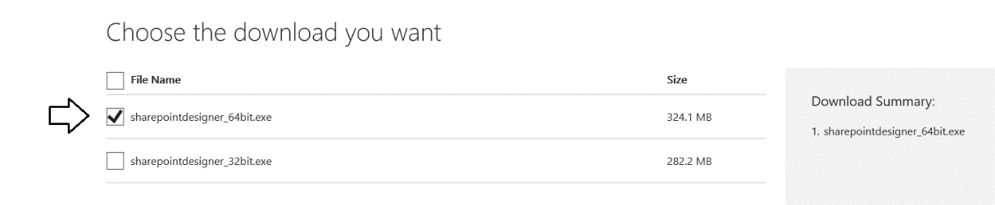

* 1. Click **Next** to download **sharePointdesigner_64bit.exe**.
  2. When prompted, begin the installation process for SharePoint Designer 2013.
  3. Move through all the steps and complete the installation.

1. Install **SharePoint Designer 2013 Service Pack 1**.
   1. In a browser, navigate to the page at the following URL.

<https://www.microsoft.com/en-us/download/details.aspx?id=42009>

* 1. Click the **Download** button.
  2. When prompted, install service pack 1 and step through the installation steps until it is completed.

1. Open SharePoint Designer 2013
   1. Press the Windows key and type SharePoint Designer
   2. Select the SharePoint Designer 2013 tile
   3. Select Use recommended settings and click Accept
   4. **Close** the Office Welcome pop-up window
2. Configure SharePoint Designer 2013 Application Option.
   1. Click on the **Options** link in the bottom, left-hand side corner of the SharePoint Designer window.

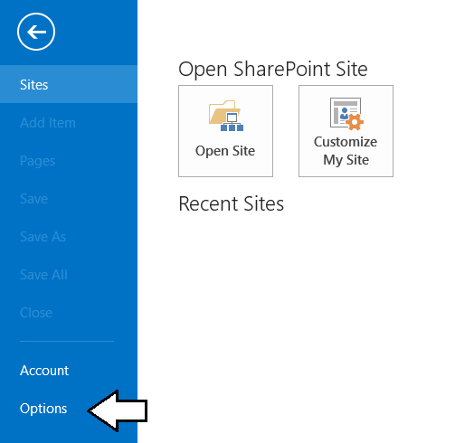

* 1. In the **SharePoint Designer Options** dialog, click the **Application Options** button.

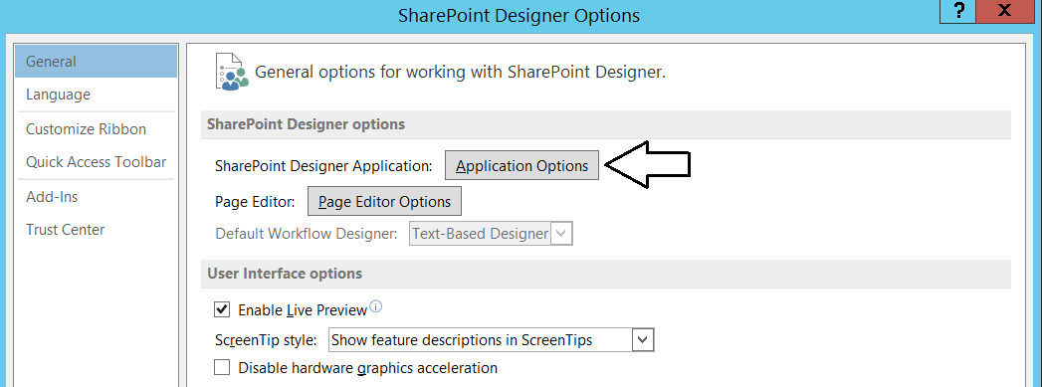

* 1. In the **Application Options** dialog, uncheck the checkbox labeled **Cache site data across SharePoint Designer sessions**.

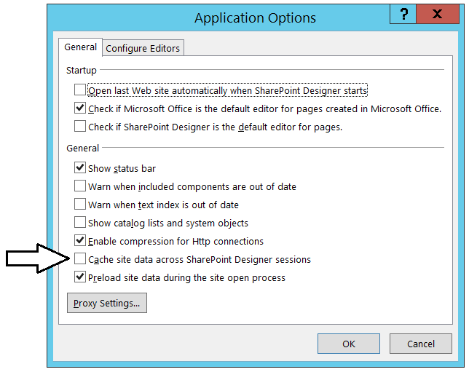

* 1. Click **OK** to close the **Applications Options** dialog.
  2. Click **OK** to close the **SharePoint Designer Options** dialog.

1. Use SharePoint Designer to open the Wingtip Intranet Team Site at <https://intranet.wingtip.com>.
   1. Click **Open Site**, set the site name to [**https://intranet.wingtip.com**](https://intranet.wingtip.com)and then click **Open**.
   2. Wait for SharePoint Designer to open the site.
   3. Take a moment to inspect the contents of the by clicking the navigation links in the **Site Objects** list on the left-hand side.

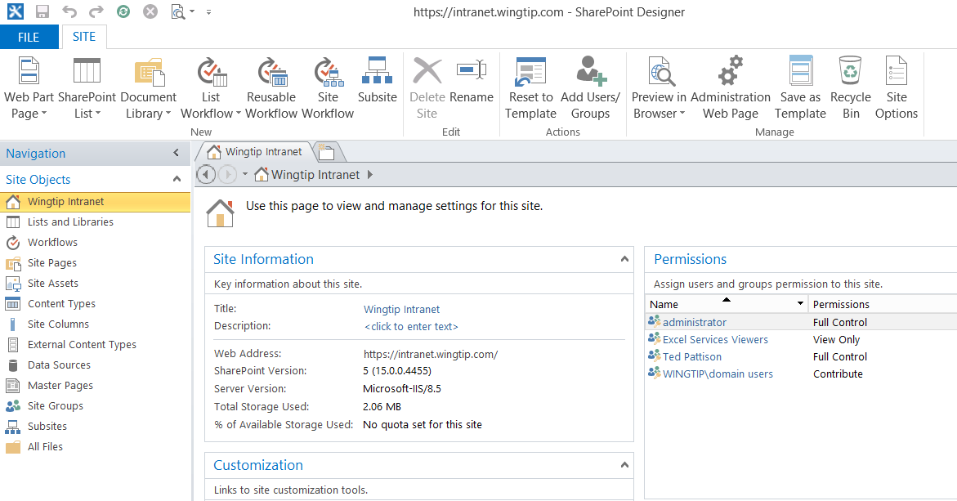

1. Create a new SharePoint 2013 workflow.
   1. Click on the **Workflows** link in the **Site Objects** list.
   2. You should be able to verify that there are currently no existing workflows in the site.

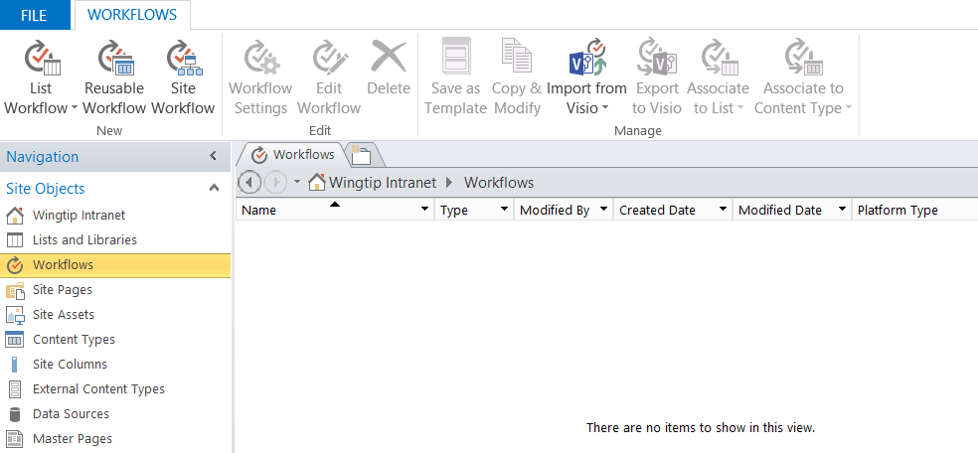

* 1. In the ribbon, click the **Site Workflow** button to display the **Create Site Workflow** dialog.

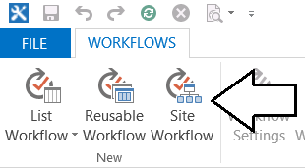

* 1. Inspect the Platform Type option at the bottom of the **Create Site Workflow** dialog box. You should see **SharePoint 2013 Workflow** as a choice. As long as you see **SharePoint 2013 Workflow** as a choice, you know that you have successfully configured support for SharePoint 2013 workflows in the local farm.
  2. Enter a **Name** of **Hello Workflow**, set **Platform Type** to **SharePoint 2013 Workflow** and click **OK** to create the new workflow.

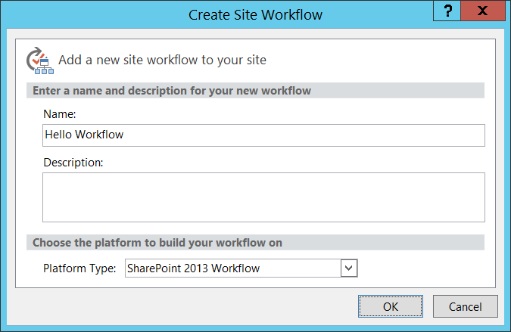

1. Once the workflow has been created, you should be able to work with it in the workflow designer as shown in the following screenshot.

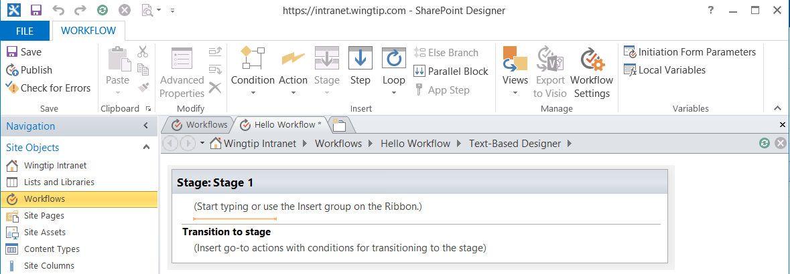

At this point you have done enough to verify that your VM provides support for creating SharePoint 2013 workflows with SharePoint Designer 2013. Feel free to continue working with SharePoint Designer if you want to continue building out and testing the workflow you have just created. Now, this VM setup guide will move ahead to the task of installing Visual Studio 2015.

### Task 14: Install Visual Studio 2015 with Update 1

In this section you will Install Visual Studio 2015 with Update 1 and then you will install the latest version of the Office/SharePoint tools for Visual Studio.

1. Download the ISO file with the installation files for Visual Studio 2015 with Update 1.
   1. You can use either the Visual Studio 2015 Enterprise version or the Visual Studio 2015 Professional version.
   2. If possible, download the 64-bit version of Visual Studio 2015 with Update 1 and not the 32-bit version.
   3. If you are an MSDN subscriber, you can download this from the MSDN Members Downloads page,
   4. A trial version can be downloaded from <https://www.visualstudio.com/en-us/downloads/download-visual-studio-vs.aspx>.
2. Configure the VM to see the ISO file as the D:\ drive.
   1. Once you do this, you should be able to see the ISO file has been mounted as a drive in the VM.
   2. From inside the VM, inspect the installation files for Visual Studio 2015 on the D:\ drive.
   3. You should be able to locate the file to begin the installation process named **vs_enterprise.exe**.

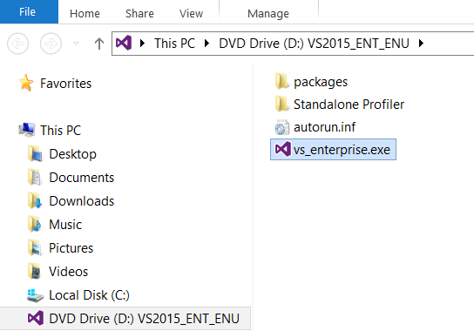

1. Install Visual Studio 2015 with Update 1.
   1. Double-click **vs_ultimate_download.exe** to begin the installation process.
   2. Select **Custom** for the **Choose the type of installation** option and click **Next**.

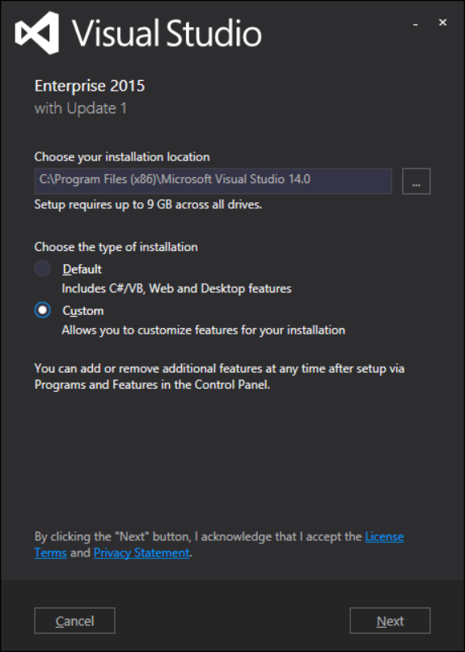

* 1. When you get to the dialog where you are prompted to **Select features**, select the following features.
     1. Microsoft Office Developer Tools
     2. Microsoft SQL Server Data Tools
     3. Microsoft Web Developer Tools
  2. Click **Next** to continue.

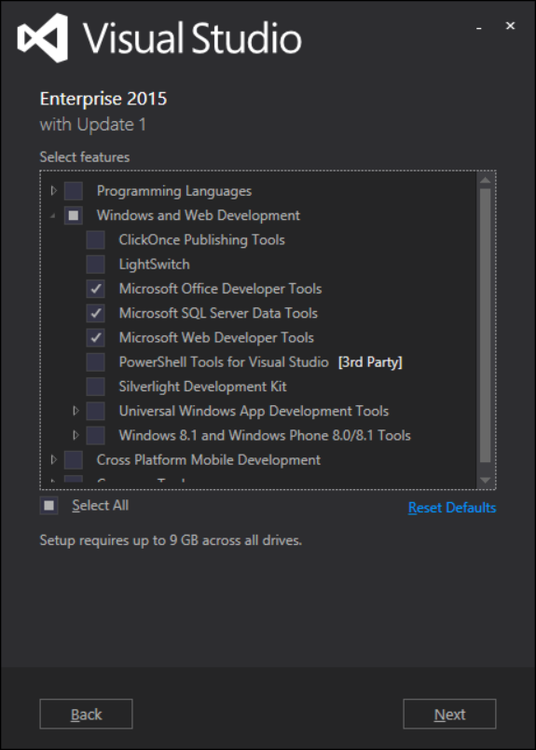

* 1. Click Install to begin the installation process.

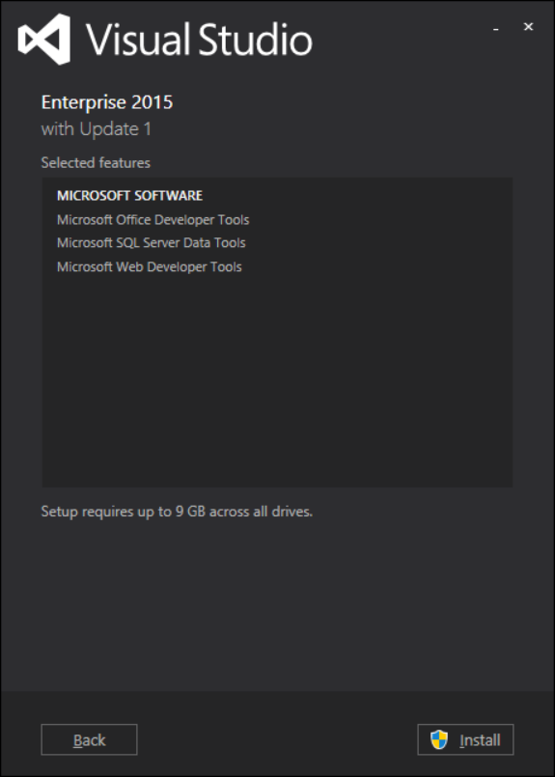

* 1. Wait for the install to finish which should take approximately 20 minutes.

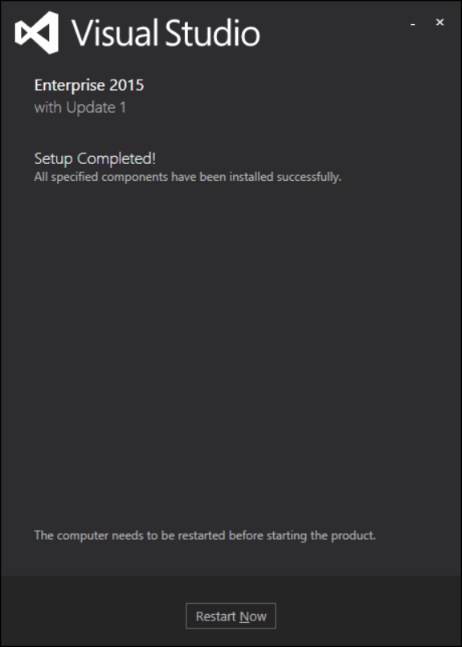

* 1. When promoted with the **Setup Complete** dialog, click the **Restart Now** button to restart the VM.
  2. When the VM restarts, log back in as **WINGTIP\Administrator** using a password of **Password1**.
  3. At this point, Visual Studio 2015 with Update 1 should be installed.

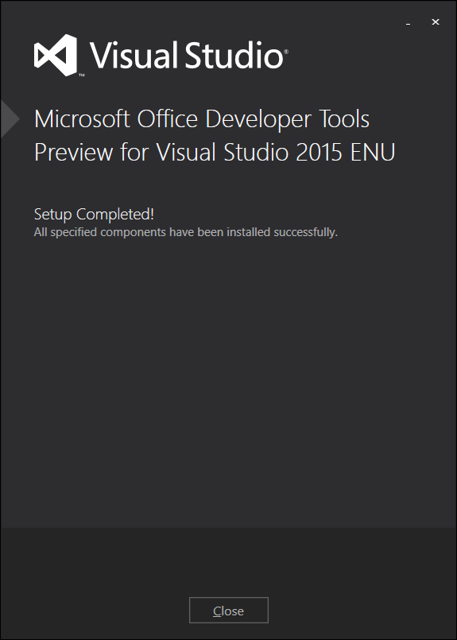

1. Update the SharePoint/Office developer tools in Visual Studio for SharePoint 2016.
   1. Using a browser, navigate to the page at the following URL

<https://www.microsoft.com/en-us/download/details.aspx?id=49972>

* 1. Click **Download** to download the **Microsoft Office Developer Tools Preview for Visual Studio 2015** dated 11/19/2015.
  2. Download and run the installation file named **officetools_bundle.exe**.
  3. Move through all dialogs to complete the installation of the update Office/SharePoint Tools in Visual Studio.

1. Test the VM by creating and running a new Visual Studio 2015 project for a SharePoint Add-in.
   1. Launch Visual Studio 2015.
   2. Using the **File** Menu select **New Project**
   3. In the **New Project** dialog, Expand **Templates** > **Visual C#** > **Office/SharePoint**.
   4. Select the **SharePoint Add-in** project template.
   5. Enter a project name of **HelloWorld** and click **OK** to begin creating the new project.

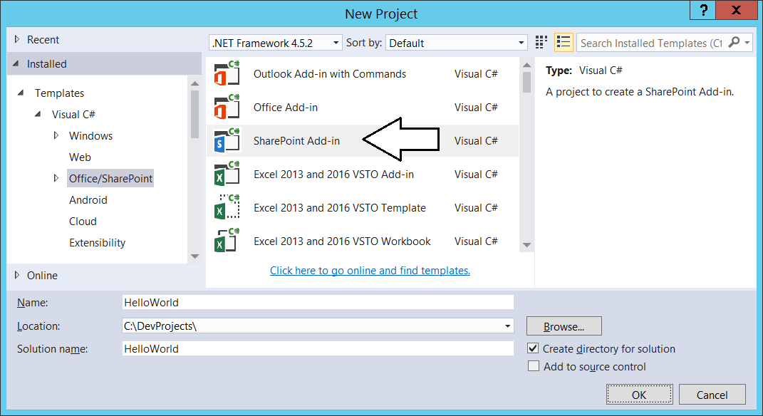

* 1. On the Specify the SharePoint Add-in settings page…
     1. Enter a debugging site URL of **https://dev.wingtip.com**.
     2. Select **SharePoint-hosted** for the **How do you want to host your SharePoint Add-in?** option.
     3. Click **Next**.

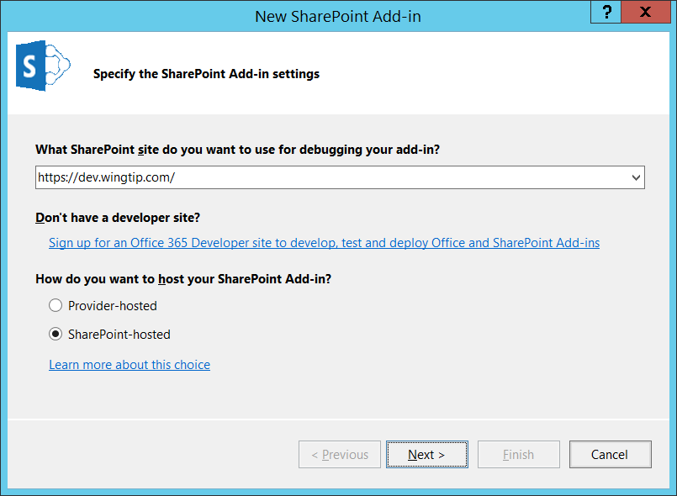

The current version of the updated Office/SharePoint tools has a few issues you will need to work through. These issues should disappear when the Office/SharePoint developer tools are updated for the RTM release of SharePoint 2016. In the meantime, you will learn a few tricks over the next few steps to get projects up and running with the preview version of the Visual Studio tools.

* 1. On the **Specify the target SharePoint version** page, select **SharePoint Online** and click **Finish**.

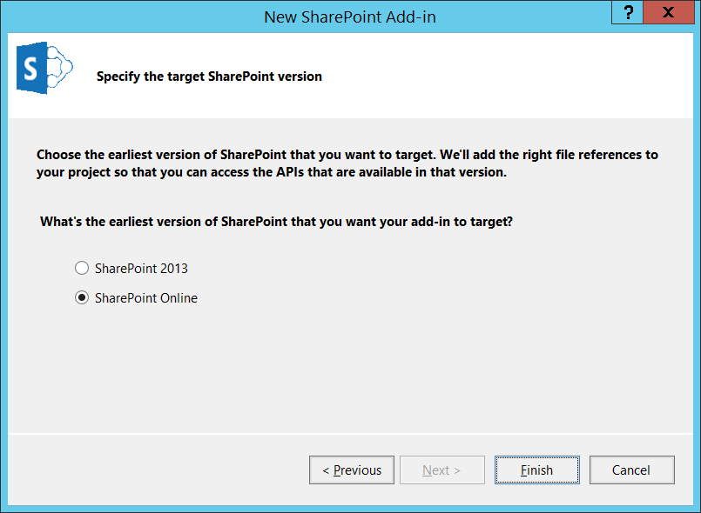

* 1. The new **SharePoint-hosted add-in** project should now be created.

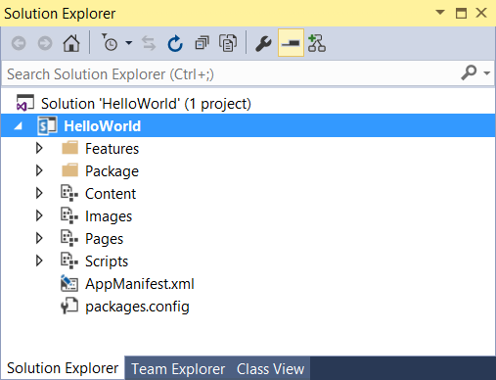

1. Test the project by running it in the Visual Studio debugger.
   1. Press the **{F5}** key and try to begin a debugging session with the project. When you do, you will receive an error indicating that the project is not configure with the correct version of SharePoint for the local SharePoint farm.

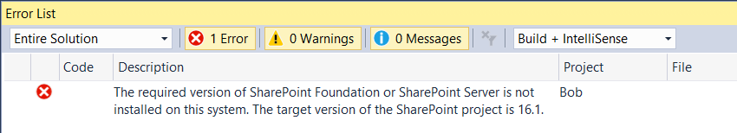

1. Update the Visual Studio project file named **HelloWorld.csproj** to support SharePoint 2016.
   1. In the Solution Explorer, right click on the **HelloWorld** project and select the **Unload Project** command.

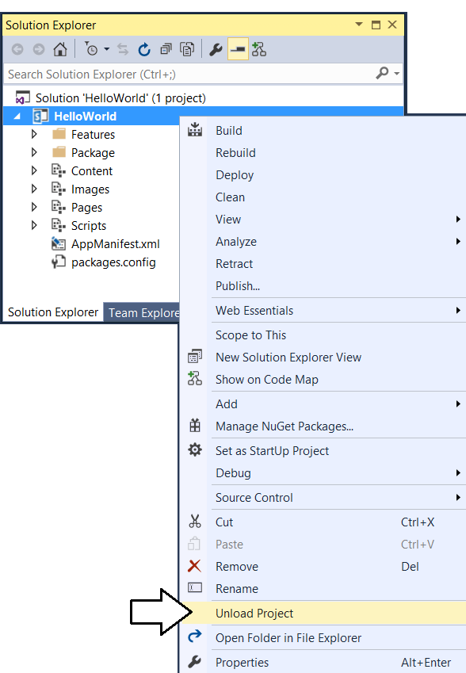

* 1. Right-click on the **HelloWorld** project again and select the **Edit HelloWorld.csproj** command.

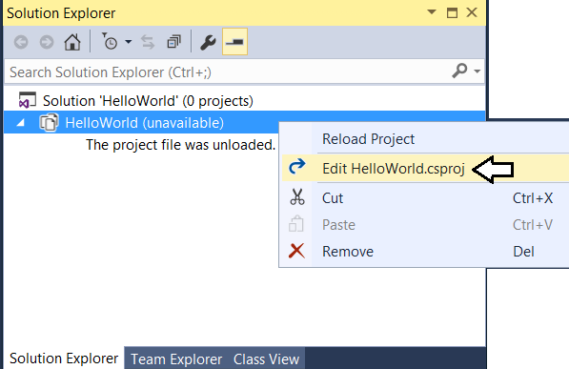

* 1. In the **HelloWorld.csproj** file, locate the **TargetOfficeVersion** element and update its value from **16.1** to **16.0**.

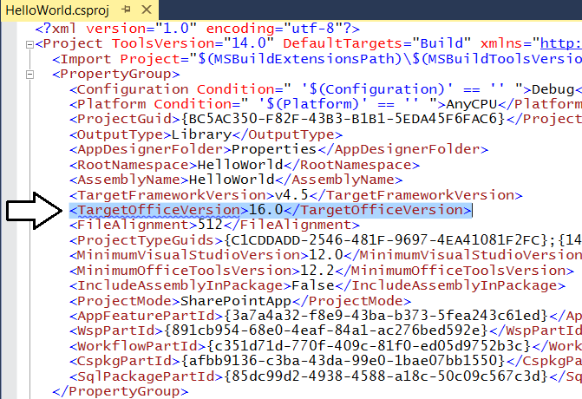

* 1. Save and close **HelloWorld.csproj**.
  2. Right-click on the **HelloWorld** project and select the **Reload Project** command.

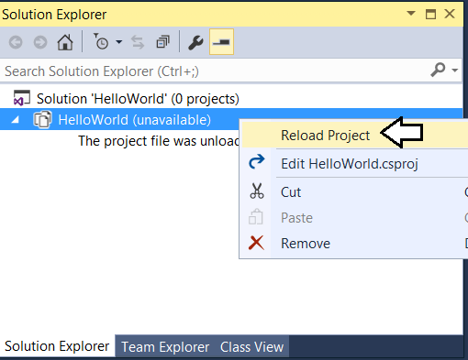

Now the project should be correctly configured so you can run a debugging session using the local SharePoint 2016 farm.

1. Press the **{F5}** key to begin a debugging session.
   1. Visual Studio should build and install the HelloWorld add-in.
   2. You should be directed to the start page of the add-in at a page running out of the **wingtip.com** domain.

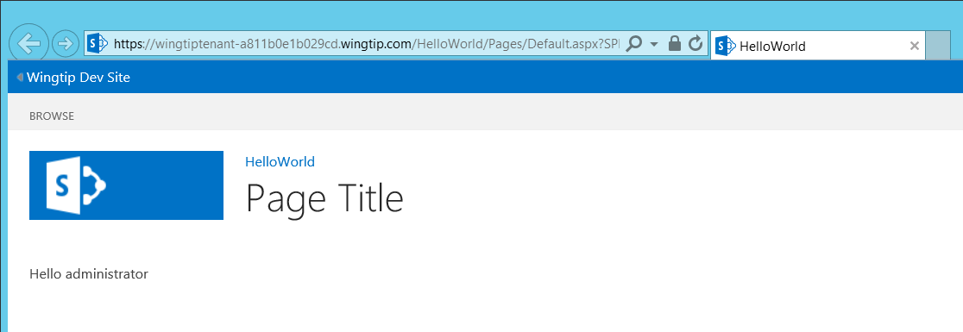

Congratulations. You have now completed the CPT SharePoint 2016 VM Setup Guide and you have a VM that you can use to complete the lab exercise for the Great SharePoint 2016 Adventure. You also have a VM that provides a development environment for general development with the SharePoint 2016 platform.